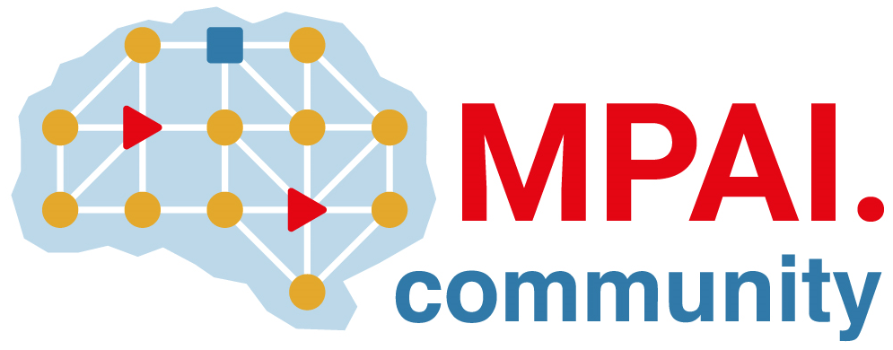 | Moving Picture, Audio and Data Coding  by Artificial Intelligence  www.mpai.community

 | Public document
N608 | 2022/02/23
Source | Requirements (MCS)
Title | MPAI-MCS Progress report and plans
Target | MPAI-17

The current activities of Requirements (MCS) are divided in two parts:
- The Avatar-based Videoconference use cases for which detailed Functional Requirements have been developed (N521). This document has been transferred to MMC-DC and Requirements (ARA) for action.
- The XR Theatre Use Case for which MPAI-MCS (XR Theatre) Use Cases and Functional Requirements WD0.1 has been produced (N609).

