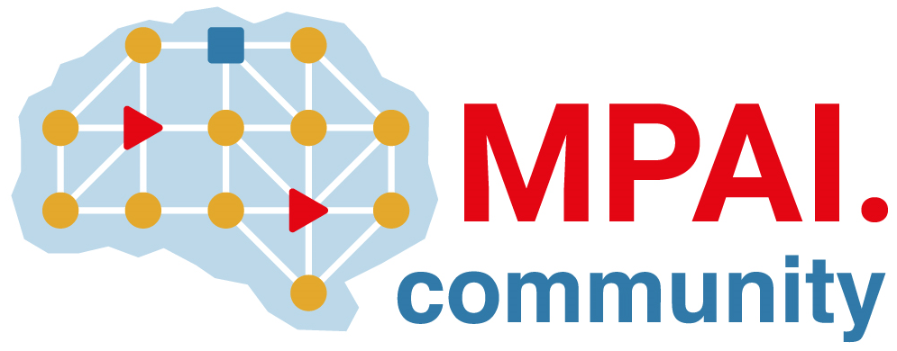 | Moving Picture, Audio and Data Coding  by Artificial Intelligence  www.mpai.community

 | Public Document
N610 | 22/03/23
Source | Requirement (NNW)
Title | Progress report and plans
Target | MPAI Community

This month, MPAI-NNW was working on two documents: use cases and requirement.
The use cases document can be considered as finalized, although complementary needs can be still integrated. It contains now 6 use cases, related to both the usage of watermarking for the NN model and for its inference.
Now that the three “support” documents are completed (state-of-the art, project presentation and use cases), it is important to focus on the requirements to define what is standard for this project. In parallel, it is important for us to get more involved in the MPAI effort, e.g. MPAI-AIF which deals with intellectual property rights (IPR); MPAI marketplace; …

