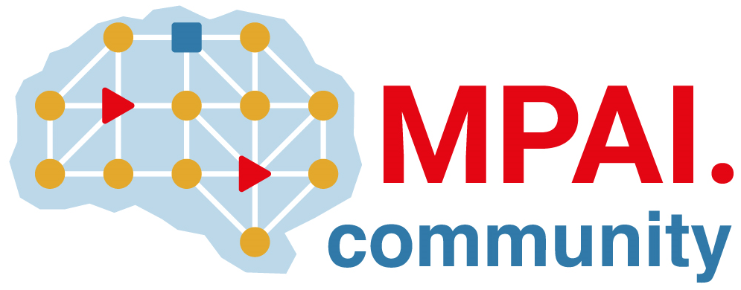 | Moving Picture, Audio and Data Coding  by Artificial Intelligence  www.mpai.community

Public document
N626 | 2022/04/20
Source | 19th MPAI General Assembly (MPAI-19)
Title | MPAI-19 Press Release
Target | MPAI Members

MPAI publishes Working Draft of Use Cases and Functional Requirements of Multimodal Conversation (MPAI-MMC) Version 2

Geneva, Switzerland – 20 April 2022. Today the international, non-profit, unaffiliated Moving Picture, Audio and Data Coding by Artificial Intelligence (MPAI) standards developing organisation has concluded its 19th General Assembly. Among the outcomes is the publication of the working draft of the Use Cases and Functional Requirements of the planned Version 2 of the Multimodal Conversation (MPAI-MMC) standard.

The MPAI process envisages that a standard be developed based on a Call for Technologies referring to two documents Functional Requirements and Framework Licence. While the MPAI-MMC V2 documents are still being finalised, MPAI offers an initial working draft of the Functional Requirements to alert the industry of its intention to initiate the development of the standard. This will happen when the Call for Technologies is published (planned to be the 13th of July 2022). Responses are expected to be submitted on the 10th of October 2022 and the standard to be published in the first few months of 2023.

Version 2 will substantially extend the capabilities of Version 1 of the MPAI-MMC standard by supporting three new use cases:
- Conversation About a Scene: a human holds a conversation with a machine about objects in a scene of which the human is part. While conversing, the human points their fingers to indicare their interest in a particular object.
- Human-Connected Autonomous Vehicle Interaction: a group of humans has a conversation on a domain-specific suject (travel by car) with a Connected Autonomous Vehicle. The machine understands the utterances, the emotion in the specch and in the faces, and the expression in their gestures. The machine manifests itself as the torso of an avatar whose face and head convey emotions congruent with the the speech it utters.
- Avatar Videoconference. In this instance of Mixed-reality Collaborative Space (MCS), avatars represent humans participating in a videoconference. Avatars reproduce the movements of the torsoes of human participants with a high degree of accuracy.

MPAI develops data coding standards for applications that have AI as the core enabling technology. Any legal entity supporting the MPAI mission may join MPAI, if able to contribute to the development of standards for the efficient use of data.

So far, MPAI has developed 5 standards (normal font in the list below), is currently engaged in extending two approved standards (underlined) and is developing other 9 standards (italic).

Name of standard | Acronym | Brief description
AI Framework | MPAI-AIF | Specifies an infrastructure enabling the execution of implementations and access to the MPAI Store. MPAI-AIF V2 is being prepared.
Context-based Audio Enhancement | MPAI-CAE | Improves the user experience of audio-related applications in a variety of contexts.
Compression and Understanding of Industrial Data | MPAI-CUI | Predicts the company performance from governance, financial, and risk data.
Governance of the MPAI Ecosystem | MPAI-GME | Establishes the rules governing the submission of and access to interoperable implementations.
Multimodal Conversation | MPAI-MMC | Enables human-machine conversation emulating human-human conversation. MPAI-MMC V2 is being prepared.
Server-based Predictive Multiplayer Gaming | MPAI-SPG | Trains a network to compensate data losses and detects false data in online multiplayer gaming.
AI-Enhanced Video Coding | MPAI-EVC | Improves existing video coding with AI tools for short-to-medium term applications.
End-to-End Video Coding | MPAI-EEV | Explores the promising area of AI-based “end-to-end” video coding for longer-term applications.
Connected Autonomous Vehicles | MPAI-CAV | Specifies components for Environment Sensing, Autonomous Motion, and Motion Actuation.
Avatar Representation and Animation | MPAI-ARA | Specifies descriptors of avatars impersonating real humans.
Neural Network Watermarking | MPAI-NNW | Measures the impact of adding ownership and licensing information in models and inferences.
Integrative Genomic/Sensor Analysis | MPAI-GSA | Compresses high-throughput experiments data combining genomic/proteomic and other.
Mixed-reality Collaborative Spaces | MPAI-MCS | Supports collaboration of humans represented by avatars in virtual-reality spaces called Ambients
Visual Object and Scene Description | MPAI-OSD | Describes objects and their attributes in a scene and the semantic description of the objects.
Visit the MPAI website, contact the MPAI secretariat for specific information, subscribe to the MPAI Newsletter and follow MPAI on social media: LinkedIn, Twitter, Facebook, Instagram, and YouTube.
Most importantly: join MPAI, share the fun, build the future.

