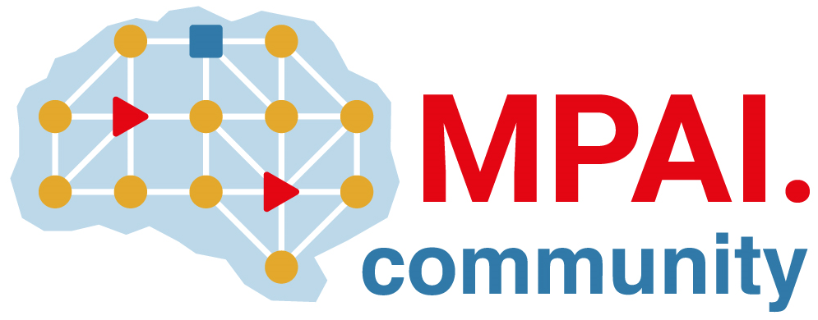 | Moving Picture, Audio and Data Coding by Artificial Intelligence  www.mpai.community

 | Public document
N650 | 2022/04/20
Source | Requirements (EEV)
Title | Requirements (EEV) progress report and plans
Target | MPAI-17

Requirements (EEV) has two major achievements in this round of general assembly meeting cycle. The first fold is that the software coordinator of EEV has successfully reproduced the results and associated coding performance of OpenDVC, which could be tagged as the first version of EEV reference model. In general, the performance of the reproduced version is slightly better than that reported in the OpenDVC technical report. Specifically, 1 million iterations were used to train the models with a mini-batch of 4. The second fold of achievement is that the non-local attention based motion compensation network has been incorporated into OpenDVC. The model is under optimization.

The coordinator also provides the BD-rate reductions over original OpenDVC model using the EEV test conditions. In general, the first version of EEV reference model is 3.57% better than original OpenDVC on MPEG class B dataset using gop size of 16.

