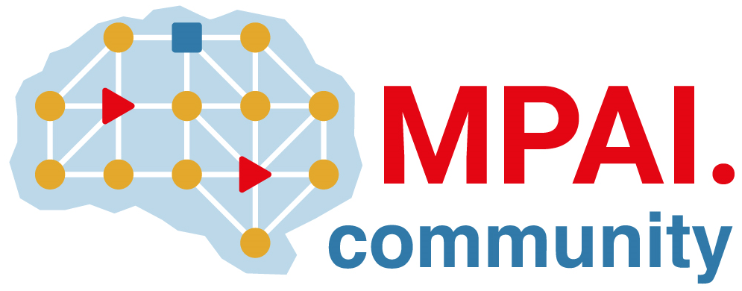 | Moving Picture, Audio and Data Coding by Artificial Intelligence  www.mpai.community

 | Public document
N698 | 2022/05/18
Source | Requirements (EEV)
Title | Requirements (EEV) progress report and plans
Target | MPAI-20

Requirements (EEV) has two major achievements in this round of general assembly meeting cycle. First, based on the first version of MPAI EEV reference model, this group has been dedicated on developing an enhanced version for the motion compensation predicted frames. In particular, the experts found that using a denoising based model for the prediction results is a promising solution. As such, the coordinators are trying to integrate the DnCNN model into the first version software model of MPAI EEV. Partial preliminary results have been obtained. The model is still under optimization and future coding tools on the top of this model is going to be discussed.

Second, the MPAI EEV has accomplished the description document to fully satisfy the curiosity on the future plan and current status and EEV from the audience. The

Last no least, we plan to deliver our documents to involve more participants and increase out impact to the video coding community by posting our news to social media, other standard organisations, MPAI work space.

