Moving Picture, Audio and Data Coding by Artificial Intelligence
www.mpai.community

 | Public document
N703 | 2022/05/18
Source | Requirements (MCS)
Title | MPAI-MCS Progress report and plans
Target | MPAI-20

Requirements (MCS) has refined the Real-to-Virtual-to-Real Reference model

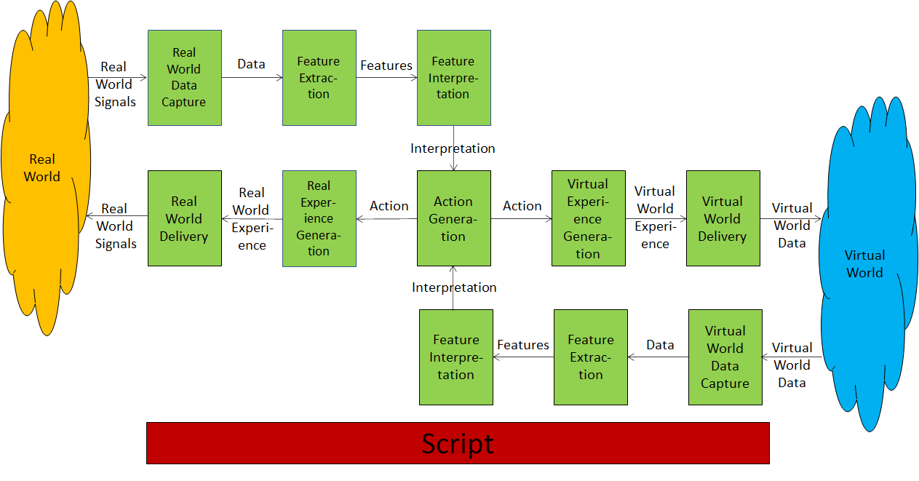

Applied the model to the XR Theatre Use Case and considered 8 sub-use cases.

- DJ/VJ performance at a dance party.
- Live theatrical stage performances.
- Live concert performances.
- Immersive art experience.
- Sporting events (e.g., esports).
- Experiential marketing/branding.
- Meetings/presentations.
- Experiential retail/shopping.

The Esports tournament use case is being analysed with the following purpose:
To specify components and their interfaces in order to enable an XR Theatre (RW) to host any pre-existing VW game for the purpose of producing an esports tournament with RW and VW audience interactivity.
To the extent that the game possesses the required interfaces, the XR Theatre can drive action within the VW.
RW= Real World; VW=Virtual World
The description of the sub-use case is

- Two teams of 5 RW players are arranged on either side of an RW stage, each using a computer to compete within a common real-time Massively Multiplayer Online (MMO) VW game space.
- The 10 players are represented in the VW game space by avatars each driven by a player with
  - A role (e.g., magicians, warriors, soldiers, etc.),
  - Properties (e.g., costumes, physical form, physical features)
  - Actions (e.g., casting spells, shooting, flying, jumping)
- The VW is populated by:
  - Environmental structures (e.g., terrain, mountains, bodies of water)
  - autonomous characters (e.g., dragon, monsters, various creatures).
- Multiple VW cameras follow the action and project it onto an immersive screen surrounding RW spectators and live-streamed to remote spectators who experience the 2D videos and all related sounds of the VW game space.
- A shout caster calls the action as the game proceeds.
- The image of RW players, player stats or other information or imagery may also be displayed on the immersive screen and the live stream.
- Additionally, the RW tournament space is augmented with lighting and special effects, music and costumed performers.
- Live stream viewers interact with one another and with commentators through live chats, Q&A sessions, etc. RW spectators also interact through shouting, waving and interactive devices (e.g., LED wands, smartphones) which can be
  - captured via camera/microphone or wireless data interface (see RW data in Figure 2) providing data.
  - data are processed to extract features
  - features are interpreted
  - RW/VW actions can be generated as a result of
    - in-person or remote audience behaviour (RW), or
    - data collected from VW action (e.g., spell casting, characters dying, bombs exploding)
- At the end of the tournament, there is an award ceremony featuring the winning players on the RW stage with great fanfare.

Use of AI is being investigated
- Controlling the PoV of spectator cameras based on actions and environmental structures within the VW, including player behaviour, autonomous characters, the environment, the importance of the action, spectator response, event audio.
- AI controls game environment and autonomous characters.

