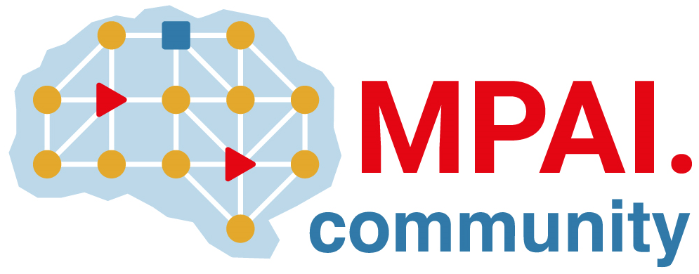 | Moving Picture, Audio and Data Coding  by Artificial Intelligence  www.mpai.community

 | Public document
N705 | 22/05/18
Source | Requirement (NNW)
Title | Progress report and plans
Target | MPAI Community

This month, MPAI-NNW pursuit its work on functional requirements, thus extending and consolidating the MPAI-NNW Use cases & functional requirements document (N702).
This document covers now all the relevant issues related to the standard:
- the scope of the standard
- the list of use-cases (that is stable and validated by all discussions during the last month)
- the structure and the final draft of the requirements
For the coming month, the objective is to finalize this document and to open the call of technologies.

