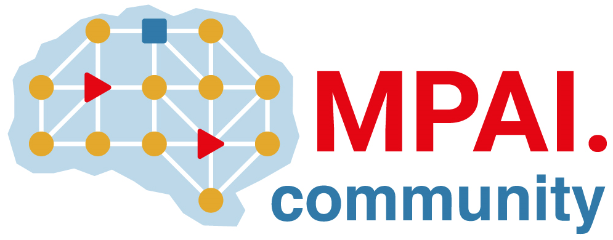 | Moving Picture, Audio and Data Coding by Artificial Intelligence  www.mpai.community

Public document
N739 | 2022/06/22
Source | Requirements (AIH)
Title | MPAI-AIH Progress report and plans
Target | MPAI-21

The group has developed “Initial MPAI-AIH Architecture” (N740) with the following contents:
- AI Health Secure Platform
- Healthcare use case
- Federated Services
The last chapter needs improvements.

