Moving Picture, Audio and Data Coding
by Artificial Intelligence
www.mpai.community

 | Public document
N741 | 2022/06/22
Source | Requirements (ARA)
Title | MPAI-ARA Progress report and plans
Target | MPAI-21

The Requirements (ARA) group has continued the review of MMC-MMC Use Case and Functional Requirements, especially the parts that rely on avatar animation.
Particularly the MMC-PSD Personal Status Display Use Case and its application to the Use Cases #3, #4 and #5.

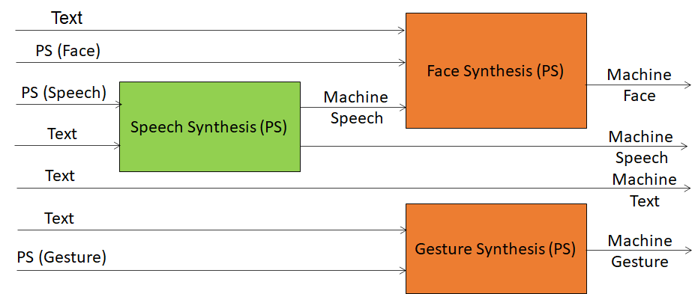
Figure 1 - Personal Status Display
Requirements (ARA) will continue reviewing the data format requirements.

