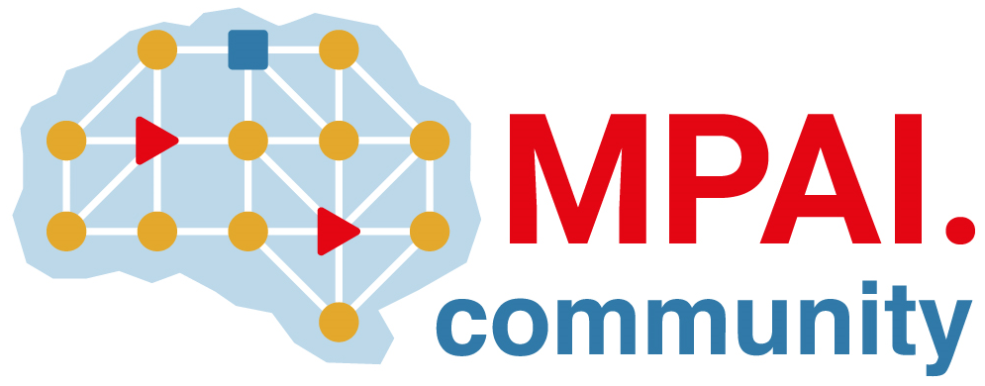 | Moving Picture, Audio and Data Coding by Artificial Intelligence  www.mpai.community

Public document
N744 | 2022/06/22
Source | Requirements (EEV)
Title | Requirements (EEV) progress report and plans
Target | MPAI-21

Requirements (EEV) has released the 2nd version of the reference model, incorporating the motion compensation prediction (MCP) enhancement network into the reference model, in this round of general assembly meeting cycle. The MCP enhancement network is accomplished by a denoising based convolutional neural network (CNN), named DnCNN. The architecture of DnCNN follows a residual learning approach, which contains a direct connection from input to the output. In further investigate the model design, the EEV has made extensive ablation study on the network depth from layer of 6 to layer of 14, selecting the optimal performances of depth of 10 to be the final choice. Based on the experimental results of the collaborative test conditions of EEV, the model obtains more than 10% than the original OpenDVC mode.

In the next step, the requirements (EEV) is planned to add more neural network models into the reference software such that further coding gain can be realized.

