Moving Picture, Audio and Data Coding
by Artificial Intelligence
www.mpai.community

Public Document
N751 | 2022/06/22
Source | Requirements (OSD)
Title | MPAI-OSD report and plans
Target | MPAI Members

The upcoming MPAI-MMC V2 will address Use Cases that include OSD-specific AIM depicted in the following Reference Models

PS-Face Description and PS_Gesture Description.

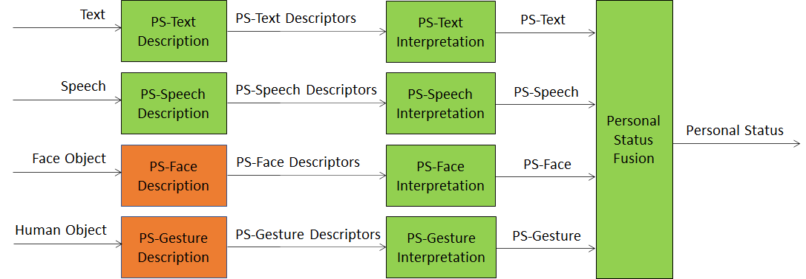
Figure 1 - MMC-PSE Reference Model
Visual Scene Description, Object Description, Gesture Description, and Scene Presentation

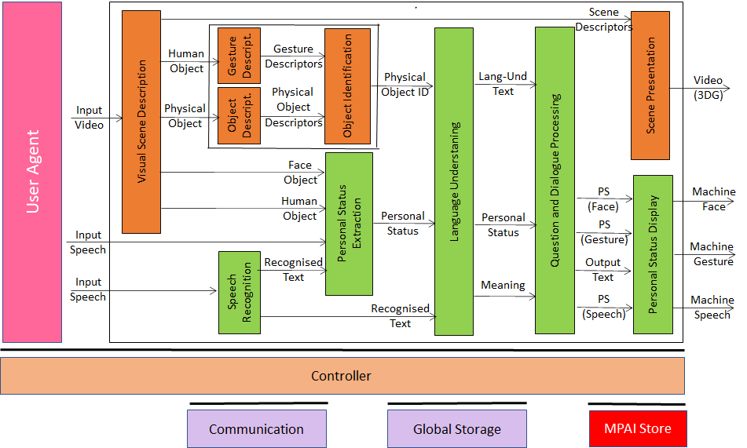
Figure 2 - MMC-CAS Reference Model
Visual Scene Description, Object Description, Object Interpretation, Face Description, and Face Recognition.

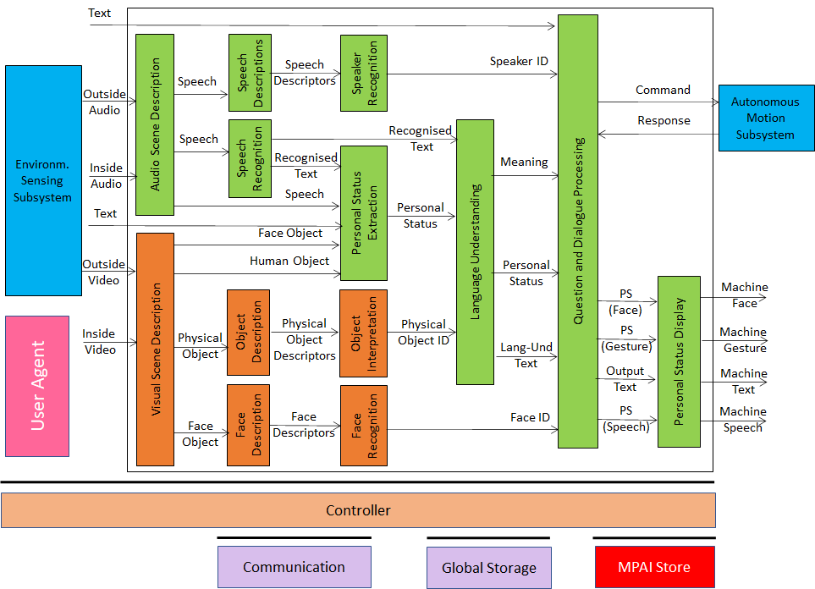
Figure 3 - CAV-HCI Reference Model
Visual Scene Description, Gesture Description, Face Description1, and Face Description2.

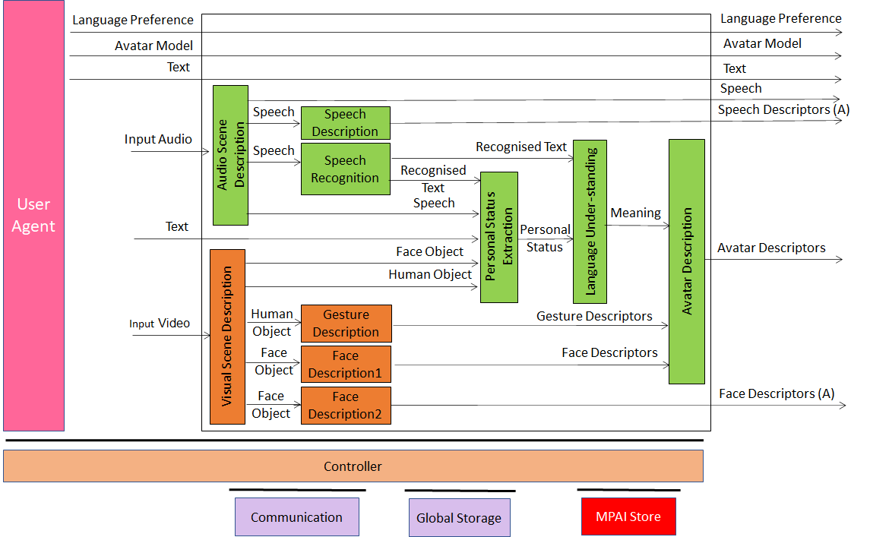
Figure 4 - MCS-ABV (Transmitting Client) Reference Model
Visual Scene Creation and AV Scene Viewer.

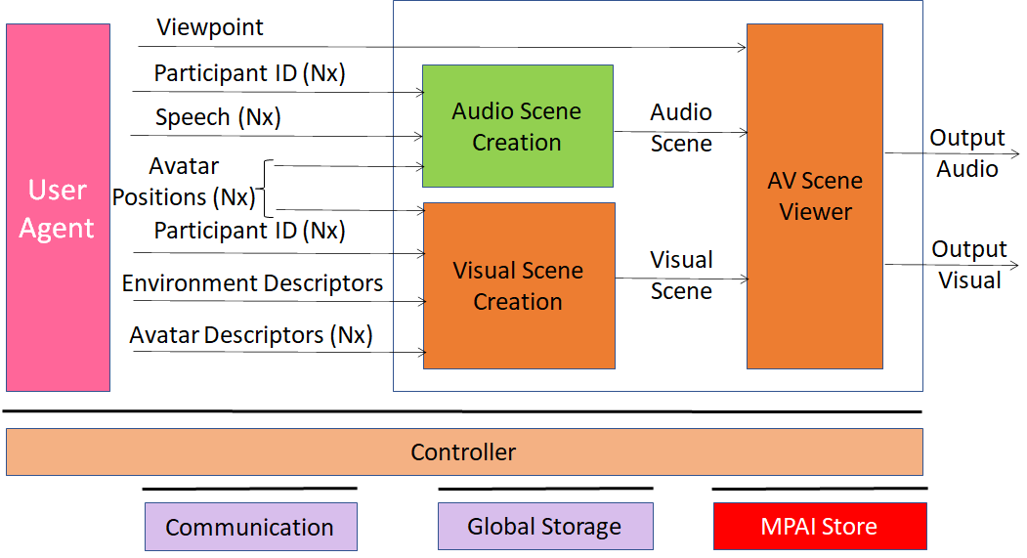
Figure 5 - MCS-ABV (Receiving Client) Reference Model

