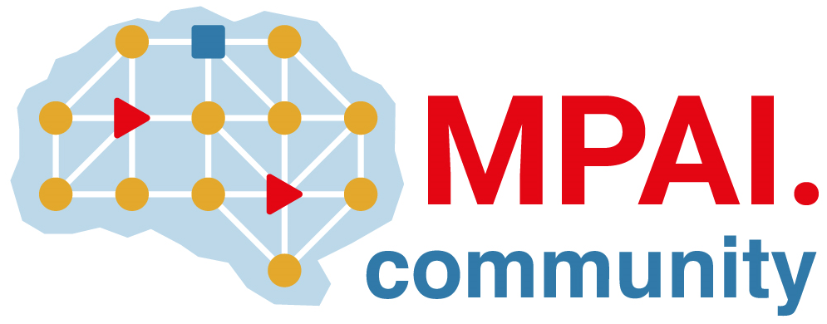 |  | Moving Picture, Audio and Data Coding by Artificial Intelligence  www.mpai.community  Public Document
N764 | 2022/07/19
Source | General Assembly #22 (MPAI-22)
Title | MPAI Timeline
Target | MPAI-22

NB1 | Dates in italic indicate estimated dates mm/dd where mm/dd=2020, mm/dd=2021, mm/dd=2022 and mm/dd=2023
NB2 | ... in a date indicate that only the month is estimated

Std | V | IntCo | UseC | FunRq | ComRq | CfT | StdDv | TchS | RfSw | ConfT | PerfA
AIF | 1 |  |  | 10/21 | 11/18 | 12/16 | 02/17 | 11/24 | 06/22 | 08/24 | --/--
AIF | 2 |  |  | 02/23 | 06/22 | 07/19 | 10/12 | 02/15 | 06/14 | 09/14 | --/--
AIH | 1 | 03/23 | 04/20 | 06/22
ARA | 1 | 01/26 | 03/23
CAE | 1 |  |  | 10/21 | 12/16 | 02/17 | 04/14 | 12/22 | 10/12 | 09/21 | 12/14
CAE | 2 |  |  | 06/22 | 06/22 | 07/19 | 10/12 | 12/14 | ??/?? | 04/12 | --/--
CAV | 1 |  | 06/09 | 07/19
CUI | 1 |  |  | 11/18 | 02/17 | 03/17 | 05/12 | 09/30 | 09/30 | 09/30 | 09/30
EEV |  | 09/30 | 03/23
EVC |  |  |  | 10/21
GSA |  |  |  | 10/21
MCS |  |  | 07/19 | 08/25
MMC | 1 |  |  | 10/21 | 12/16 | 02/17 | 04/14 | 09/30 | 10/12 | 10/12 | 10/12
MMC | 2 |  |  | 02/23 | 06/22 | 07/19 | 10/12 | 02/15 | ??/?? | 10/12 | 11/16
OSD |  |  |  | 05/12
SPG |  |  |  | 10/21
NNW |  |  | 03/23
XRV |  |  |  | 06/22

General Assemblies

# | 19 | 20 | 21 | 22 | 23 | 24 | 25 | 26 | 27 | 28 | 29 | 30 | 31 | 32 | 33 | 34 | 35 | 36 | 37
y | 22 | 22 | 22 | 22 | 22 | 22 | 22 | 22 | 22 | 23 | 23 | 23 | 23 | 23 | 23 | 23 | 23 | 23 | 23
m | 04 | 05 | 06 | 07 | 08 | 09 | 10 | 11 | 12 | 01 | 02 | 03 | 04 | 05 | 06 | 07 | 08 | 09 | 10
d | 20 | 18 | 22 | 19 | 24 | 21 | 19 | 16 | 14 | 18 | 15 | 15 | 12 | 10 | 14 | 19 | 16 | 14 | 11
# | 0 | 1 | 2 | 3 | 4 | 5 | 6 | 7 | 8 | 9 | 10 | 11 | 12 | 13 | 14 | 15 | 16 | 17 | 18
y | 20 | 20 | 20 | 20 | 21 | 21 | 21 | 21 | 21 | 21 | 21 | 21 | 21 | 21 | 21 | 21 | 22 | 22 | 22
m | 09 | 10 | 11 | 12 | 01 | 02 | 03 | 04 | 05 | 06 | 07 | 08 | 09 | 10 | 11 | 12 | 02 | 03 | 03
d | 30 | 21 | 18 | 16 | 21 | 17 | 17 | 14 | 12 | 09 | 19 | 25 | 30 | 27 | 24 | 22 | 26 | 23 | 23

# | Acronym | Title
 | MPAI-AIF | AI Framework
 | MPAI-AIH | AI Health data
 | MPAI-ARA | Avatar Representation and Animation
 | MPAI-CAE | Context-based Audio Enhancement
 | MPAI-CAV | Connected Automotive Vehicles
 | MPAI-CUI | Compression and Understanding of Industrial Data
 | MPAI-EEV | AI-based End-to-End Video Coding
 | MPAI-EVC | AI-Enhanced Video Coding
 | MPAI-GSA | Integrative AI-based Analysis of Genomic/ Sensor Experiments
 | MPAI-MCS | Mixed-reality Collaborative Spaces
 | MPAI-MMC | Multi-Modal Conversation
 | MPAI-NNW | Neural Network Watermarking
 | MPAI-OSD | Visual Object and Scene Description
 | MPAI-SPG | Server-based Predictive Multiplayer Gaming
 | MPAI-XRV | XR Venues

General Assemblies

