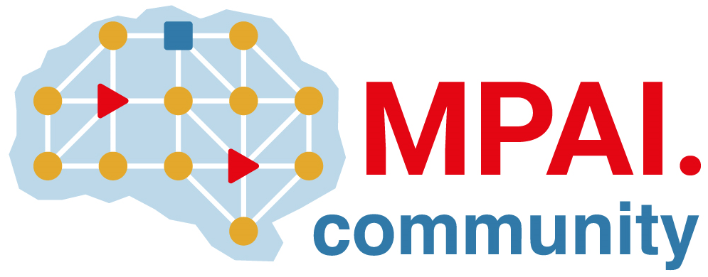 | Moving Picture, Audio and Data Coding by Artificial Intelligence  www.mpai.community

Public document
N781 | 2022/07/19
Source | Requirements (AIH)
Title | MPAI-AIH Progress report and plans
Target | MPAI-21

The group has developed “MPAI-AIH Use Cases and Functional Requirements WD0.1” (N782) is requests that the AIH work item be promoted to Functional Requirements.

