Moving Picture, Audio and Data Coding
by Artificial Intelligence
www.mpai.community

 | Public document
N783 | 2022/07/19
Source | Requirements (ARA)
Title | MPAI-ARA Progress report and plans
Target | MPAI-22

The Requirements (ARA) group has finished its review of the MMC-MMC Use Case and Functional Requirements. It has also reviewed the MPAI-MMC V2 Call for Technologies.
Requirement (ARA) will discuss its next course of action while waiting for the responses to the Call.
Requirements (ARA) notes the following MPAI activities where Requirements (ARA) is doing work.

Environment Model
The Avatar-Based Videoconference Manager distributes the model of the Environment where the Videoconference will be held.

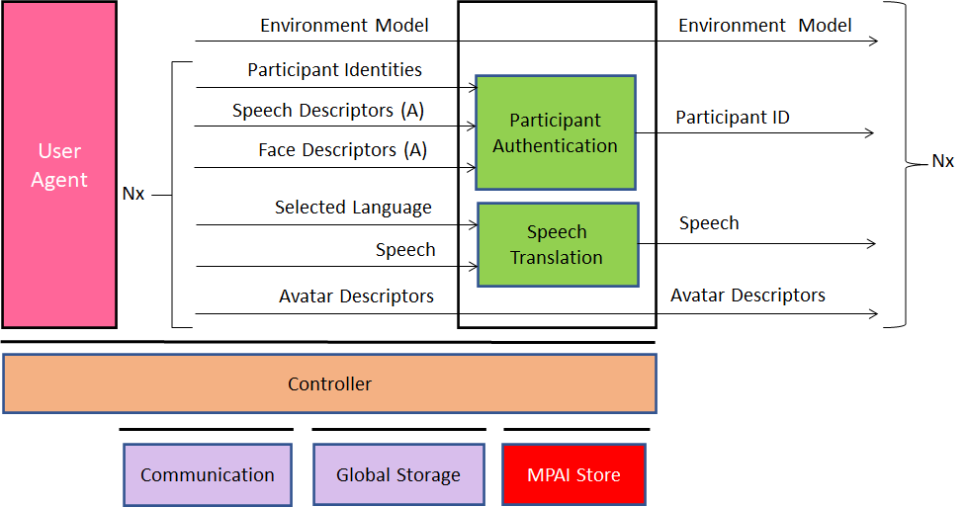
Figure 1 - The MCS-ABV Server Reference Model

Avatar Model and Avatar Description
Each participant uses their Transmitting Client to send their own Avatar Model and computes their own Avatar Descriptors for the Server to distribute to the other participants

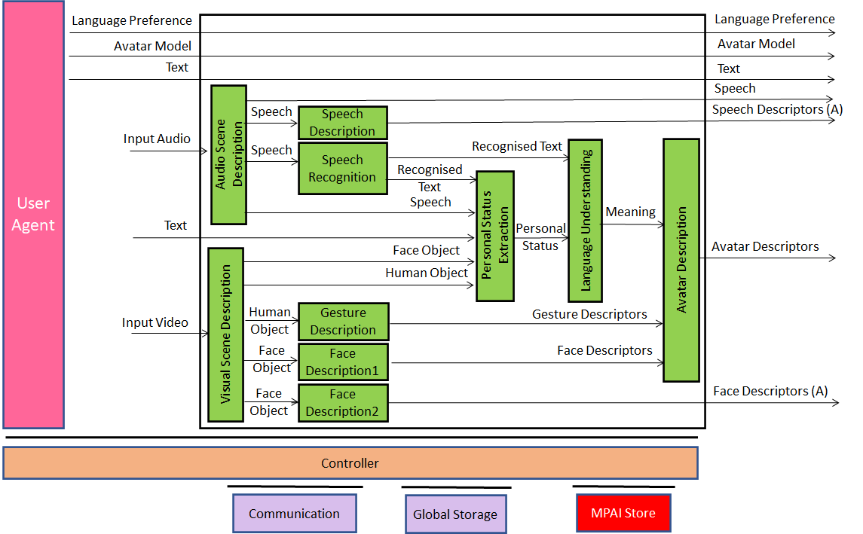
Figure 2 - The MCS-ABV Tramsmitting Client Reference Model
Personal Status Display
The Personal Status Display (MMC-PSD) is a widely reusable component for human to machine conversation applications.

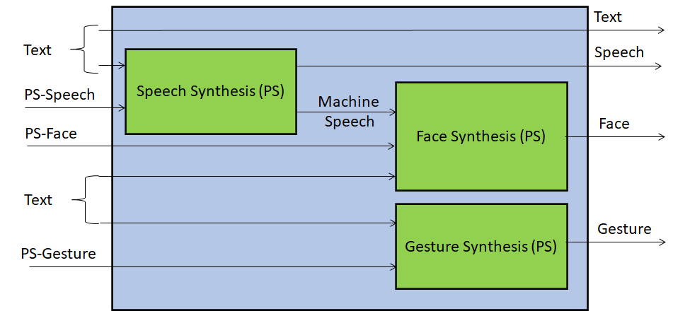
Figure 3 - Personal Status Display

