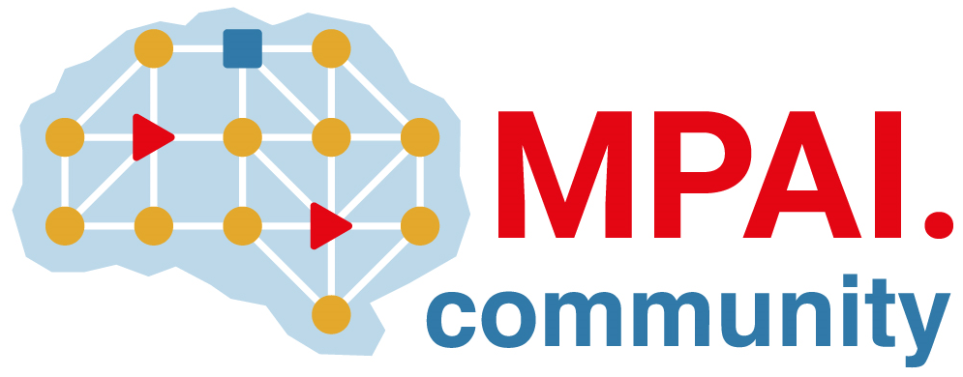 | Moving Picture, Audio and Data Coding  by Artificial Intelligence  www.mpai.community

Public document
N790 | 22/07/19
Source | Requirement (NNW)
Title | Progress report and plans
Target | MPAI Community

This month, MPAI-NNW finalized all the documents supporting the call for technologies:
- NNW-DC Terms of Reference N792
- Call for technologies N793
- Use cases and functional requirement N794
- Framework Licence N801
As a preparation step for issuing the call for technologies, two supplementary actions have been carried out:
- creation of a promotion video (https://youtu.be/-G4mZ_AVldw)
- the organisation of a webinar that was held July 12th (https://youtu.be/iM26lyQ4FHw)
For the coming month, the objective is to advertise the NNW project to bring new members and respondents and prepare the means for evaluating the answer of the call.

