Moving Picture, Audio and Data Coding
by Artificial Intelligence
www.mpai.community

Public Document
N794 | 2022/07/19
Source | Requirements (OSD)
Title | MPAI-OSD report and plans
Target | MPAI Members

Contents
1 Introduction 1
2 Connected Autonomous Vehicles 1
2.1 Autonomous Motion Subsystem 1
2.2 Environment Sensing Subsystem 1
2.3 Human-Cav Interaction 2
3 Mixed-reality Collaborative Spaces 3
3.1 Avatar-Based Videoconference 3
3.1.1 MCS-ABV Transmitting Client 3
3.1.2 MCS-ABV Virtual Secretary 4
3.1.3 MCS-ABV Receiving Client 4
3.2 Conversation About a Scene 5
4 Multimodal Conversation 5
4.1 Personal Status Extraction 5

Introduction
This document analyses the Use Cases, and the Composite AIMs addressing areas covered by Requirements (OSD) activities. The relevant AIMs are depicted in ocra.

Connected Autonomous Vehicles
Connected Autonomous Vehicles (MPAI-CAV) is an MPAI standard project seeking to define identified CAV standard components and their interfaces.

Autonomous Motion Subsystem
Autonomous Motion Subsystem (AMS) issues commands to drive the CAV to the intended destination.
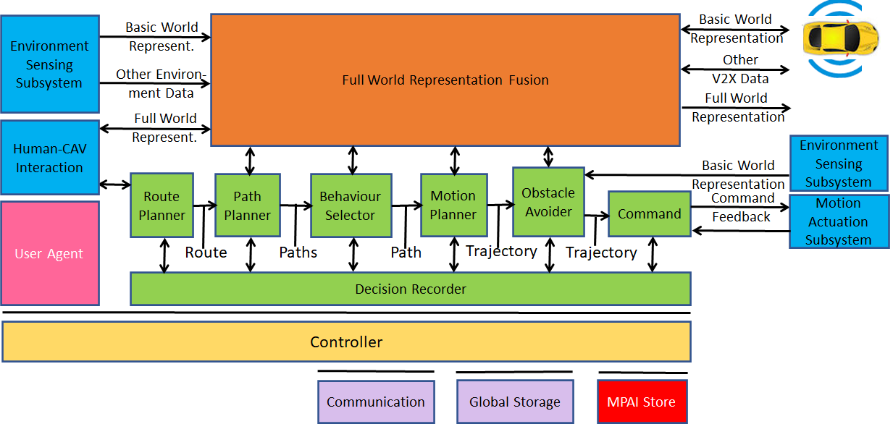
Figure 1 - CAV-AMS Reference Model

Environment Sensing Subsystem
Environment Sensing Subsystem (ESS) acquires and processes information from the Environment via a variety of sensors.
The stack of AIMs on the left-hand side processes raw data from sensors to facilitate the subsequence process of Descriptor Extraction carried out by the AIM stach in the middle.

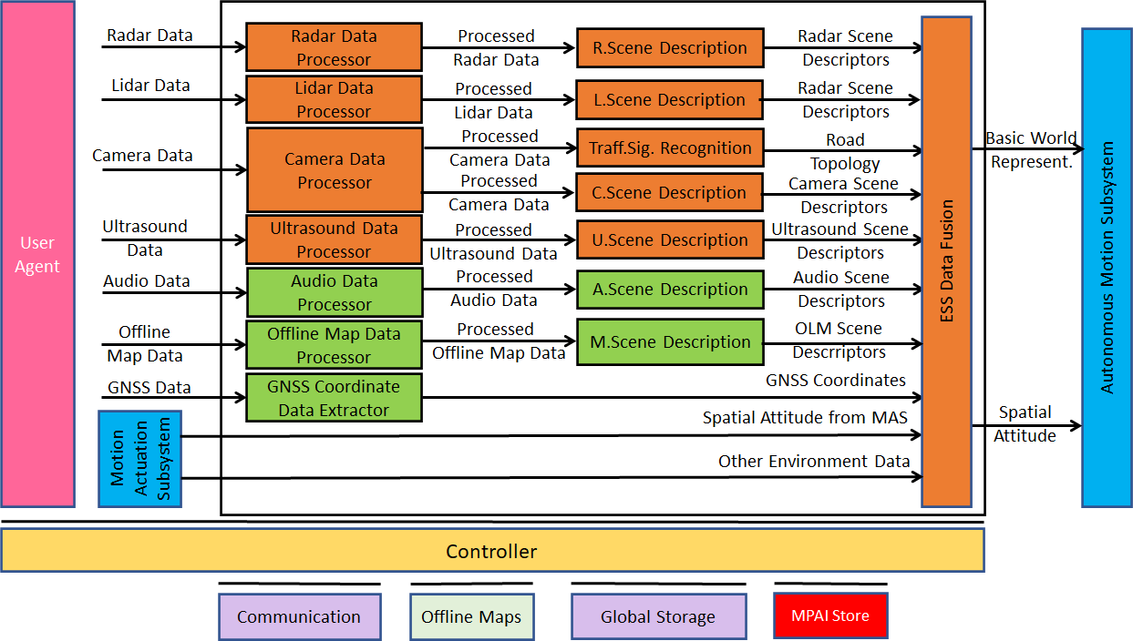
Figure 2 - CAV-EES Reference Model

Human-Cav Interaction
Human-CAV Interaction (HCI) Handles human-CAV interactions.
The main processes are: Visual Scene Description, Object Description, Object Interpretation, Face Description and Face Recognition.

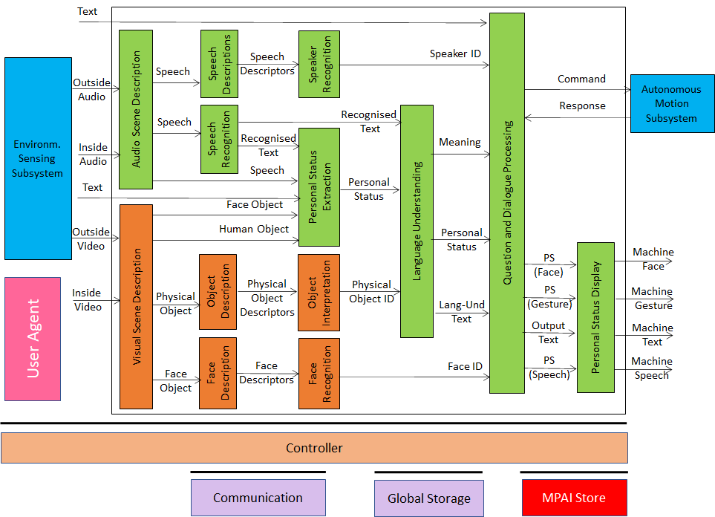
Figure 3 - CAV-HCI Reference Model

Mixed-reality Collaborative Spaces

Avatar-Based Videoconference
A system allowing human participants to attend a videoconference represented by their avatars who accurately represents their features and movements.
MCS-ABV is composed of 4 subsystems 5 of which use technologies falling within the Requirements (OSD) activities.

MCS-ABV Transmitting Client
The purpose of the MCS-ABV Transmitting Client is to create an accurate set of descriptors to be used by Receiving Clients.
The main processes are: Visual Scene Description, Gesture Description, Face Description1, and Face Description2.

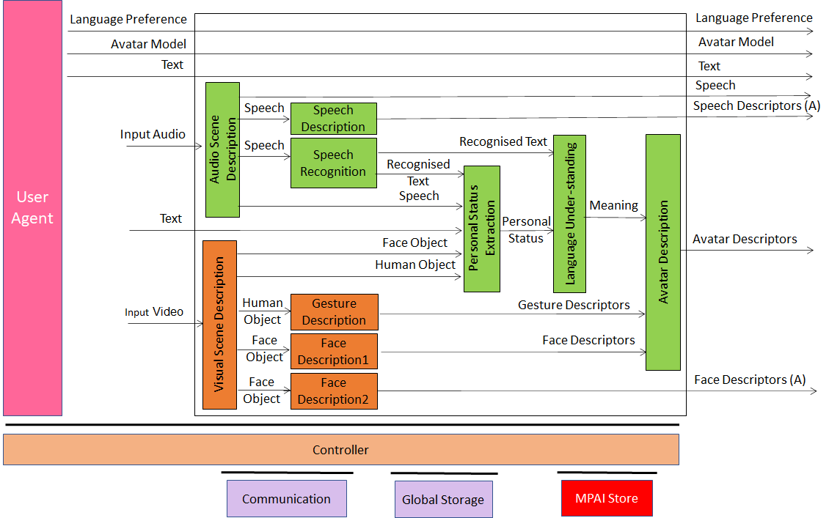
Figure 4 - MCS-ABV (Transmitting Client) Reference Model

MCS-ABV Virtual Secretary
The purpose of the MCS-ABV Virtual Secretary is to create a summary of the utterances of the avatars using the Personal Status Descriptor to improve its understanding.

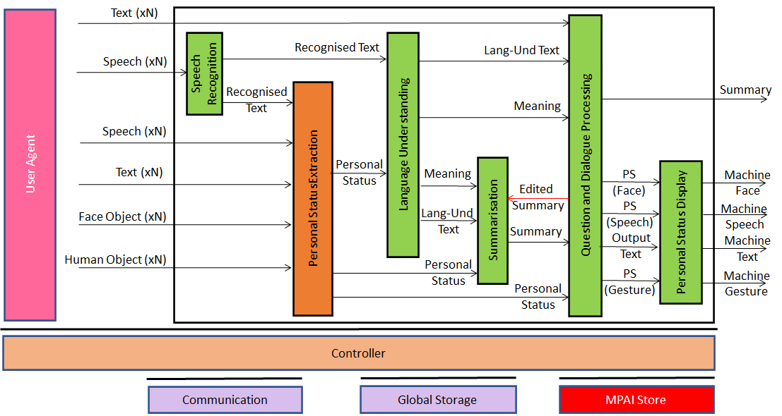
Figure 4 - MCS-ABV Virtual Secretary Reference Model

MCS-ABV Receiving Client
The purpose of the MCS-ABV Receiving Client is to allow participants to dispose the avatars participating in the videoconference preserving the source of their utterances.
The main processes are: Visual Scene Creation and AV Scene Viewer.

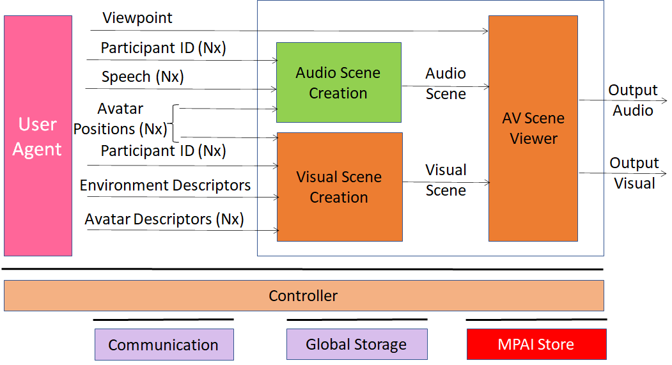
Figure 6 - MCS-ABV (Receiving Client) Reference Model

Conversation About a Scene
In MCS-CAS a machine converses with a human by understanding their gesture (finger pointing to an object) and Personal Status
The main processes are: Visual Scene Description, Object Description, Gesture Description, and Scene Presentation,

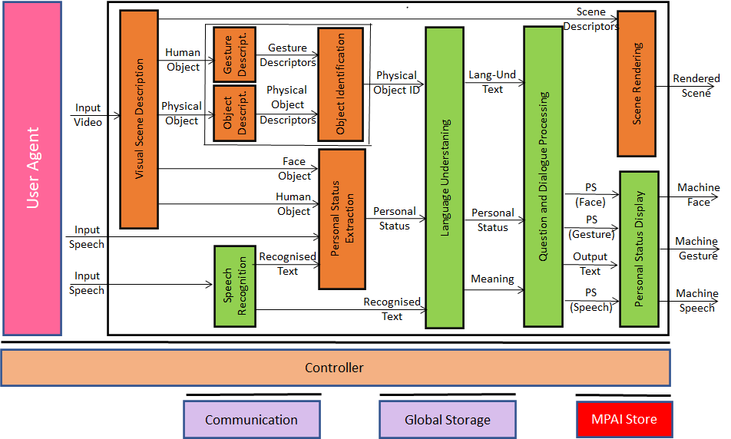
Figure 5 - MMC-CAS Reference Model

Multimodal Conversation

Personal Status Extraction
The purpose of MMC-PSE is to extract the Personal Status of Text, Speech, Face, and Gesture.
The main processes are: PS-Face Description and PS-Gesture Description.

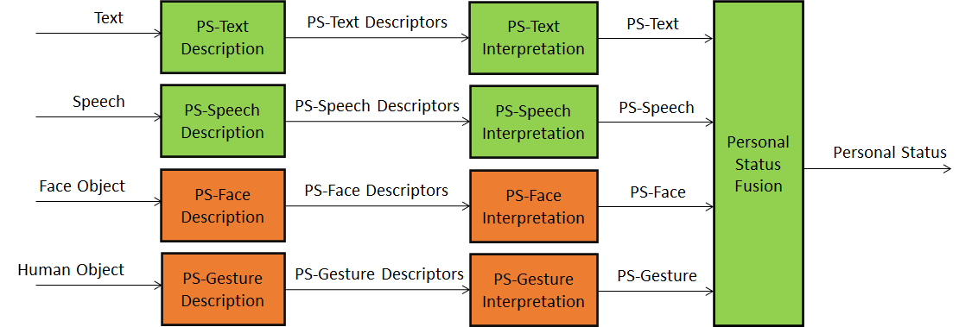
Figure 7 - MMC-PSE Reference Model

