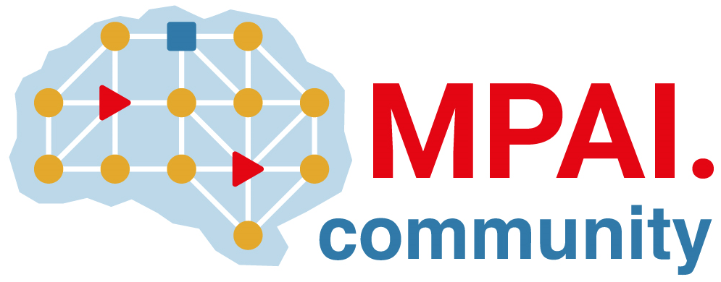 | Moving Picture, Audio and Data Coding by Artificial Intelligence  www.mpai.community

Public document
N832 | 2022/08/24
Source | NNW-DC
Title | Template for responses to the MPAI-NNW Call for Technologies
Target | Submitters to MPAI-NNW CfT

Abstract
This document is provided as a help to those who intend to submit a response to the MPAI-NNW Call for Technologies. Text in yellow (as in this sentence) provides guidance to submitters and should NOT be included in a submission. Text in green shall be mandatorily included in a submission. If a submission does not include the green text, the submission will be rejected.
If the submission is in multiple files, each file shall include the green statement.
Text in white is the text suggested to respondents for use in a submission.

Introduction
This document is submitted by <organisation name> (if an MPAI Member) and/or by <organisation name>, a <company, university etc.> registered in ... (if a non-MPAI member) in response to the MPAI-NNW Call for Technologies issued by Moving Picture, Audio and Data Coding by Artificial Intelligence (MPAI) on 2022/07/19 as MPAI document N792.
In the opinion of the submitter, this document proposes technologies that satisfy the requirements of MPAI document MPAI-NNW Use Cases & Functional Requirements issued by MPAI on 2022/07/19 as MPAI document N793.

Possible additions
This document also contains comments on the Functional Requirements as requested by N793
This document also contains proposed technologies that satisfy additional requirements as allowed by N793.

<Company and/or Member> explicitly agrees to the steps of the MPAI standards development process defined in Annex 1 to the MPAI Statutes (N421), in particular <Company and or Member> declares that <Company and or Member> or its successors will make available the terms of the Licence related to its Essential Patents according to the MPAI-NNW Framework Licence (N801), alone or jointly with other IPR holders after the approval of the MPAI-NNW Technical Specification by the MPAI General Assembly and in no event after commercial implementations of the MPAI-NNW Technical Specification become available on the market.

< Company and/or Member> acknowledges the following points:
- MPAI is not obligated, by virtue of this Call for Technologies, to select a particular technology or to select any technology if those submitted are found inadequate.
- A representative of <Company and/or Member> shall present this submission at a NNW-DC meeting communicated by MPAI Secretariat (mailto:secretariat@mpai.community). If no <Company and/or Member> will attend the meeting and present the submission, this submission will be discarded.
- <Company and/or Member> shall make available a working implementation, including source code – for use in the development of the MPAI-NNW Reference Software and eventual publication by MPAI as a normative Technical Specification – before the technology submitted is accepted for the MPAI-NNW Technical Specification.
- The software submitted may be written in programming languages that can be compiled or interpreted and in hardware description languages, upon acceptance by MPAI for further evaluation of their submission in whole or in part.
- <Company> shall immediately join MPAI upon acceptance by MPAI for further evaluation of this submission in whole or in part.
- If <Company> does not join MPAI, this submission shall be discarded.

Information about the submission
This information corresponds to Annex A on N792. It is included here for submitter’s convenience.

- Title of the proposal
- Organisation: company name, position, e-mail of contact person
- What are the main functionalities of your proposal?
- Does your proposal provide or describe a formal specification and APIs?
- Will you provide a demonstration to show how your proposal meets the evaluation criteria?

Comments on/extensions to requirements (if any)

Overview of Requirements supported by the submission
Please answer Y or N. Detail on the specific answers can be provided in the submission.

Requirement |  | Response
Use cases
4. | Additional/Comments on use cases | Y/N
Impact of the watermark on the performance
5.1 | List of Tasks to be performed by the Neural Network | Y/N
5.1 | Comment the process of testing the impact of the watermark injection on the performance | Y/N
5.1.1.d | Methods to measure the quality of the produced inference | Y/N
Detection capability
5.2 | List of potential modifications | Y/N
5.2 | Parameters and ranges of proposed modifications | Y/N
Decoding capability
5.3 | List of potential modifications, together with their corresponding parameters and ranges | Y/N
5.3.5.i | Suitable distance to evaluate the difference between the original and retrieved watermarks | Y/N
Processing cost
5.4 | Specification of testing environments | Y/N
5.4 | Specification of values characterizing the processing of NNs | Y/N

New Proposed requirements (if any)

Y/N
Y/N
Y/N

- Detailed description of submission

Proposal chapter #1

Proposal chapter #2
....

Conclusions

