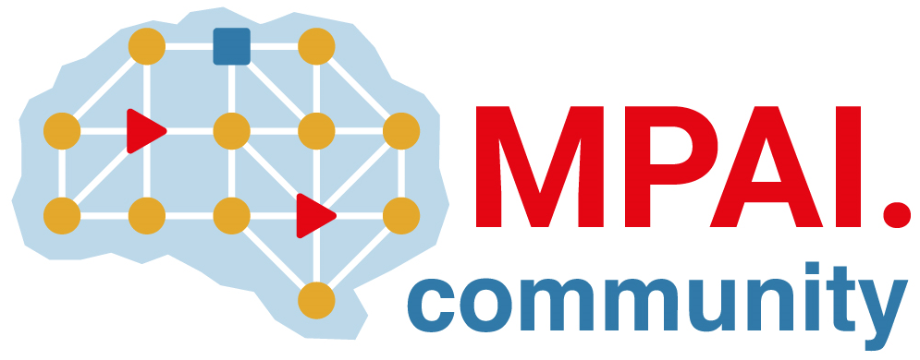 | Moving Picture, Audio and Data Coding  by Artificial Intelligence  www.mpai.community

 | Public document
N834 | 2022/08/24
Source | Requirements (ARA)
Title | MPAI-ARA Progress report and plans
Target | MPAI-23

The Requirements (ARA) group has made a thorough review of the MPAI-MMC V2 Use Cases and Functional Requirements. In particular, it has reviewed “Clarifications about MPAI-MMC V2 CfT data formats” highlighting the need to clarify the role of the Action Generation Component in the case communication is between humans, but highly mediated by a machine

