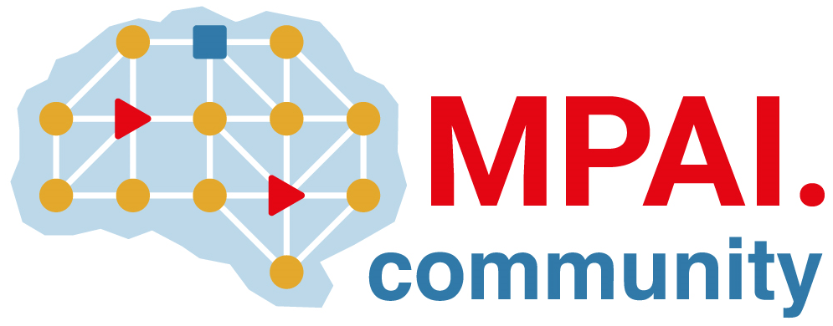 | Moving Picture, Audio and Data Coding by Artificial Intelligence  www.mpai.community

N837 | 2022/08/24
Source | Requirements (EEV)
Title | Requirements (EEV) progress report and plans
Target | MPAI-23

Requirements (EEV) plans to use the framework published in Chinese Conference on Image and Graphics Technologies as the latest reference model. The following permission is made.

Peking University/Peng Cheng Lab contribute Chuanmin Jia, Weimin Zhang, Kai Lin, and Siwei Ma. Towards Neural Video Compression: A Rate Distortion Modeling Perspective, IGTA, 2022.

Peking University/Peng Cheng Lab declares that, in case the MPAI’s End-to-End Video Coding Exploration to which this submission is made will become part of the MPAI Work Plan per Annex I of the MPAI Statutes and deliver a Technical Specification, Peking University/Peng Cheng Lab submitting this contribution or its successors will make available the terms of the Licence related to its Essential IPR in the Technical Specification in accordance to the “Basic Framework Licence for Collaborative Explorations” [N461] and will endeavour to make its Licence in accordance with the Framework Licence of the Technical Specification, alone or jointly with other IPR holders, after the approval of the Technical Specification by the MPAI General Assembly and in no event after commercial implementations of the Technical Specification become available on the market.

