Moving Picture, Audio and Data Coding by Artificial Intelligence
www.mpai.community

Public document
N844 | 2022/08/24
Source | Requirements (XRV)
Title | XR Venue (MPAI-XRV) Use Case and Functional Requirements WD0.1.3
Target | MPAI Community

Abstract
XR Venues (MPAI-XRV) is an MPAI project addressing a multiplicity of use cases enabled by AR/VR/MR (XR) and enhanced by Artificial Intelligence technologies. The word venue is used as a synonym for a real and virtual environments.
The goals of the project are:
- To identify and characterise AI Modules (AIMs) reusable across use cases.
- To develop requirements for the AI Workflows (AIWs) implementing the identified use cases and for AIM functions and input/output data.
- To draft and publish a Call for Technologies satisfying the identified functional requirements and the commercial requirements.
- To specify the enabling technologies in a standard.
Contents
Abstract 1
1 Introduction 2
2 A Real-Virtual Interaction Model 3
3 Terms and definitions 5
4 Devices and data in the XR Theatre Use Case 6
5 XR Venue use cases 7
5.1 eSports Tournament (XRV-EST). 7
5.1.1 Purpose 7
5.1.2 Description 7
5.1.3 Processing 8
5.1.4 Reference architecture 9
5.1.5 AI Modules 10
5.2 Live theatrical stage performance. 12
5.2.1 Purpose and advantages 12
5.2.2 Description 12
5.2.3 Reference Architecture 13
5.2.4 Input/output data 13
5.2.5 AI Modules 13
5.3 Experiential retail/shopping. 13
5.3.1 Purpose 13
5.3.2 Description 13
5.4 Immersive art experience. 13
5.4.1 Purpose 13
5.4.2 Description 13
5.5 DJ/VJ performance at a dance party. 14
5.5.1 Purpose 14
5.5.2 Description 14
5.6 Live concert performance. 14
5.6.1 Purpose 14
5.6.2 Description 14
5.7 Experiential marketing/branding. 14
5.7.1 Purpose 14
5.7.2 Description 15
5.8 Meetings/presentations. 15
5.8.1 Purpose 15
5.8.2 Description 15
6 References 15
6.1 Normative References 15
6.2 Informative Reference 15
Annex A MPAI-wide terms and definitions 16
Annex B Notices and Disclaimers Concerning MPAI Standards (Informative) 19
Annex C The Governance of the MPAI Ecosystem (Informative) 21

Introduction
In recent years, Artificial Intelligence (AI) and related technologies have been applied to a broad range of applications, have started affecting the life of millions of people and are expected to do so even more in the future. As digital media standards have positively influenced industry and billions of people, so AI-based data coding standards are expected to have a similar positive impact. Indeed, research has shown that data coding with AI-based technologies is generally more efficient than with existing technologies for, e.g., compression and feature-based description.
However, some AI technologies may carry inherent risks, e.g., in terms of bias toward some classes of users. Therefore, the need for standardisation is more important and urgent than ever.
The international, unaffiliated, not-for-profit MPAI – Moving Picture, Audio and Data Coding by Artificial Intelligence Standards Developing Organisation has the mission to develop AI-enabled data coding standards. MPAI Application Standards enable the development of AI-based products, applications, and services.
As a part of its mission, MPAI has developed standard operating procedures to enable users of MPAI implementations to make informed decision about their applicability. Central to this is the notion of Performance, defined as a set of attributes characterising a reliable and trustworthy implementation.
For the aforementioned reasons, to fully achieve the MPAI mission, Technical Specifications must be complemented by an ecosystem designed, created and managed to underpin the life cycle of MPAI standards through the steps of specification, technical testing, assessment of product safety and security, and distribution.
In the following, Terms beginning with a capital letter are defined in Error! Reference source not found. if they are specific to this project and in Error! Reference source not found. if they are common to all MPAI Standards.
The MPAI Ecosystem is fully specified in [1]. It is composed of:
- MPAI as provider of Technical, Conformance and Performance Specifications.
- Implementers of MPAI standards.
- MPAI-appointed Performance Assessors.
- The MPAI Store which takes care of secure distribution of validated Implementations.
- End Users who use Implementations from the MPAI Store.
Figure 1 depicts the MPAI-AIF Reference Model under which Implementations of MPAI Application Standards and user-defined MPAI-AIF conforming applications operate.
An AIF Implementation allows execution of AI Workflows (AIW), composed of basic processing elements called AI Modules (AIM).
MPAI Application Standards normatively specify Syntax and Semantics of the input and output data and the Function of the AIW and the AIMs, and the Connections between and among the AIMs of an AIW.
In particular, an AIM is defined by its Function and data, but not by its internal architecture, which may be based on AI or data processing, and implemented in software, hardware or hybrid software and hardware technologies.

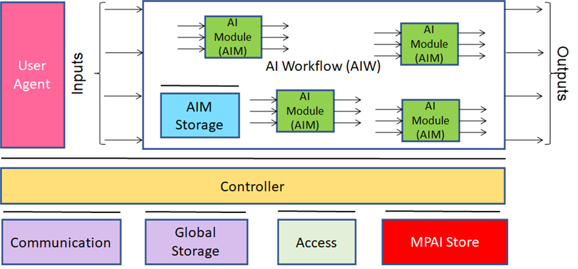
Figure 1 - The AI Framework (AIF) Reference Model and its Components
MPAI defines Interoperability as the ability to replace an AIW or an AIM Implementation with a functionally equivalent Implementation. MPAI also defines 3 Interoperability Levels of an AIW executed in an AIF:
Level 1 – Conforming to the MPAI-AIF Standard.
Level 2 – Conforming to an MPAI Application Standard.
Level 3 – Assessed by a Performance Assessor.
MPAI offers Users access to the promised benefits of AI with a guarantee of increased transparency, trust and reliability as the Interoperability Level of an Implementation moves from 1 to 3. Additional information on Interoperability Levels is provided in Annex C.

A Real-Virtual Interaction Model
A main feature of MPAI-XRV is the strong interaction, even interchangeability, of an Environment from the Real/Virtual World and an Environment from the Virtual/Real World. The project has developed a model, depicted in Figure 2 and Figure 4 to guide its analysis of the MPAI-XRV use cases.
The
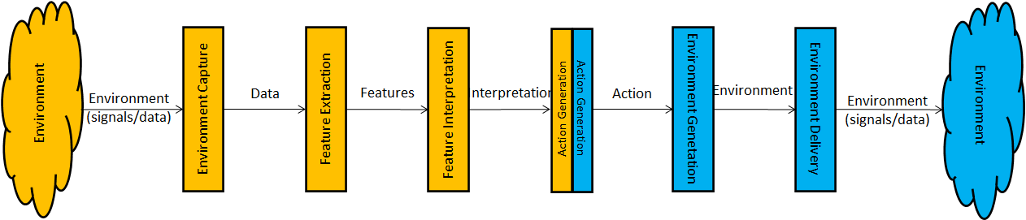
Figure 2 – Environment A to Environment B Interactions
Table 1 defines the functions of the processing elements that capture and process an Environment from the Universe or a Metaverse and deliver an Environment to a portion of the same or another Metaverse or of a Universe.
Table 1 - The functions of the components in the MPAI Metaverse Model
Environment Capture | Captures Environment as collections of signals and/or data in appropriate formats.
Feature Extraction | Analyses Data to extract Features.
Feature Interpretation | Analyses Features to yield Interpretations.
Action Generation | Analyses Interpretations to generate Actions.
Experience Generation | Analyses Actions to generate Environment.
Environment Delivery | Delivers Environment as collections of signals and/or data in appropriate formats.

Action is the output of a machine that expresses how the machine intends to respond to the information that it has acquired – either directly or through interpretation – from the Environment
The model assumes that there is a complete symmetry between the actions performed and the data formats exchanged between the Real World and a Virtual World. Actions initiated by the Environment on the left of Figure 4 has an impact on the Environment on the right and may trigger actions that will influence the Environment on the left.

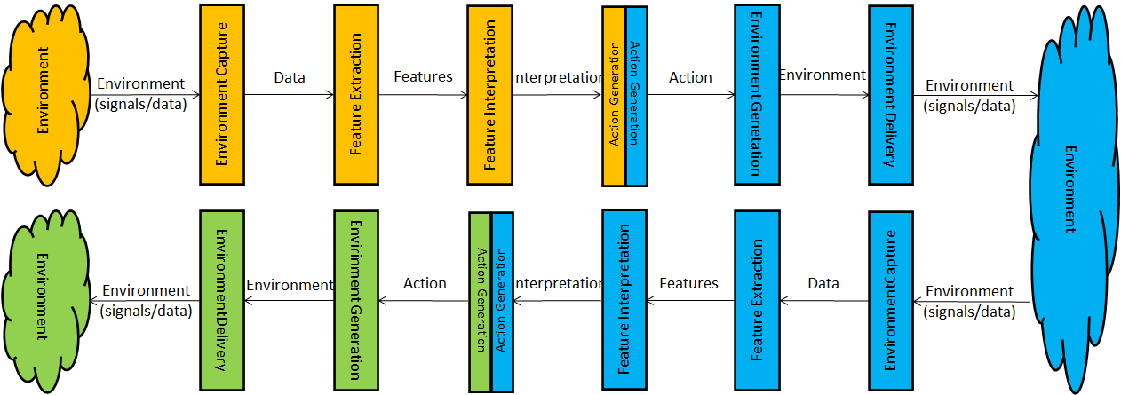
Figure 3 – Environment A to Environment B to Environment C Interactions
In the specific instance of the XR Theatre Use Case, where there is a Universe and a Metaverse, it is necessary to introduce a new function called

Script | A collection of descriptors that the director/producer selects for execution at runtime as a sequence of descriptors controlling the action/experience in both Real and Virtual Worlds.

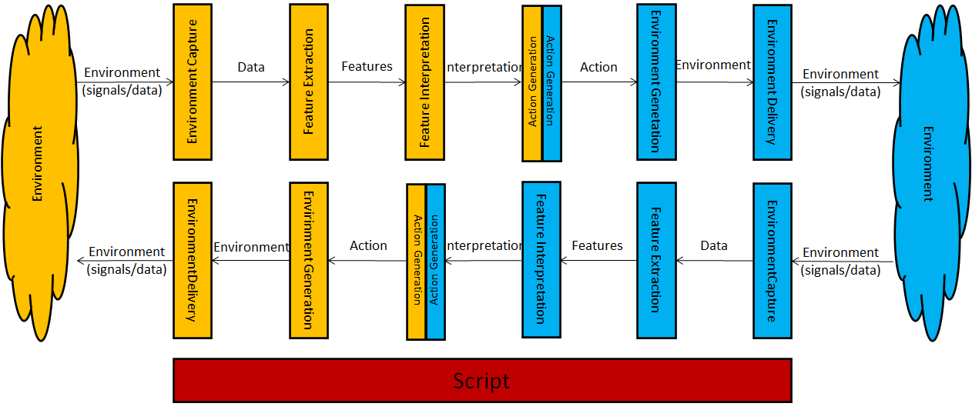
Figure 4 – Reference Model of the XR Theatre Use Case

Terms and definitions
The meaning of terms used in capital letters in this document have the meaning given in Table 2. The Terms of MPAI-wide applicability are defined in Error! Reference source not found..

Table 2 –Terms used in this document

Term | Definition
Action Generation | The process that triggers an Action based on Interpreted Features
AI Framework (AIF) | The environment where AIWs are executed.
AI Module (AIM) | A processing element receiving AIM-specific Inputs and producing AIM-specific Outputs according to according to its Function. An AIM may be an aggregation of AIMs.
AI Workflow (AIW) | A structured aggregation of AIMs implementing a Use Case receiving AIW-specific inputs and producing AIW-specific inputs according to its Function.
Attitude | An element of the internal status related to the way a human or avatar intends to position vis-à-vis the Environment or subsets of it, e.g.,  For person: “Confrontational”, “Collaborative” and “Aggressive”.  For crowd: “Confrontational”, “Collaborative” and “Aggressive”
Avatar | An animated 3D object representing a real or fictitious person in a Virtual Space.
Cognitive State | An element of the internal status reflecting the way a human or avatar understands the Environment, such as  For a person: “Confused”, “Confident” and “Assured”.  For a crowd: “my team is going to lose”
Crowd Status | The ensemble of information, expressed by Emotion, Cognitive State and Attitude, derived from observing the collective behaviour of RW and on-line spectators (via audio, video, interactive controllers, and smartphone apps) in response to actions of a team, a player, or the game.
Data | Information in digital form.
Data Format | The standard digital representation of Data.
Emotion | An element of the internal status resulting from the interaction of a human or avatar with the Environment or subsets of it, such as  For a person, “Victorious”, “Fearful” and “Angry”.  For a crowd: “Victorious”, “Fearful” and “Disappointed”
Extended Reality (XR) | Any of Augmented Reality (AR), Virtual Reality (VR) and Mixed Reality (MR).
Feature | An attribute of Data.
Feature Extraction | The process that extracts Features from Data.
Feature Interpretation | The process that assigns a semantic value to a Feature.
Player Status | The ensemble of information internal to the Player, expressed by Emotion, Cognitive State, and Attitude.
Real World | The Environment as sensed by Sensors and affected by Actuators.
Use Case | A particular instance of the Application domain target of an Application Standard.
XR Venue | A Real or Virtual Environment target of MPAI-XRV Use Cases.

Devices and data in the XR Theatre Use Case
A comprehensive view of the devices and data relevant to the XR Theatre Use Case are provided by Figure 5.

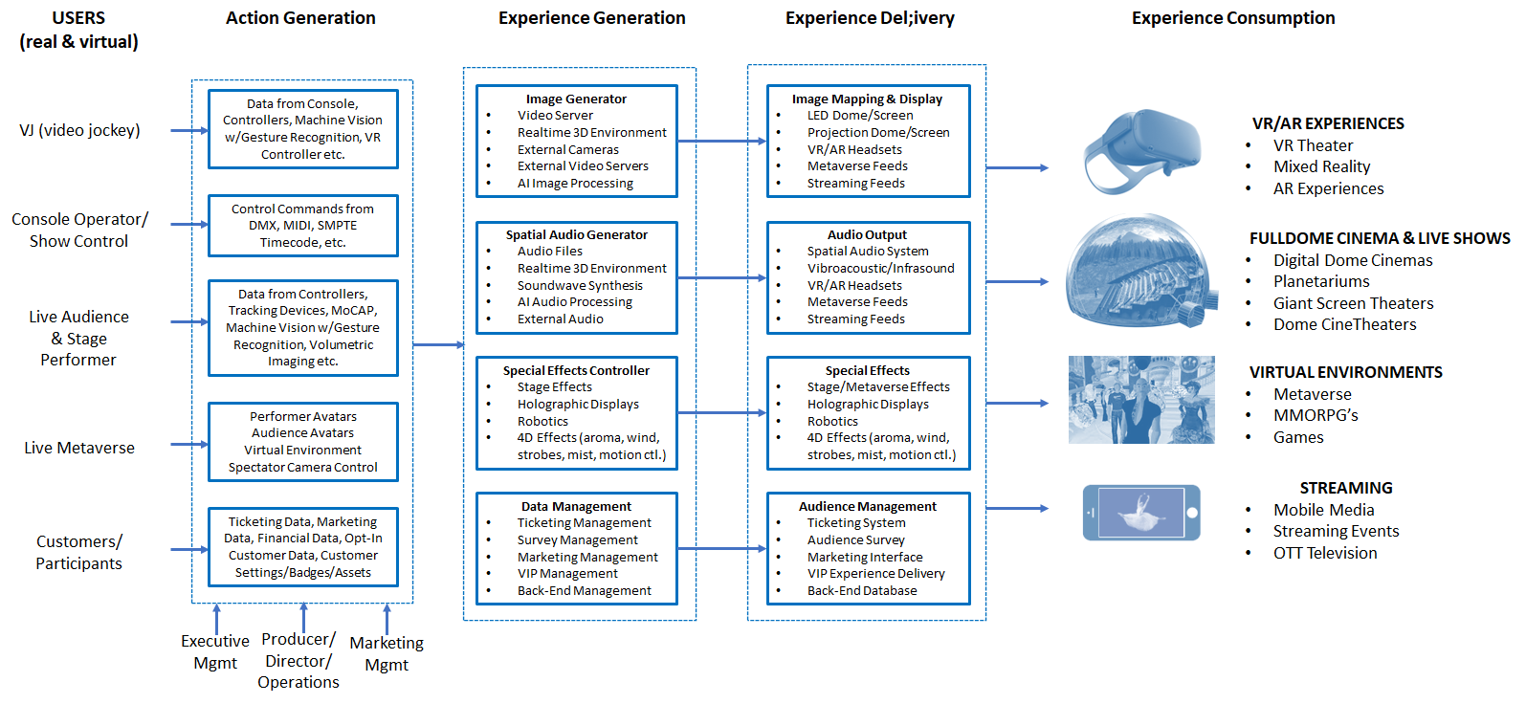
Figure 5 - Devices and data of the XR Theatre Use Case
VJ/DJ/Console operator (real-time show control team) inputs command into systems via:
- Buttons
- Joysticks
- Controllers (inertial, proximity, consoles etc.)
- Hand gestures
- Headset
The commands into the Action Generator Engine (AGE) modify the multisensory elements (visual, audio, …) of both the Real and the Virtual World Experiences, including:
- Video/audio clips from media servers.
- Real-time 2D/3D generated graphics/audio (from a game engine, AI engines generating 3D).
- Additional video/audio sources
- 3D objects, characters, scenes.
- Lighting and special effects.
- Other experiential elements in both the Real and Virtual Worlds.
Multisensory elements may further be modified by additional real-world and virtual-world data, including:
- Audience behaviour.
- Performer behaviour.
- Events on the stage/dome/metaverse.

XR Venue use cases
So far, the following use cases have been identified:

- eSports Tournament.
- Live theatrical stage performance.
- DJ/VJ performance at a dance party.
- Live concert performance.
- Experiential retail/shopping.
- Immersive art experience.
- Meetings/presentations.
- Experiential marketing/branding.

eSports Tournament (XRV-EST).

Purpose
To define interfaces between components enabling an XR Theatre (RW) to host any pre-existing VW game for the purpose of producing an esports tournament with RW and VW audience interactivity. To the extent that the game possesses the required interfaces, the XR Theatre can drive action within the VW.

Description and flow of actions
The eSports Tournament Use Case consists of the following:
- Two teams of 5 RW players are arranged on either side of a RW stage, each using a computer to compete within a common real-time Massively Multiplayer Online (MMO) VW game space.
- The 10 players in the VW are represented by avatars each driven by
  - Role (e.g., magicians, warriors, soldier, etc.).
  - Properties (e.g., costumes, physical form, physical features).
  - Actions (e.g., casting spells, shooting, flying, jumping) operating in the VW
- The VW is populated by
  - Avatars representing the other players.
  - Autonomous characters (e.g., dragon, monsters, various creatures)
  - Environmental structures (e.g., terrain, mountains, bodies of water).
- The action in the VW is captured by multiple VW cameras and
  - Projected onto an immersive screen surrounding RW spectators
  - Live streamed to remote spectators as a 2D video.
with all related sounds of the VW game space.
- A shoutcaster calls the action as the game proceeds.
- The image of RW players, player stats or other information or imagery may also be displayed on the immersive screen and the live stream.
- The RW tournament venue is augmented with lighting and special effects, music, and costumed performers.
- Interactions:
  - Live stream viewers interact with one another and with commentators through live chats, Q&A sessions, etc.
  - RW spectators interact through shouting, waving and interactive devices (e.g., LED wands, smartphones) through processing where:
    - Data are captured by camera/microphone or wireless data interface (see RW data in Figure 2).
    - Features are extracted and interpreted.
- RW/VW actions can be generated as a result of:
  - In-person or remote audience behaviour (RW).
  - Data collected from VW action (e.g., spell casting, characters dying, bombs exploding)
- At the end of the tournament, an award ceremony featuring the winning players on the RW stage is held with great fanfare.

Processing

Data/Features capture
Data may come from:
- The VW
  - Player/Autonomous character behaviour
    - Position/orientation
    - Jumping, walking, flying
    - Fighting, driving
    - Casting spells
  - The environment (not static, evolves with the game)
    - Terrain
    - Foliage
    - Object (building, statue, …)
  - Players’ viewports.
  - Metadata: Current game score, players’ status (gas left in car, # of spells left)
- The RW
  - Real players
    - Controller data
    - Video feeds (face)
    - Utterances, vocalisation
  - Spectator (local and remote) response fans supporting their favourite players’ teams
    - Audio: fans screaming, clapping hands
    - Video: waving wands, waving arms
    - Smartphone: interaction with application
    - Remote: IM chats, web interactives
  - Other data:
    - Players’ and teams’ history
    - Video clips of players

Feature extraction
- Players
  - Facial descriptors
  - Audio descriptors: volume, pitch
- Spectators
  - Video: descriptors for people moving up and down, waving
  - Audio descriptors: volume, cheering, booing

Feature Interpretation
- Real Players
  - Interpret mood, attitude, emotion, sentiment, intention
- Spectators
  - Sentiment, intent, and mood of the chats (dynamic)
  - Warnings to players
- Other data
  - Prediction, interpretation of importance based on history

Actions
- Virtual World
  - Spectators drop an obstacle in front of the opposing team.
  - A spectator camera (virtual camera controlled by AI) adapts to the environment where it shoots a scene
- Real World
  - Visual/auditory cues for the visual/auditory impaired
  - Modulation of sound, light, and special effects (fireworks, fog, …)
  - Selection of video feeds to display (local and remote)

Reference architecture
Figure 6 provides the Reference Model of the eSports Events Use Case.

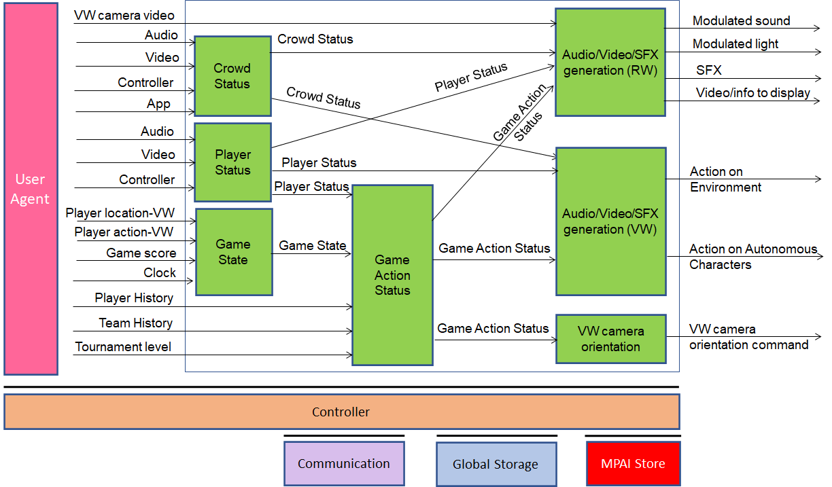Figure 6 - Reference Model of eSports Tournament

AI Modules
- Extraction and interpretation of players’ features, represented by the Gaming Personal Statuses of the players as perceived by a machine.
- Extraction and interpretation of emergent crowd features, represented by the Crowd Status as perceived by a machine.
- Extraction and interpretation of the importance of game action based on player/team history, game score, player status.
- Based on 2-3-4, generation of such actions in the RW as modulation of sound, light, and special effects (fireworks, fog, …) and selection of video feeds to display (local and remote)
- Based on 3-4 generation of such actions in the virtual world as modulation of the virtual environment including bad weather based on crowd status, control the behaviour of autonomous characters, drop obstacles on the opposing team, in general the fans’ emotional or physical responses conspire to help their team or obstruct the opposing team.
- Based on 4 control the position and orientation of multiple VW cameras that are displayed both in the RW and live stream.
- Based on #4 control the display of game stats, player stats and other relevant info in the RW and live stream.
- Control of autonomous characters, environmental features (mountains, time of day etc.) and other VW actions based on crowd status (VW and live streamed). – not an AIM.

Table 3 gives the list of AIMs, their functions and their input/output data

Table 3 - AIMs, their functions and I/O data
AIM name | Function | Input | Output
Player Status | Extract Player Status | - Audio  - Video  - Controllers | - Player Status
Crowd Status | Extract Crowd Status | - Audio  - Video  - Controllers  - Apps | - Crowd Status
Game State | Creates Game State | - Player location in VW  - Player action in VW  - Game score  - Clock (e.g., timeout) | - Game State
Game Action Status | Assesses importance of game action in play | - Nx Player Statuses  - Nx Player histories  - Team history  - Tournament level  - Game State | - Game Action Status
Audio/Video/SFX generation (RW) | Creates RW experience for spectators (RW/live streaming) | - Player Status  - Crowd Status  - Game Action Status | - Modulated sound  - Modulated light  - SFXs  - Video for display
Audio/Video/SFX generation (VW) | Creates VW experience | - Player Status  - Crowd Status  - Game Action Status | - E.g., bad weather if crowd is angry  - Drop obstacles on opposing team  - Autonomous characters behaviour control
VW camera Orientation | Issues commands orientating VW cameras | - Game Action Status | - Orientation commands of multiple VW cameras

Table 4 records comments on the data formats.

Table 4 - Comments on data formats
Data format | Comments
Controller data | The data generated by the controllers of the players (console or game controller) or the spectators (wands, or other input devices). Game specific.
Player Location (VW) | The location of the player’s avatar in the VW. In other use cases we have introduced Player Attitude (location and orientation). This can be standard.
Players’ Action | One of the possible actions of the players’ avatar in the VW. Game specific.
Game State | The set of information elements of a game at a given point in time, such as, player position and orientation, player resources, player actions, game levels and score. Game specific
Crowd Status | The ensemble of information, expressed by Emotion, Cognitive State and Attitude, derived from observing the collective behaviour of RW and on-line spectators (via audio, video, interactive controllers, and smartphone apps) in response to actions of a team, a player, or the game.
Player Status | The ensemble of information internal to the Player, expressed by Emotion, Cognitive State, and Attitude.
Game Action Status | Importance, priority of Game State in context of team/player history, tournament status. Game specific
Action on Environment | Set of developer-defined parameters identifying the action. Game specific.
Action on Autonomous Char. | Game specific.

Live theatrical stage performance.

Purpose and advantages
To define interfaces and components to facilitate live multisensory immersive stage performances which ordinarily require extensive on-site show control staff to operate. Use of the XRV allows more direct, precise yet spontaneous show implementation and control to achieve the show director’s vision by freeing staff from repetitive and technical tasks and focusing their artistic and creative skills.
Theatrical stage performances such as Broadway theatre, musicals, dramas, operas, and other performing arts increasingly use video scrims, backdrops, and projection mapping to create digital sets rather than constructing physical stage sets, allowing animated backdrops, and reducing the cost of mounting shows.
The use of immersion domes – especially LED volumes – promises to surround audiences with virtual environments that the live performers can inhabit and interact with the virtual environment and the participants.
Use of AI in these XRV systems will allow:
- Orchestration of the complex lighting, video, audio, and stage set cues that must adapt to the pace of live performers without extensive staff.
- Large shows to tour to smaller venues that otherwise could not support complex productions.
- Virtual-world and real-world attendance and audience interactivity.
- A more direct connection between the artist and participants by consolidating many complex experiential modalities into a simple user interface.
- Artists to access a large amount of data from opted-in individuals.

Description and flow of actions
The typical set up can be described as follows:
- A physical stage
- Lighting, stage projections, and SFX
- Audience (standing or seated) in the dome.
- Performers.
- Experience delivery system (immersive video and audio, touch, smell).
- Capture of biometric data (wearable fabric, embedded in the seat, remote sensing).
- A script or cue list describing the show events
- Show operator(s)
- Metaverse that mirrors selected elements of the RW space.
In a show, performers are on the stage made a digital twin in the metaverse createdby:
- Body motion (MoCap) used to animate an avatar.
- Keyed 2D image mapped on a plane.
- Volumetrically captured 3D images producing photorealistic digital embodiments.
The physical stage blends seamlessly into the 3D backdrop projected onto the dome. The stage itself and set pieces on the stage may be projection-mapped or wrapped with LED to integrate them into the scene. Performers enter the stage. As they move about the stage, whether dancing, acting, etc., their performance is mirrored in the metaverse. The performance is accompanied by music, lighting, and SFX.

(bodymetric capture is interpreted as mudra by an AIM)

Reference Architecture

Input/output data

AI Modules

Experiential retail/shopping.

Purpose
To offer a retail shopping experience enhanced using immersive/interactive technologies driven by using AI. The environment gives the user the impression that it is intelligent because the environment has access to the user’s identity/preferences/shopping history/shopping list and is capable to guide the buyer to the area containing products of their supposed interest, propose products, annotate products and to display a particular product and make it flash because the environment thinks it is of interest to the buyer.
The environment broadcast music etc. to all buyers in the environment driven by the preferences. Friends in the shop at the same time can “meet”, but buyers can opt out from being discoverable (by the store, by friends etc.). Buyers can opt out from the loyalty card and not have the product they buy recorded by the shop.
The environment can be digitally rethemed for different occasions.
The venue where the experience takes shape can be anywhere, e.g., in a vehicle or in a public transit space.

Description

Immersive art experience.

Purpose
Define interfaces and components to enhance magical Environments created by skilled artists to provide each user with a unique interactive experience including the ability to modify the environment per their personal style and preferences.

Description
Immersive art experiences such as Immersive Van Gogh provide visitors with a visually and aurally immersive experience, often based on the work of a specific artist. These are typically passive walk-through and sit-down experiences. The addition of AI to these Environments allows numerous enhancements including the recognition of individual visitors, allowing them to interact with and modify these environments based on pre-selected preferences and style choices. AI style transfer allows the featured artist’s style to be applied to unique visitor interactions which might include AI voice or text-based image diffusion, gesture-based interactions, proximity effects and more. The addition of AR glasses allows visitors to experience, create and interact with “holograms” within the Environment. Biometric wearables allow the AI to monitor and adjust the multisensory experience to maximize target brain/nervous system states related to well-being, restorative states and more. The XR Venue model also allows visitors in the RW and VW to interact.

DJ/VJ performance at a dance party.

Purpose
Define interfaces and components to enhance the overall experience within a nightclub, lounge or dance party Environment. The goal is to empower the DJ/VJ to create and control entertaining immersive and interactive experiences that reduce social inhibitions, encourage play, invoke a greater sense of togetherness, encourage personal connections, evoke altered states of consciousness, amplify user’s self-expression and generally create a highly pro-social experience for participants.

Description
Dance parties, lounges, clubs, and electronic music festivals use powerful visuals, sound and other effects to captivate participants. The DJ (disc jockey) mixes audio tracks, energizes the crowd and is central to the experience. However, the visual artist or VJ (video jockey) is also an important contributor, often supported by lighting, laser and effects operators, dancers, performers and more. Quite often these venues offer peripheral activities as well to further engage participants off of the dance floor, including interactive screens, spatial art, vendors offering costumes and LED accessories. These venues can be thought of as play spaces. Pro-social intoxicants such as alcohol are sometimes used to lower inhibitions that would otherwise limit social connections. XR Venues can supercharge the dance party experience by providing powerful immersive visuals and by including VW participants Assisted by AI, all music, visuals, lights, and effects can be controlled by a single DJ (or immersive jockey) using gestures, simple control surfaces, vocal commandsm and such. In addition, expanded peripheral activities for deeper engagement might include immersive visuals that respond to emergent crowd behaviours, “photonic go-go booths” that modulate immersive visuals to amplify the creative expression of dancers’ movements, and AI-based matchmaking that fosters connections between like-minded attendees.

Live concert performance.

Purpose
Define interfaces and components to enhance live musical concerts with AI-driven visuals and special effects and allow enhanced audience participation while extending concert performances into the metaverse.

Description
Similar to live theatrical stage performances, musical concerts – whether orchestral or popular music – are increasingly using visuals and other effects to enhance the audience experience. A band or orchestral musicians on stage can be substantially enhanced by video projections from a live VJ, audio responsive visuals, image magnification from cameras and other effects. In addition, skilful live mixing of audio is critical to the audience experience, but it complicated by architectural properties of the physical venue. AI can dynamically optimize the listening experience and allow tight synchronization of visuals with spontaneous musical performances in addition to optimizing the VW experience for remote attendees.

Experiential marketing/branding.

Purpose
Define interfaces and components to enhance a wide range of experiences in support of corporate branding.

Description
Wherever there are a lot of people gathered we often find advertisers or corporate brands seeking visibility. Experiential marketing goes beyond simple advertising or signage by offering memorable experiences to attendees. Experiential marketing often makes use of pop-up venues or storefronts co-located at festivals, sporting events, concerts and more. Digital interactive or immersive experiences are increasingly employed, often incorporating branded story-worlds or iconic brand elements. The XRV allows delivery of a unique experience to each participant and deeper engagement to build brand loyalty. In addition, the experience can be extended into the VW to reach a larger number of attendees.

Meetings/presentations.

Purpose
Define interfaces and components to enhance live presentations and dialog, both in RW and VW, using rich multimedia, dialog mapping, AI-based mediation and fact checking.

Description
Meetings and presentations are increasingly hybrid, including both live and virtual attendees, allowing the sharing of rich multimedia content including documents, videos and website links. Use of an XRV for presentations and especially dialog - including political discourse - presents an opportunity for AI to monitor, track, organize and summarize numerous data in real-time to overlook hyperbole and guide the conversation toward rapid convergence on positive outcomes. Real-time fact-finding/fact-checking, dialog mapping (creating a logical tree showing relationships and dependencies between various points raised), group polling and other advanced methods can be employed in an XRV to guide dialog or facilitate presentations.

References

Normative References
MPAI-XYZ normatively references the following documents:
- MPAI; Technical Specification: The Governance of the MPAI Ecosystem V1, 2021; https://mpai.community/standards/mpai-gme/.
- MPAI; Technical Specification: Artificial Intelligence Framework (MPAI-AIF) V1.1; https://mpai.community/standards/mpai-aif/.

Informative Reference

- MPAI-wide terms and definitions
The Terms used in this standard whose first letter is capital and are not already included in Error! Reference source not found. are defined in Error! Reference source not found..

Table 5 - MPAI-wide Terms
Term | Definition
Access | Static or slowly changing data that are required by an application such as domain knowledge data, data models, etc.
AI Framework (AIF) | The environment where AIWs are executed.
AI Module (AIM) | A processing element receiving AIM-specific Inputs and producing AIM-specific Outputs according to according to its Function. An AIM may be an aggregation of AIMs.
AI Workflow (AIW) | A structured aggregation of AIMs implementing a Use Case receiving AIW-specific inputs and producing AIW-specific inputs according to its Function.
AIF Metadata | The data set describing the capabilities of an AIF set by the AIF Implementer.
AIM Metadata | The data set describing the capabilities of an AIM set by the AIM Implementer.
Application Programming Interface (API) | A software interface that allows two applications to talk to each other
Application Standard | An MPAI Standard specifying AIWs, AIMs, Topologies and Formats suitable for a particular application domain.
Channel | A physical or logical connection between an output Port of an AIM and an input Port of an AIM. The term “connection” is also used as a synonym.
Communication | The infrastructure that implements message passing between AIMs.
Component | One of the 9 AIF elements: Access, AI Module, AI Workflow, Communication, Controller, Internal Storage, Global Storage, MPAI Store, and User Agent.
Conformance | The attribute of an Implementation of being a correct technical Implementation of a Technical Specification.
Conformance Tester | An entity authorised by MPAI to Test the Conformance of an Implementation.
Conformance Testing | The normative document specifying the Means to Test the Conformance of an Implementation.
Conformance Testing Means | Procedures, tools, data sets and/or data set characteristics to Test the Conformance of an Implementation.
Connection | A channel connecting an output port of an AIM and an input port of an AIM.
Controller | A Component that manages and controls the AIMs in the AIF, so that they execute in the correct order and at the time when they are needed.
Data | Information in digital form.
Data Format | The standard digital representation of Data.
Data Semantics | The meaning of Data.
Device | A hardware and/or software entity running at least one instance of an AIF.
Ecosystem | The ensemble of the following actors: MPAI, MPAI Store, Implementers, Conformance Testers, Performance Testers and Users of MPAI-AIF Implementations as needed to enable an Interoperability Level.
Event | An occurrence acted on by an Implementation.
Explainability | The ability to trace the output of an Implementation back to the inputs that have produced it.
Fairness | The attribute of an Implementation whose extent of applicability can be assessed by making the training set and/or network open to testing for bias and unanticipated results.
Function | The operations effected by an AIW or an AIM on input data.
Global Storage | A Component to store data shared by AIMs.
Identifier | A name that uniquely identifies an Implementation.
Implementation | - An embodiment of the MPAI-AIF Technical Specification, or  - An AIW or AIM of a particular Level (1-2-3).
Internal Storage | A Component to store data of the individual AIMs.
Interoperability | The ability to functionally replace an AIM/AIW with another AIM/AIW having the same Interoperability Level
Interoperability Level | The attribute of an AIW and its AIMs to be executable in an AIF Implementation and to be:  - Implementer-specific and satisfying the MPAI-AIF Standard (Level 1).  - Specified by an MPAI Application Standard (Level 2).  - Specified by an MPAI Application Standard and certified by a Performance Assessor (Level 3).
Knowledge Base | Structured and/or unstructured information made accessible to AIMs via MPAI-specified interfaces
Message | A sequence of Records.
Normativity | The set of attributes of a technology or a set of technologies specified by the applicable parts of an MPAI standard.
Performance | The attribute of an Implementation of being Reliable, Robust, Fair and Replicable.
Performance Assessment | The normative document specifying the procedures, the tools, the data sets and/or the data set characteristics to Assess the Grade of Performance of an Implementation.
Performance Assessment Means | Procedures, tools, data sets and/or data set characteristics to Assess the Performance of an Implementation.
Performance Assessor | An entity authorised by MPAI to Assess the Performance of an Implementation in a given Application domain
Port | A physical or logical communication interface of an AIM.
Profile | A particular subset of the technologies used in MPAI-AIF or an AIW of an Application Standard and, where applicable, the classes, other subsets, options, and parameters relevant to that subset.
Record | Data with a specified structure.
Reference Model | The AIMs and theirs Connections in an AIW.
Reference Software | A technically correct software implementation of a Technical Specification containing source code, or source and compiled code.
Reliability | The attribute of an Implementation that performs as specified by the Application Standard, profile and version the Implementation refers to, e.g., within the application scope, stated limitations, and for the period of time specified by the Implementer.
Replicability | The attribute of an Implementation whose Performance, as Assessed by a Performance Assessor, can be replicated, within an agreed level, by another Performance Assessor.
Robustness | The attribute of an Implementation that copes with data outside of the stated application scope with an estimated degree of confidence.
Scope | The domain of applicability of an MPAI Application Standard.
Service Provider | An entrepreneur who offers an Implementation as a service (e.g., a recommendation service) to Users.
Specification | A collection of normative clauses.
Standard | The ensemble of Technical Specification, Reference Software, Conformance Testing and Performance Assessment of an MPAI application Standard.
Technical Specification | (Framework) the normative specification of the AIF.  (Application) the normative specification of the set of AIWs belonging to an application domain along with the AIMs required to Implement the AIWs that includes:  - The formats of the Input/Output data of the AIWs implementing the AIWs.  - The Connections of the AIMs of the AIW.  - The formats of the Input/Output data of the AIMs belonging to the AIW.
Testing Laboratory | A laboratory accredited by MPAI to Assess the Grade of Performance of Implementations.
Time Base | The protocol specifying how AIF Components can access timing information.
Topology | The set of AIM Connections of an AIW.
Use Case | A particular instance of the Application domain target of an Application Standard.
User | A user of an Implementation.
User Agent | The Component interfacing the user with an AIF through the Controller
Version | A revision or extension of a Standard or of one of its elements.
Zero Trust | A cybersecurity model primarily focused on data and service protection that assumes no implicit trust.

- Notices and Disclaimers Concerning MPAI Standards (Informative)

The notices and legal disclaimers given below shall be borne in mind when downloading and using approved MPAI Standards.

In the following, “Standard” means the collection of four MPAI-approved and published documents: “Technical Specification”, “Reference Software” “Conformance Testing” and, where applicable, “Performance Testing”.

The life cycle of MPAI Standards
MPAI Standards are developed in accordance with the MPAI Statutes. An MPAI Standard may only be developed when a Framework Licence has been adopted. MPAI Standards are developed by specially established MPAI Development Committees that operate based on consensus, as specified in Annex 1 of the MPAI Statutes. While the MPAI General Assembly and the Board of Directors administer the process of the said Annex 1, MPAI does not independently evaluate, test, or verify the accuracy of any of the information or the suitability of any of the technology choices made in its Standards.

MPAI Standards may be modified at any time by corrigenda or new editions. A new edition, however, may not necessarily replace an existing MPAI standard. Visit the web page to determine the status of any given published MPAI Standard.

Comments on MPAI Standards are welcome from any interested parties, whether MPAI members or not. Comments shall mandatorily include the name and the version of the MPAI Standard and, if applicable, the specific page or line the comment applies to. Comments should be sent to the MPAI Secretariat. Comments will be reviewed by the appropriate committee for their technical relevance. However, MPAI does not provide interpretation, consulting information, or advice on MPAI Standards. Interested parties are invited to join MPAI so that they can attend the relevant Development Committees.

Coverage and Applicability of MPAI Standards
MPAI makes no warranties or representations of any kind concerning its Standards, and expressly disclaims all warranties, expressed or implied, concerning any of its Standards, including but not limited to the warranties of merchantability, fitness for a particular purpose, non-infringement etc. MPAI Standards are supplied “AS IS”.

The existence of an MPAI Standard does not imply that there are no other ways to produce and distribute products and services in the scope of the Standard. Technical progress may render the technologies included in the MPAI Standard obsolete by the time the Standard is used, especially in a field as dynamic as AI. Therefore, those looking for standards in the Data Compression by Artificial Intelligence area should carefully assess the suitability of MPAI Standards for their needs.

IN NO EVENT SHALL MPAI BE LIABLE FOR ANY DIRECT, INDIRECT, INCIDENTAL, SPECIAL, EXEMPLARY, OR CONSEQUENTIAL DAMAGES (INCLUDING, BUT NOT LIMITED TO: THE NEED TO PROCURE SUBSTITUTE GOODS OR SERVICES; LOSS OF USE, DATA, OR PROFITS; OR BUSINESS INTERRUPTION) HOWEVER CAUSED AND ON ANY THEORY OF LIABILITY, WHETHER IN CONTRACT, STRICT LIABILITY, OR TORT (INCLUDING NEGLIGENCE OR OTHERWISE) ARISING IN ANY WAY OUT OF THE PUBLICATION, USE OF, OR RELIANCE UPON ANY STANDARD, EVEN IF ADVISED OF THE POSSIBILITY OF SUCH DAMAGE AND REGARDLESS OF WHETHER SUCH DAMAGE WAS FORESEEABLE.

MPAI alerts users that practising its Standards may infringe patents and other rights of third parties. Submitters of technologies to this standard have agreed to licence their Intellectual Property according to their respective Framework Licences.

Users of MPAI Standards should consider all applicable laws and regulations when using an MPAI Standard. The validity of Conformance Testing is strictly technical and refers to the correct implementation of the MPAI Standard. Moreover, a positive Performance Assessment of an implementation applies exclusively in the context of the MPAI Governance and does not imply compliance with any regulatory requirements in the context of any jurisdiction. Therefore, it is the responsibility of the MPAI Standard implementer to observe or refer to the applicable regulatory requirements. By publishing an MPAI Standard, MPAI does not intend to promote actions that are not in compliance with applicable laws, and the Standard shall not be construed as doing so. In particular, users should evaluate MPAI Standards from the viewpoint of data privacy and data ownership in the context of their jurisdictions.

Implementers and users of MPAI Standards documents are responsible for determining and complying with all appropriate safety, security, environmental and health and all applicable laws and regulations.

Copyright
MPAI draft and approved standards, whether they are in the form of documents or as web pages or otherwise, are copyrighted by MPAI under Swiss and international copyright laws. MPAI Standards are made available and may be used for a wide variety of public and private uses, e.g., implementation, use and reference, in laws and regulations and standardisation. By making these documents available for these and other uses, however, MPAI does not waive any rights in copyright to its Standards. For inquiries regarding the copyright of MPAI standards, please contact the MPAI Secretariat.

The Reference Software of an MPAI Standard is released with the MPAI Modified Berkeley Software Distribution licence. However, implementers should be aware that the Reference Software of an MPAI Standard may reference some third-party software that may have a different licence.

- The Governance of the MPAI Ecosystem (Informative)

Level 1 Interoperability
Concerning Figure 1 MPAI issues and maintains a standard – called MPAI-AIF – whose components are:
- An environment called AI Framework (AIF) running AI Workflows (AIW) composed of interconnected AI Modules (AIM) exposing standard interfaces.
- A distribution system of AIW and AIM Implementation called MPAI Store from which an AIF Implementation can download AIWs and AIMs.
A Level 1 Implementation shall implement the MPAI-AIF Technical Specification executing AIWs composed of AIMs able to call the MPAI-AIF APIs.

Implementers’ benefits | Upload to the MPAI Store and have globally distributed Implementations of  - AIFs conforming to MPAI-AIF.  - AIWs and AIMs performing proprietary functions executable in AIF.
Users’ benefits | Rely on Implementations that have been tested for security.
MPAI Store’s role | - Tests the Conformance of Implementations to MPAI-AIF.  - Verifies Implementations’ security, e.g., absence of malware.  - Indicates unambiguously that Implementations are Level 1.

Level 2 Interoperability
In a Level 2 Implementation, the AIW must be an Implementation of an MPAI Use Case and the AIMs must conform with an MPAI Application Standard.

Implementers’ benefits | Upload to the MPAI Store and have globally distributed Implementations of  - AIFs conforming to MPAI-AIF.  - AIWs and AIMs conforming to MPAI Application Standards.
Users’ benefits | - Rely on Implementations of AIWs and AIMs whose Functions have been reviewed during standardisation.  - Have a degree of Explainability of the AIW operation because the AIM Functions and the data Formats are known.
Market’s benefits | - Open AIW and AIM markets foster competition leading to better products.  - Competition of AIW and AIM Implementations fosters AI innovation.
MPAI Store’s role | - Tests Conformance of Implementations with the relevant MPAI Standard.  - Verifies Implementations’ security.  - Indicates unambiguously that Implementations are Level 2.

Level 3 Interoperability
MPAI does not generally set standards on how and with what data an AIM should be trained. This is an important differentiator that promotes competition leading to better solutions. However, the performance of an AIM is typically higher if the data used for training are in greater quantity and more in tune with the scope. Training data that have a large variety and cover the spectrum of all cases of interest in breadth and depth typically lead to Implementations of higher “quality”.
For Level 3, MPAI normatively specifies the process, the tools and the data or the characteristics of the data to be used to Assess the Grade of Performance of an AIM or an AIW.

Implementers’ benefits | May claim their Implementations have passed Performance Assessment.
Users’ benefits | Get assurance that the Implementation being used performs correctly, e.g., it has been properly trained.
Market’s benefits | Implementations’ Performance Grades stimulate the development of more Performing AIM and AIW Implementations.
MPAI Store’s role | - Verifies the Implementations’ security  - Indicates unambiguously that Implementations are Level 3.

The MPAI ecosystem
Figure 7 is a high-level description of the MPAI ecosystem operation applicable to fully conforming MPAI implementations as specified in the Governance of the MPAI Ecosystem Specification [1]:
- MPAI establishes and controls the not-for-profit MPAI Store.
- MPAI appoints Performance Assessors.
- MPAI publishes Standards.
- Implementers submit Implementations to Performance Assessors.
- If the Implementation Performance is acceptable, Performance Assessors inform Implementers and the MPAI Store.
- Implementers submit Implementations to the MPAI Store tested for Conformance and security.
- Users download and use Implementations and submit experience scores.

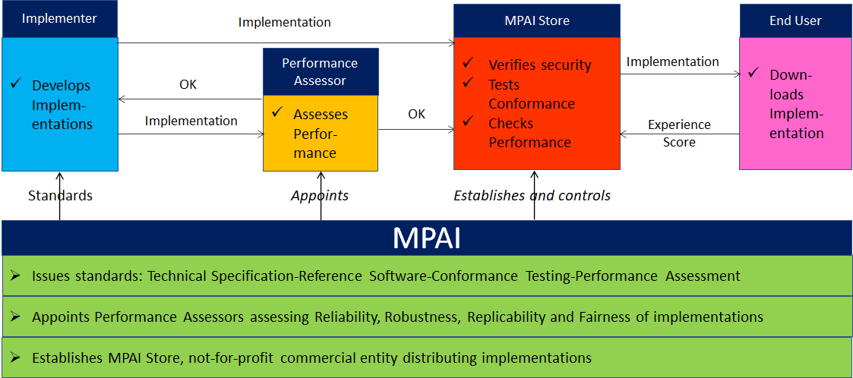
Figure 7 - The MPAI ecosystem operation

