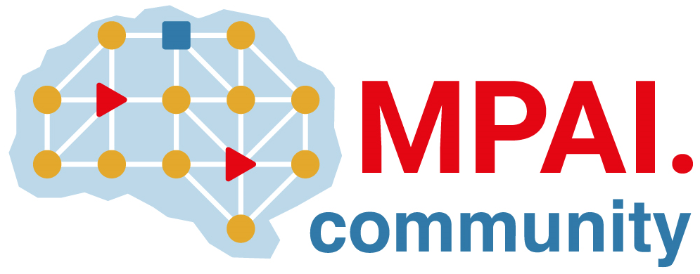 | Moving Picture, Audio and Data Coding by Artificial Intelligence  www.mpai.community

Public document
N856 | 2022/09/19
Source | Board of Directors
Title | MPAI eelebrates its 2nd anniverssary
Target | MPAI-24

At MPAI-24 MPAI celebrates its second anniversary. It is important to look back to the last 24 months to prepare to another year of work.
These are the main results of the 2nd year of MPAI activity.
- Approved the MPAI-AIF and MPAI-CAE Technical Specifications.
- Approved several revisions of all five Technical Specifications approved.
- Promoted the establishment of a patent pool for MPAI standards as specified by the MPAI Statutes.
- Submitted four Technical Specifications to IEEE for adoption without change as IEEE standards. Three (AIF, CAE, and MMC) should be approved by the end of 2022.
- Kickstarted the MPAI Ecosystem by
  - Promoting the establishment of the MPAI-Store.
  - Adopting the MPAI-MPAI Store Agreement.
  - Contributing to the definition of the IEEE-MPAI Store agreement on ImplementerID Registration Authority.
  - Revising the MPAI-GME standard to accommodate the developments of the Ecosystem.
- Developed MPAI-AIF Reference Software to enable implementation of other MPAI Technical Specifications.
- Developed drafts of the MPAI-AIF Conformance Testing,
- Developed MPAI-CAE and MPAI-MMC Reference Software and Conformance Testing drafts.
- Continued the development of Use Cases and Functional Requirements for MPAI-CAV, MPAI-EVC, and MPAI-SPG.
- Opened new activities in AI Health (MPAI-AIH), Avatar Representation and Animation (MPAI-ARA), End-to-End Video Coding (EEV), MPAI Metaverse Model (MMM), Neural Network Watermarking (NNW), and XR Venues (XRV).
- Developed 3 Calls for Technologies for MPAI-AIF V2, MPAI-MMC V2, and MPAI-NNW. Responses are expected by MPAI-25.
- Published Towards Pervasive and Trustworthy Artificial Intelligence.
- Published papers on conferences and journals.

In its third year of activities MPAI plans on:
- Make the MPAI Ecosystem fully operational.
- Complete the specification sets of MPAI-AIF, MPAI-CAE, and MPAI-MMC.
- Promote the development of the MPAI implementations market.
- Develop extensions of MPAI-AIF and MPAI-MMC.
- Develop the new MPAI-NNW Technical Specification.
- Achieve publication of MPAI-AIF, MPAI-CAE, MPAI-CUI, and MPAI-MMC as IEEE standards.
- Submit MPAI-AIF V2, MPAI-CAE V2, MPAI-MMC V2, MPAI-NNW for adoption without modification by IEEE.
- Initiate the standard development process for MPAI-AIH, MPAI-ARA, MPAI-CAV, MPAI-EVC, MPAI-SPG, and MPAI-XRV.
- Promote the MPAI Metaverse Model and make it the compass for MPAI standard development.
- Be ready to exploit new standardisation opportunities.
- Continue active publication of papers on MPAI activities and results.
- Strengthen relationship with other bodies.
- Widen the MPAI membership.

The Board of Directors is committed to assist MPAI to reach the goals identified above and requests MPAI Members’ collaboration in this endeavour.

