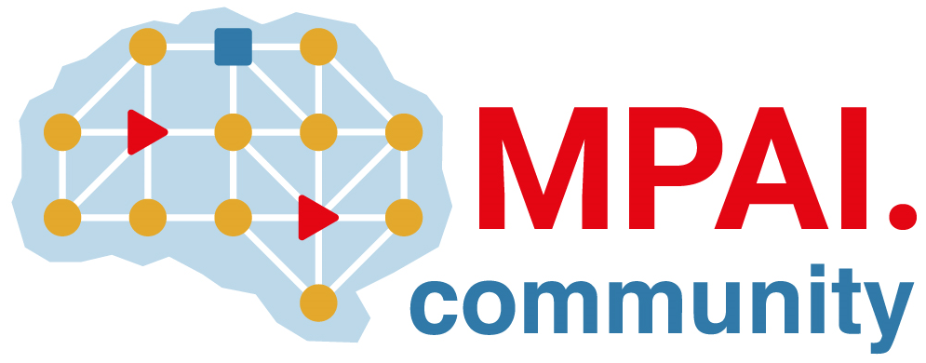 | Moving Picture, Audio and Data Coding by Artificial Intelligence  www.mpai.community

Public document
N873 | 2022/09/30
Source | NNW-DC
Title | Initial structure of the MPAI-NNW Technical Specification
Target | MPAI Members

Introduction

The usual introduction to all MPAI standard

Scope of the standard

What is the standard about:
Methodology to evaluate neural network watermarking technologies Specifically,
- The impact on the performance of a watermarked neural network (and its inference) versus its non-watermarked neural network.
- The ability of the detector/decoder to detect/decode a payload when the watermarked neural network has been modified.
- The computational cost of injecting, detecting and decoding a payload in the watermark

Use cases of the standard
- Watermarking provider: general numbers about my watermarking technology
- AI creator: I want to know the impact of the watermark on my solution
- AI creator: I want to know how well a watermarking technology will protect my solution
- End-user: I want to make sure that an inference has really been produced by that neural network

