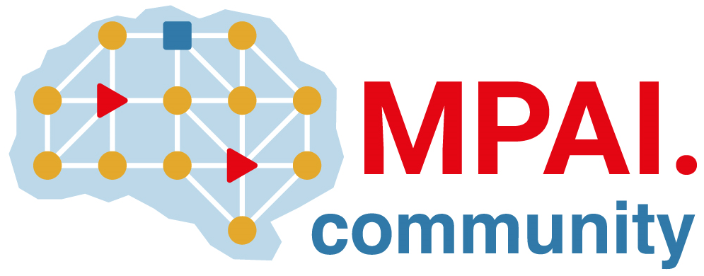 | Moving Picture, Audio and Data Coding by Artificial Intelligence  www.mpai.community

Public document
N874 | 2022/09/30
Source | Requirements (AIH)
Title | MPAI-AIH Progress report and plans
Target | MPAI-23

- Definition of requirements for MPAI-AIH: work in progress
- Major architectural components identification – and integration with MPAI-AIF (AIM and AIW).
- Definition of the architecture APIs (smart device, third parties and blockchain)
- Work being done:
  - APIs, Blockchain and Smartcontracts
  - Study of workflows for potential standardization
  - Identification data types acquired;
  - Identification of processing flows on the data, either as single entity or workflow;
  - Identification of potential processing that can leverage the architecture.
- Due to annual vacations and team restructuring, we are still working on MPAI-AIF requirements:
- Since most of the kownledge and information lies on the completion of a national AIM-H project (1st. Stage), this is still a work in progress

