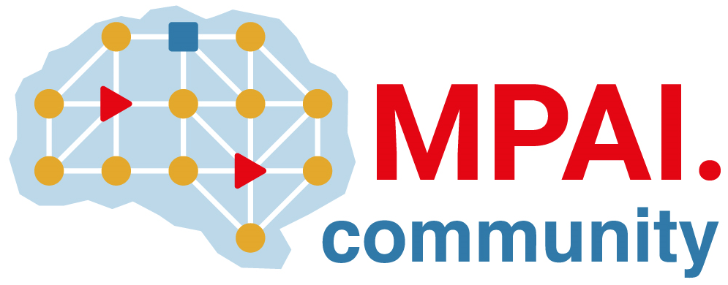 | Moving Picture, Audio and Data Coding by Artificial Intelligence  www.mpai.community

Public document
N879 | 2022/09/30
Source | Requirements (EEV)
Title | Requirements (EEV) progress report and plans
Target | MPAI-24

Requirements (EEV) plans to further investigate the end-to-end video coding framework with emerging techniques in computer vision and also seek possible applications to emerging solutions.

Regarding the reference model development, the EEV-0.3 model has been finalized and released, obtaining over 7% of coding gain than the previous version. There are three coding tools in the EEV-0.3 model, enhance inter prediction network, in-loop restoration network and coarse-to-fine residual modelling. In the next step, the Requirements (EEV) is expected to improve the rate-distortion efficiency and summarize the current models and methods for possible publications in a conference like IEEE DCC or ISCAS.

