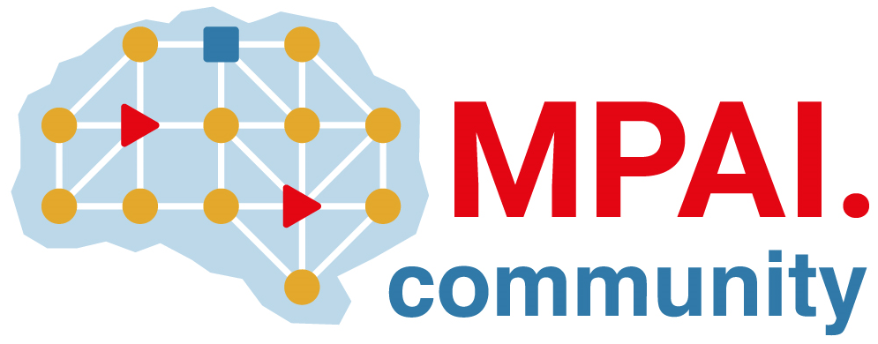 | Moving Picture, Audio and Data Coding by Artificial Intelligence  www.mpai.community

Public document
N882 | 2022/09/30
Source | Requirements (MCS)
Title | MPAI-MCS Progress report and plans
Target | MPAI-24

Requirements (MCS) is looking forward to receiving the responses to the MPAI-MMC V2 Call for Proposals.

