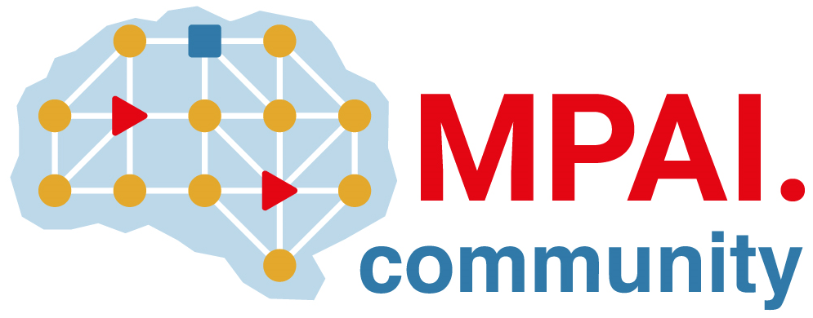 |  | Moving Picture, Audio and Data Coding  by Artificial Intelligence  www.mpai.community
Public document
N885 | 2022/09/30
Source | Requirements (OSD)
Title | MPAI-OSD report and plans
Target | MPAI Members

Requirements(OSD) is awaiting the responses to the MPAI-MMC V2 Call.

