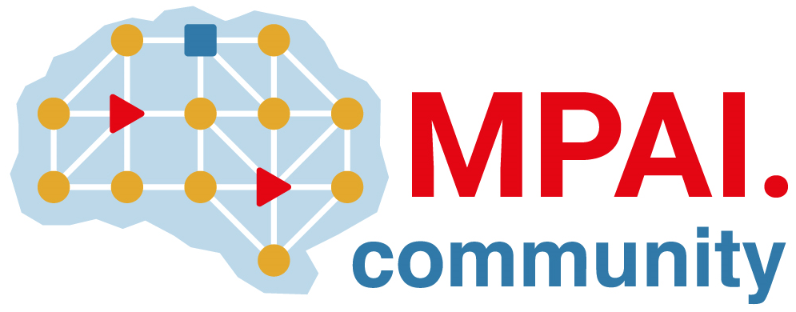 | Moving Picture, Audio and Data Coding  by Artificial Intelligence  www.mpai.community

 | Public document
N915 | 2022/10/26
Source | Requirements (ARA)
Title | MPAI-ARA Progress report and plans
Target | MPAI-25

One proposal was received outlining strategies to support the use case of two independent users exchanging and remotely animating their avatar models.

