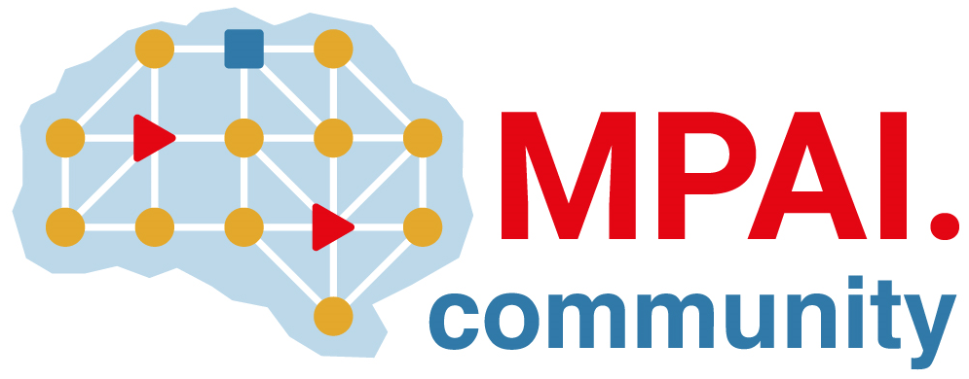 | Moving Picture, Audio and Data Coding by Artificial Intelligence  www.mpai.community

Public document
N919 | 2022/10/26
Source | Requirements (EEV)
Title | Requirements (EEV) progress report and plans
Target | MPAI-25

Requirements (EEV) has invited the experts from Shanghai Jiao Tong University (SJTU) to join the studying of EEV. It is planned to further investigate the end-to-end video coding for emerging use cases such as drones and unmanned aerial vehicles (UAV).

Regarding the progress, Requirements (EEV) is currently running experiments using the software of HEVC, VVC, EEV-0.3 and DCVC in diverse UAV datasets. In the next step, the Requirements (EEV) is expected to improve the rate-distortion efficiency and summarize the current models and methods for possible publications in a conference like IEEE DCC. Related materials is under construction.

