Moving Picture, Audio and Data Coding
by Artificial Intelligence
www.mpai.community

Public document
N920 | 2022/10/26
Source | Video group
Title | MPAI-EVC Evidence Project report and plan
Target | MPAI Members

The goal of the group is to enhance EVC (Essential Video Coding) using AI-tools to reach at least 25% improvement over the baseline profile. The group is currently working on three coding tools: Intra prediction, Super Resolution, and in-loop filtering. For each tool, in the following we describe the proposed approach and the steps of database building, learning phase and inference.

BVI dataset
Th new dataset based on BVI-DVC Part 1 (University of Bristol) combined with:
- Ultravideo dataset, containing 16 4K 10-bit raw sequences, available here http://ultravideo.fi/
- The opensource SVT datasets (7 new plus 5 old 4K sequences), available here https://www.svt.se/opensource/content
- The Tencent video dataset (85 4K sequences), available here https://multimedia.tencent.com/resources/tvd

for a total of 350 4K sequences.

To be used in the MPAI-EVC experiments, the sequences must be pre-processed. The actions taken by the group to prepare the sequences for the training are shown in Figure 1.

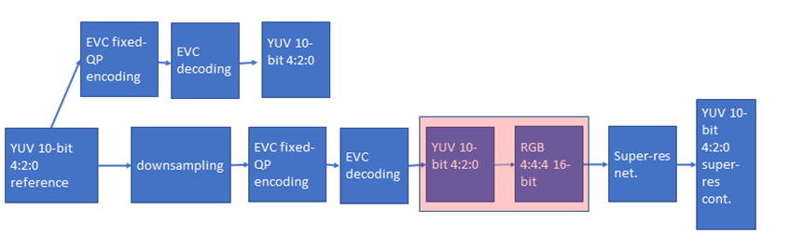
Figure 1 processing workflow

We finished the coding at fixed QP (as per the Common Test Conditions): 22, 27, 32, 37, 42, 47.
The coded video sequences are in YUV 4:2:0 10-bit format, and come either in the BT.709 or BT.2020 colour spaces. Since the super-resolution network operates on PNG images, the application of the correct colour space information in the conversion process from YUV to PNG is critical to avoid introducing unwanted image deterioration and, as a consequence, losing coding efficiency due to factors other than the coding scheme itself.
Thus, two different workflows are followed, accounting for the colour space difference. The ffmpeg command lines used for the conversion of BT.709 and BT.2020 content respectively, are

ffmpeg -pix_fmt yuv420p10le -s videosize -i inpufile.yuv -vf scale=out_color_matrix=bt709:flags=full_chroma_int+accurate_rnd+lanczos -c:v png outputdir/%3d.png

and

ffmpeg -pix_fmt yuv420p10le -s videosize -i inpufile.yuv -vf scale=out_color_matrix=bt2020:flags=full_chroma_int+accurate_rnd+lanczos -c:v png outputdir/%3d.png

Other datasets, such as the Youtube UGC dataset are being investigated.
The dataset is ready, and it is available on MPAI ftp server.
Also the test sequences are available on the ftp server.

Figure 2: MPAI-EVC datasets

We now have two datasets (Figure 2): a huge training dataset with 350 4K sequences that we use for training. Moreover, we have a test dataset with few sequences, only 24 sequences, which we use for testing. The overlap between these two datasets is zero, which means we do not use test sequences in the training phase.
In addition, all the results we present are based on the test sequences. We usually call them JVET sequences, because they are in common with the MPEG JEVET group.

Intra prediction tool
We address the challenge of predicting an intra-coded block given its context (Intra prediction) as an image inpainting problem, i.e. recovering pixels of an image that are unavailable due to, e.g. occlusions or information loss. Masked convolutional neural networks have been recently proposed for image inpainting exploiting the apriori information from the context to recover the missing image area. The method we propose relies on masked convolutions to generate the block predictor starting from a decoded context of 64 × 64 pixels (Figure 3). For example, for each 32x32 coding unit a 64x64 context is sent to the autoencoder. The autoencoder returns to the EVC encoder a 32x32 predictor that is considered as a 6th EVC Intra predictor mode that is put into competition with the other 5 predictors. The generated bitstream is fully decodable under the assumption that the autoencoder network is also available at the decoder side.
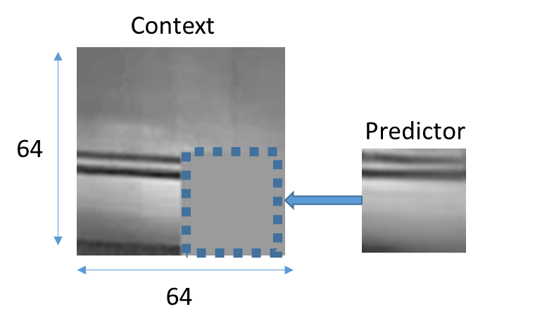
Figure 3: context con the left and the predictor on the right

The masked autoencoder (Figure 4) is trained in a supervised manner for 1000 Epochs over a set of randomly drawn patches from about 800 images representing various types of contents by minimising the absolute error (ABS) between the network output and the original patch.

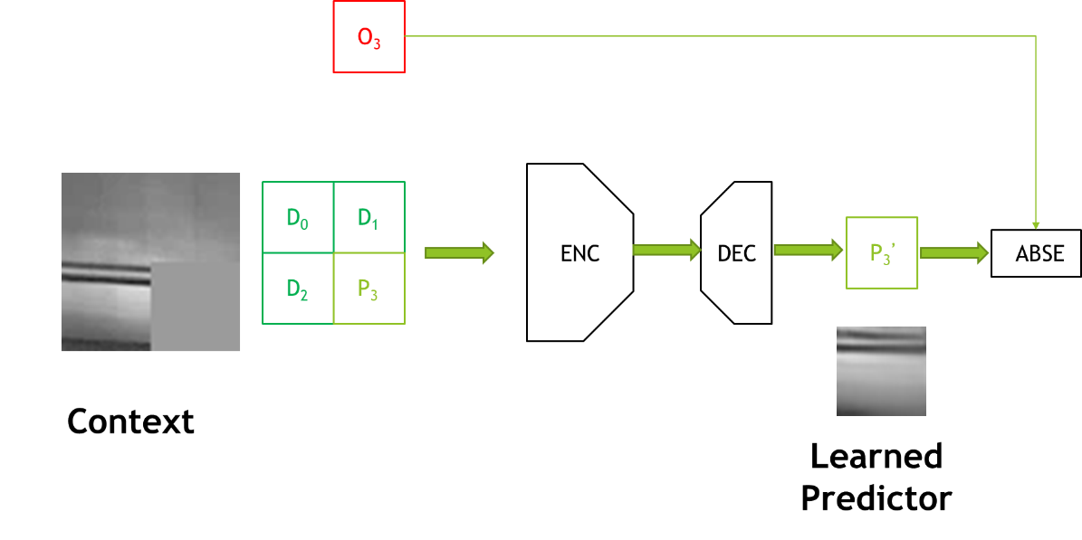
Figure 4: Procedure for training the convolutional autoencoder used to generate the Intra predictor.

We worked on the architecture of the encoder, switching to a VGG-inspired topology where the encoder is made of 5 pairs of stacked convolutional layers with 3x3 filters interleaved by subsampling for a total of 10 convolutional layers (results in Table 1).
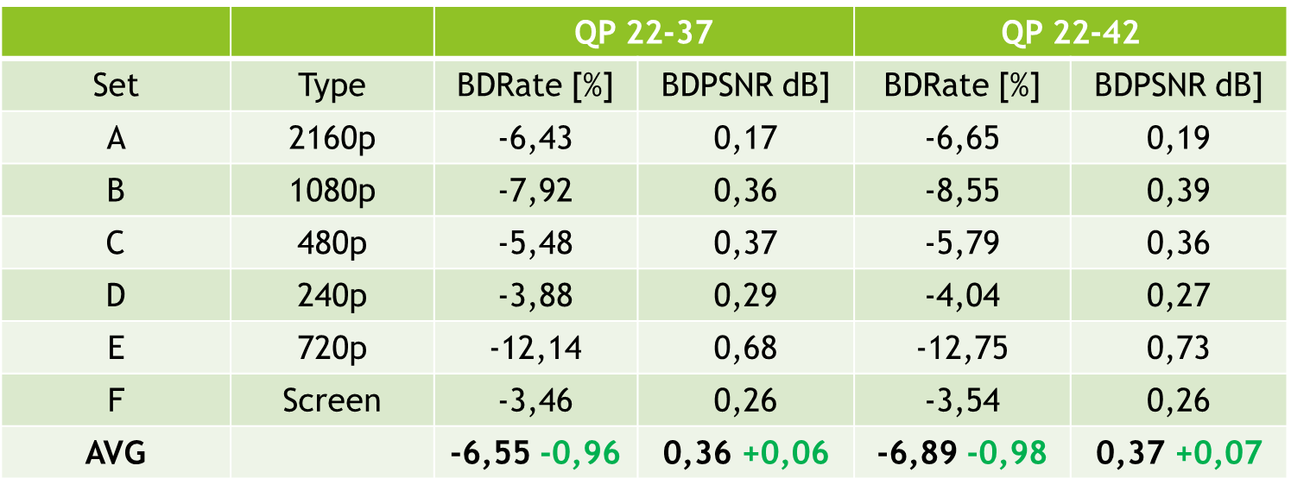
Table 1: results with VGG-like architecture over the standard JVET test sequences for the 22-37 and 22-42 QP ranges and for 5 modes

Table 1 shows the improvement compared to the previous architecture: in green the delta wrt reference, 5 modes. The BD rate increased by an average of 1 percent from the previous architecture.

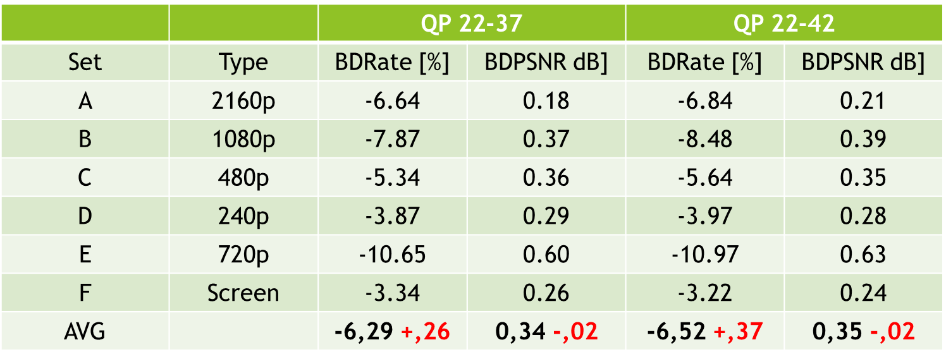
Table 2: results with the new architecture VGG-like and for 6 modes

Table 2 shows that at the moment there is no gain in adding a sixth mode (values in red), rather there is a generalized loss (small gains only for class A, more pronounced losses for class E). We are trying to explain these numbers by calculating some statistics on the predictor modes (Table 3).

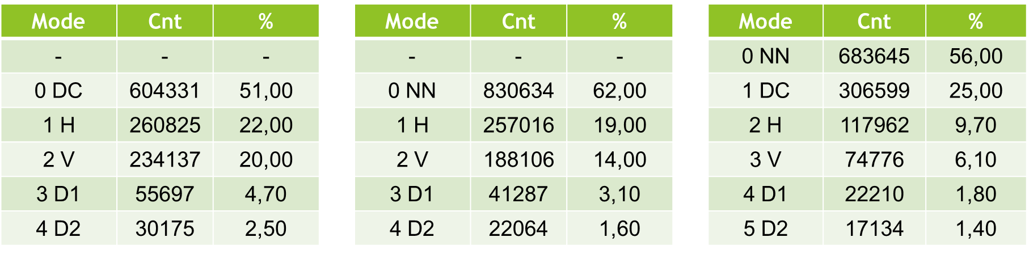
Table 3: percentage of modes use: left: 5 modes, reference; middle: 5 modes, new architecture; right: 6 modes new architecture on JVET Class A

Table 3 shows the percentage of use of a particular mode on the Class A JVET sequences. With the new architecture and 5 modes, the percentage of neural predictor use increases from 51% to 62%. Unfortunately, by adding the sixth mode, the percentage drops to 56%, because with 5 modes the DC mode is replaced, while with 6 modes the DC mode reaches 25% utilisation.

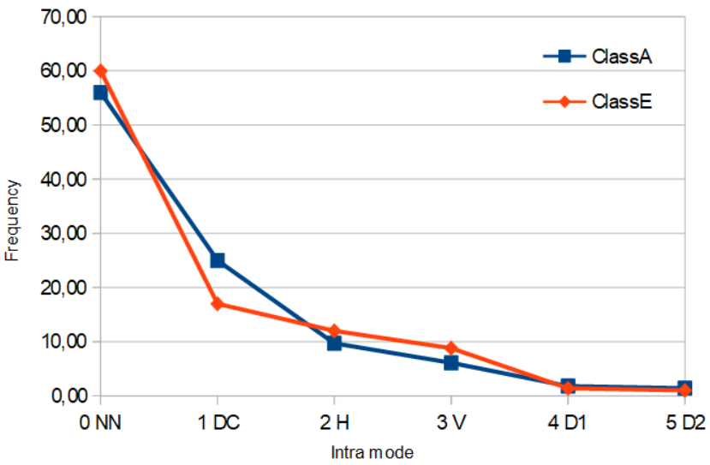
Figure 5: distribution of modes use

Figure 5 shows that Class A has about 81% of the predictions in modes 0 and 1, whereas this number drops to 76% for the Class E.
Adding a 6th new intra yield no gains currently. From our analysis, it seems that NN predictor is more selected than DC but still we have no gains. This is probably due to the cost of signalling the 6th predictor. We are investigating the bit-cost for signalling and residuals.

Super-resolution tool
The super-resolution step is added as a post-processing tool. The picture before encoding with EVC baseline profile is downscaled and then the super-resolution network is applied to the decoded picture to get the native resolution.
We have carried out extensive training of the selected deep-learning approach for super-resolution on 4 QPs (15,30,37 and 45). We have tested its performances on 8 test sequences for the case of SD to HD, and on 3 test sequences for the case of HD to 4K.
The group has worked on the computation of the BD-rate SD to HD, Table 2, showing an improvement of -3.14% when compared with the ground truth EVC.

Sequence | Class | BD-Rate
Crowd Run | Class B 1920x1080 60/50 fps, 8 bpp | -1.24%
Ducks Take Off | Class B 1920x1080 60/50 fps, 8 bpp | 2.12%
Park Joy | Class B 1920x1080 60/50 fps, 8 bpp | 1.40%
Diego and Owl | Class B 1920x1080 60/50 fps, 8 bpp | 8.11%
Rome 1 | Class B 1920x1080 60/50 fps, 8 bpp | 0.19%
Rome 2 | Class B 1920x1080 60/50 fps, 8 bpp | -18.81%
Rush Hour | Class B 1920x1080 60/50 fps, 8 bpp | 4.90%
Talk Show | Class B 1920x1080 60/50 fps, 8 bpp | -21.75%
Average: -3.14%
Table 2: BD-rate performances on all the 8 test sequences

The HD to 4K testing phase has been finalised on all QPs (15,30,37 and 45).
Figure 6 shows the BD-rate curves for each sequence, where the network trained on QP 15 dataset has been used over the test set for all QPs. The reasoning behind it, is to learn the features information, which is intrinsic within the compressed sequences, at the highest quality possible (QP 15). This will avoid any shortcoming in the generalization capabilities that we have faced doing separated training for each QP.

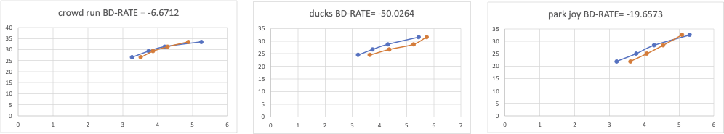

Figure 6 BD-Rate curve for all sequences and QPs, showing the BD-rate variation (Bjontegaard) averaged over all the QPs.

Training Dataset set
This consists first in the conversion from YUV to RGB (PNG) format and then applying the patch selection for each sequence as part of the original compressed dataset. This will be done only for the lower QP because in the preliminary experiment, as described above, we are able to guarantee the best performances, while avoiding any generalization issue.

The training datasets, patches extraction, for all the types of training listed in ‘Training Strategies’, have been initiated. However, for the SD2HD case some issues with few sequences have been found and are under investigation. We have also started to analyze the test sequences to see if there are any potential problems, so that we will be ready after training to run the test.

Training Strategies
We have identified different types of training strategies as follow:
- Without training, so using only the weights of the original DRLN approach. This approach has been tested. However, the DLRN network has been modified to remove an intermediate layer that it was not used but was introducing memory management issues. This has the effect that using the original weights of the network will not map to the new DRLN network producing results that are not usable. This makes comparison no longer possible.
- Training only of the lower QP. This will help in reducing the overall required training time. This approach has been so far found as the best solution providing good results for all QPs at the inference stage and limiting generalization issues as shown in the previous sections.
- Training only on the SD2HD transformation and use it also for the HD24K. This will allow us to reduce the overall required training time.
- Training only on uncompressed data. This will be done, to see if the obtained quality can be further improved.

Training results for the HD24K case
We have carried out extensive training of the DRLN approach for super-resolution using the new datasets as defined in the Common Test Conditions, where the sequences were encoded at QPs: 22, 27, 32, 37, 42, 47. Based on the preliminary results, as shown in the previous sections, the training has been carried out using patches from the lowest QP, in this case 22. The number of epochs used were 50, as in the preliminary experiments.
The results of the training for the HD24K are shown in the figure 7 and figure 8, representing the loss function and the PSNR of the training and validation respectively:

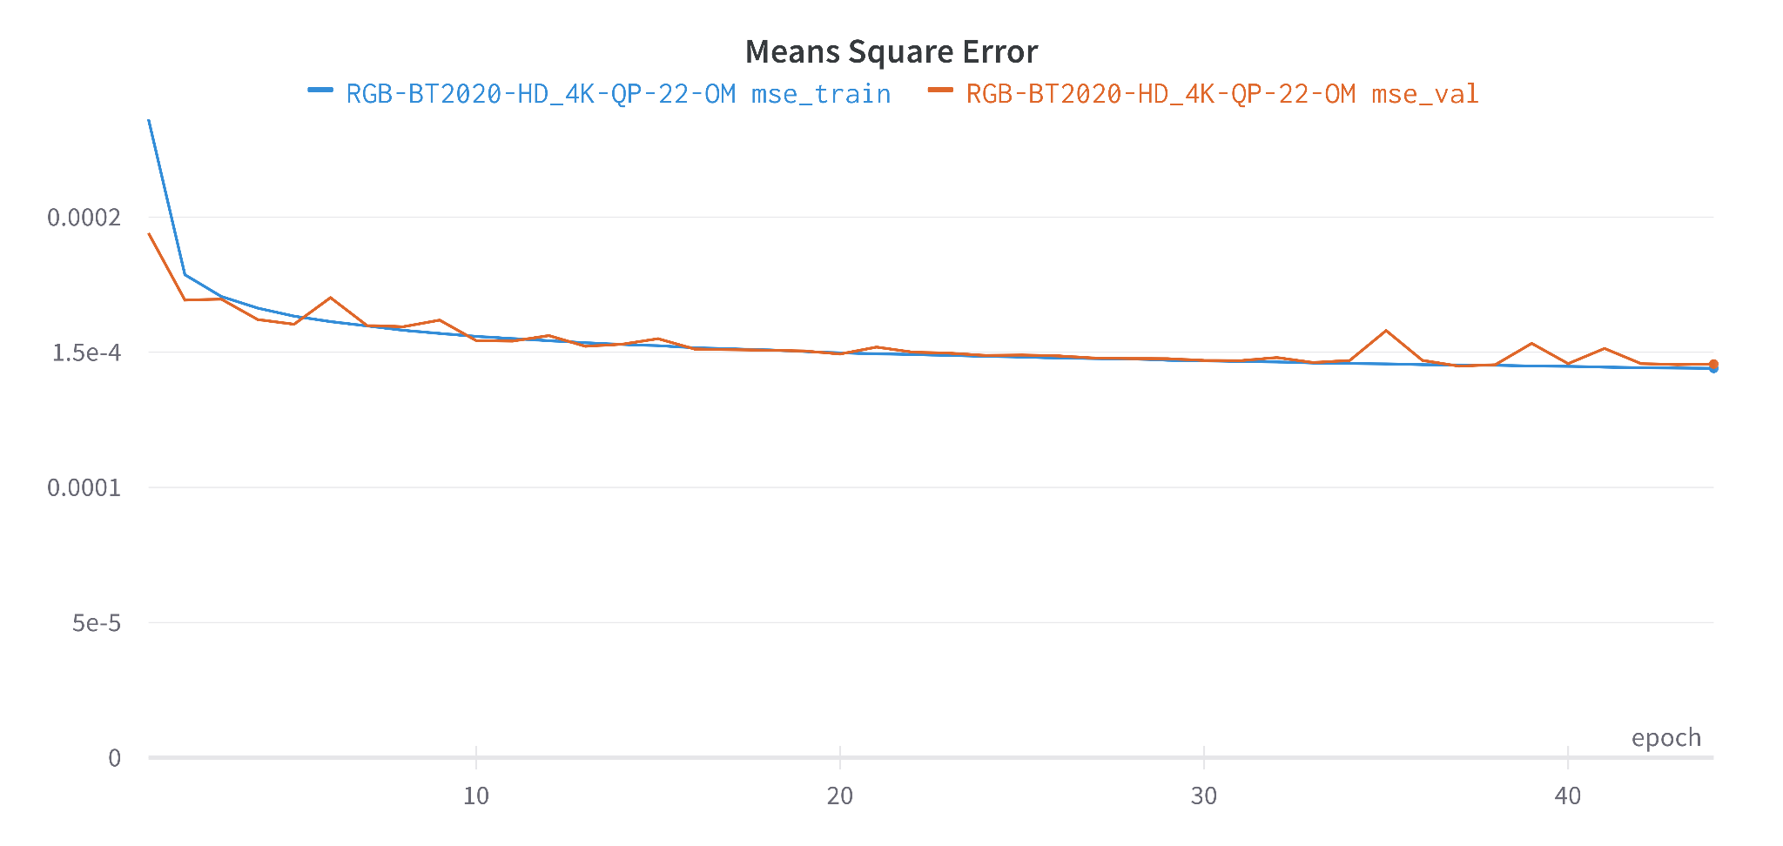

Figure 7: Loss function: Training and validation results of the HD24K case.

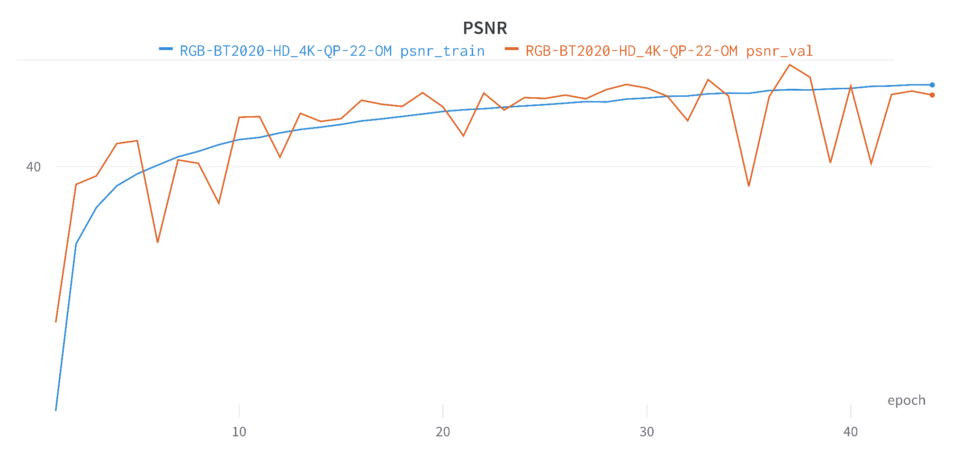
Figure 8: PSNR: Training and validation results of the HD24K case

Training results for the SD2HD case
We finished the training of the SR neural network on the task SD to HD. As in the previous section, training was carried out using the lowest QP patches (QP 22). Figures 9 and 10 show the loss function and PSNR of training and validation respectively up to epoch 50.

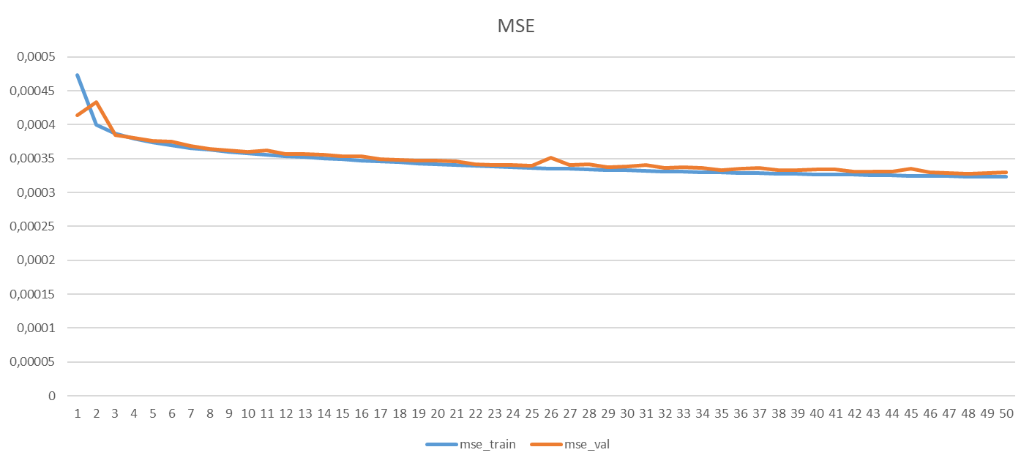
Figure 9: Mean Square Error (MSE) loss for training and validation of the SD2HD case

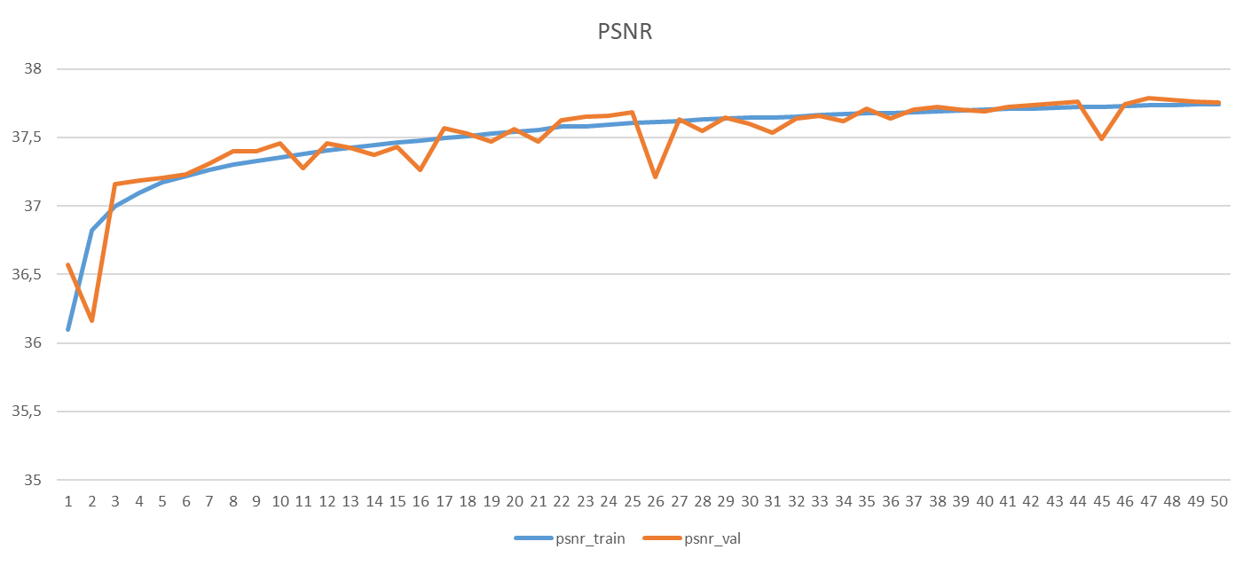
Figure 10: PSNR for training and validation of the SD2HD case

Inference on the new dataset
The inference phase on the new dataset is still ongoing. Tests have been carried out but we are checking their validity.

Intra & super resolution combined
The group started to test the pipeline with the two combined tools: Intra and Super resolution (Figure 11). So far, the percentages available for the Intra tool and the super resolution tool have been summed linearly, but the underlying process is strongly not linear. For this reason it was necessary to have a combined result to really calculate the actual coding gain.
In the combined tests, the picture is downscaled before being compressed with EVC Intra enhanced. At the output of the decoder the SR tool is applied to get the native full resolution. We are currently working only on the first frame of the sequence. The QPs under consideration are: 22, 27, 32, 37, 42, 47.
The comparison is between the original full resolution and the upscaled picture.

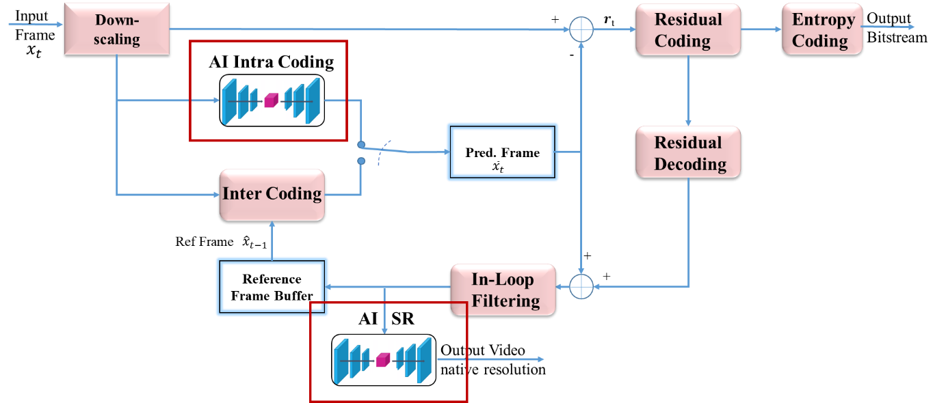
Figure 11 : synergy plan between Intra and Super resolution tools

We planned to perform the following tests:
  - Test 1:
    - HD Intra enhanced (with deep learning) EVC to 4K upsampled with SR tool
    - HD MPEG5-EVC upsampled to 4K with Lanczos

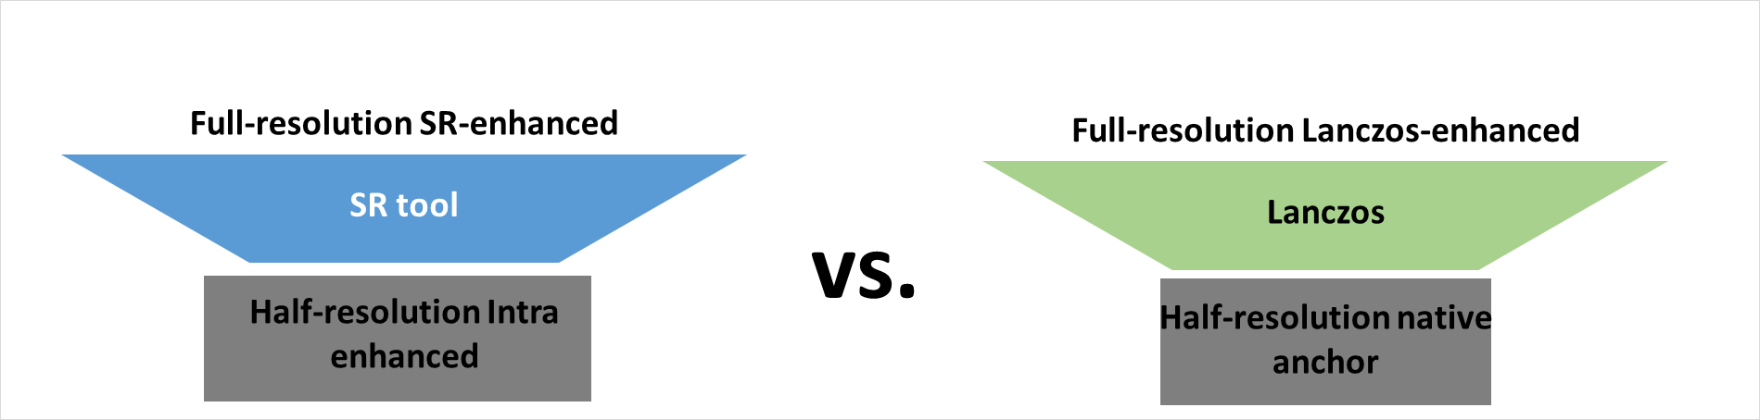

  - Test 2:
    - HD Intra enhanced (with deep learning) EVC to 4K upsampled with SR tool
    - 4K native full resolution coded with MPEG5-EVC

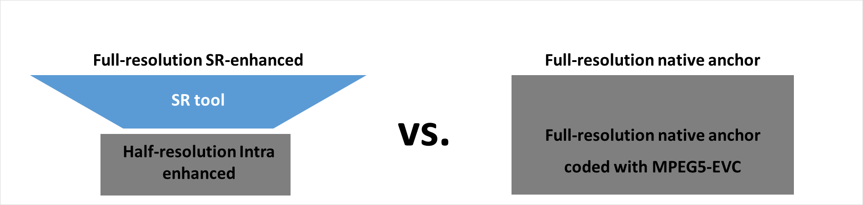

  - Test 3:
    - HD MPEG5-EVC upsampled to 4K with Lanczos
    - 4K native full resolution coded with MPEG5-EVC

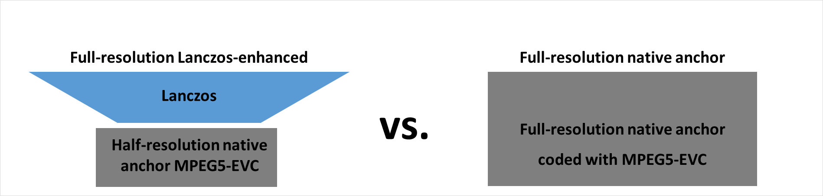

We have started the HD to 4K testing phase on all QPs (15,30,37 and 45).
Figure 12 shows the BD-rate curves for each of the test sequences, where the network trained on QP 15 dataset has been used over the test set for all QPs, as already explained for the previous experiments.
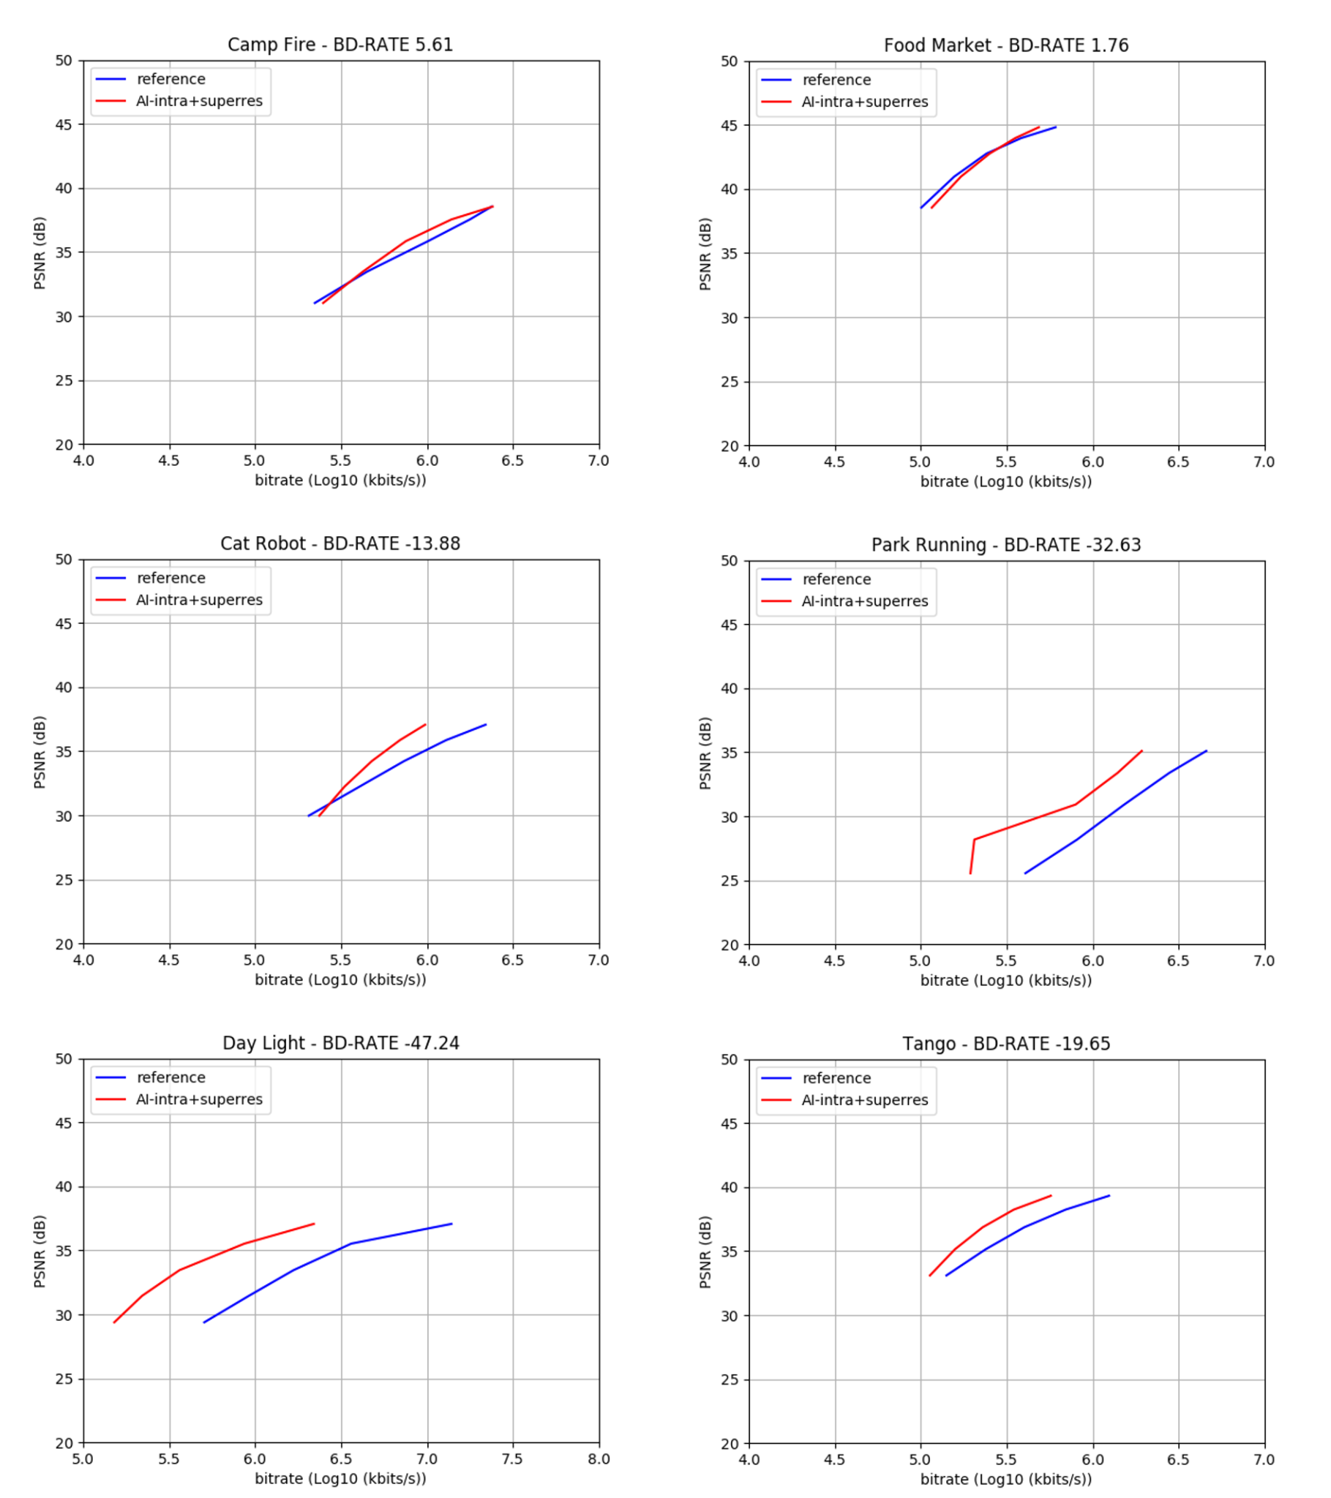

Figure 12: results of preliminary BD-Rate evaluations

The group discussed further testing the combination of the Intra and the SR tools for a random access configuration. The group agreed upon the configuration settings, including the GOP structure (IBBBBBBBB). Currently, the encodings for the Intra-augmented setup are ongoing for the JVET Class A (4K) sequences downsampled to HD. Due to the long encoding time, these experiments are expected to be completed not before the end of the month of October. Preliminary results on some QPs of some sequences show gains over the standard EVC encode also for this random access setup. Once all the encodings are completed, the decoded sequences will be upsampled to original 4K using the SR tool and the final RD curves will be plotted, and the BDRate values will be computed.

In-loop filter
Starting from the paper A Deep Learning Approach for Multi-Frame In-Loop Filter of HEVC we have started to go in-depth in the available on the git:
https://github.com/tianyili2017/MultiFrame-InLoop-Filter
This approach is implemented in HEVC and the plan is to port it into the EVC codec.
We reached out to one of the authors of the paper and shared insights on porting his code from HEVC to the basic EVC profile.
The group is working on the following topics:
- the communication between HEVC and the neural network
- adding a counter to understand how many times the neural network is selected
- drive the network without HEVC code

Inter prediction
The group started the work on inter prediction with the aim of improving it by exploiting deep learning. It is currently analysing the state of the art.
We have selected 6 papers:
- Bi-Prediction_Enhancement_with_Deep_Frame_Prediction_Network_for_Versatile_Video_Coding
- Deep_Frame_Prediction_for_Video_Coding
- Deep_Inter_Prediction_via_Reference_Frame_Interpolation_for_Blurry_Video_Coding
- Deep_Video_Prediction_Network-Based_Inter-Frame_Coding_in_HEVC
- Neural Network based Inter bi-prediction Blending
- Neural_Network-Based_Enhancement_to_Inter_Prediction_for_Video_Coding
- Neural_Reference_Synthesis_for_Inter_Frame_Coding

The next steps are:
Tool | Date | Topic | Who
Intra prediction | 2 meeting cycles | Porting to HEVC | Attilio
Super Resolution | 1 meeting cycle | Visual evaluation of the compressed test sequences of the new dataset | All
In-loop | 1 meeting cycle | Start porting from HEVC code to EVC | Attilio, Alessandra, Roberto
Combined results | 1 meeting cycle | Testing combined results: intra + super resolutions | Alessandro, Giovanni, Attilio
Inter prediction | 2 meting cycle | Study of the state of the art | Gopi

Future Plan
- motion compensation: improve the motion compensation using NN architecture
- inter prediction: use NN architectures to refine the quality of inter-predicted blocks; introduce new inter prediction mode which tries to predict a frame directly without the use of side information; leverage on Optical Flow algorithm for the motion estimation.
- quantization: uniform scalar quantization used in classical video codec standards does not conform to the characteristics of the human visual system. It is possible to use a quantization strategy based on neural networks.
- arithmetic encoder: improve the CABAC performance by leveraging NN to directly predict the probability distribution of intra modes instead of the handcraft context models

