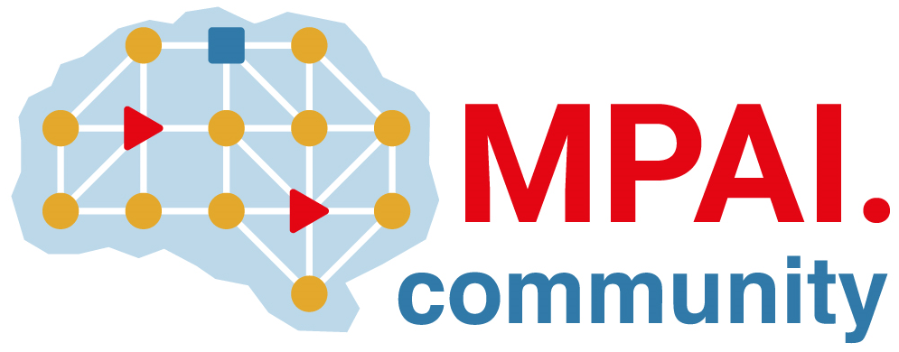 | Moving Picture, Audio and Data Coding by Artificial Intelligence  www.mpai.community

Public document
N922 | 2022/30/26
Source | Requirements (MCS)
Title | MPAI-MCS Progress report and plans
Target | MPAI-25

ARA responses received.
Wait for ARA TS to mature before resuming MCS activities.

