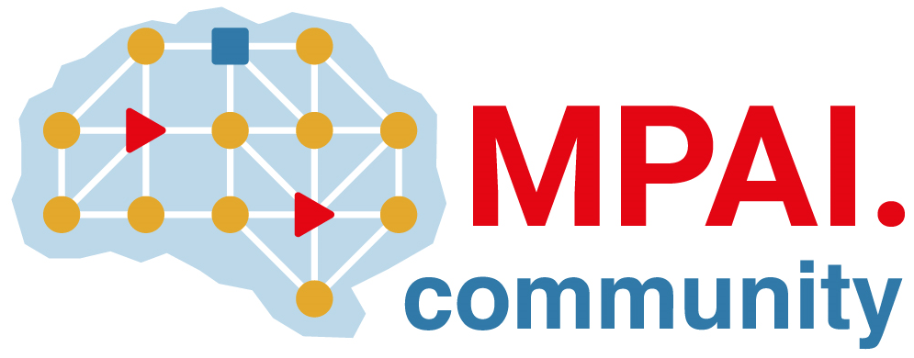 |  | Moving Picture, Audio and Data Coding  by Artificial Intelligence  www.mpai.community
Public document
N925 | 2022/10/26
Source | Requirements (OSD)
Title | MPAI-OSD report and plans
Target | MPAI Members

No responses to the MPAI-MMC V2 Call falling under the MPAI-OSD area of work were received.

