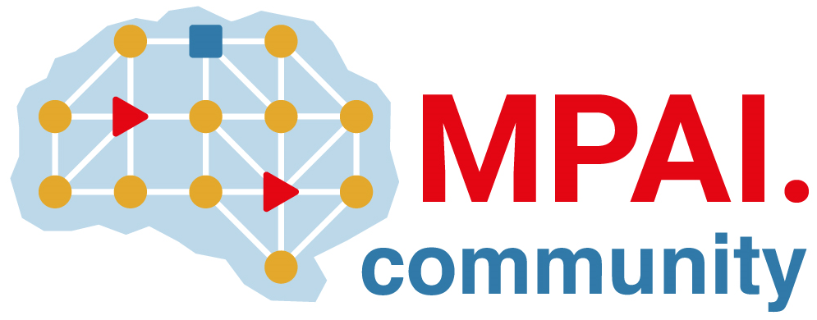 | Moving Picture, Audio and Data Coding by Artificial Intelligence  www.mpai.community

Public document
N936 | 2022/11/23
Source | 26th MPAI General Assembly (MPAI-26)
Title | MPAI-26 Press Release
Target | MPAI Members

MPAI calls for new members to support its standard development plans

Geneva, Switzerland – 23 November 2022. Today the international, non-profit, unaffiliated Moving Picture, Audio and Data Coding by Artificial Intelligence (MPAI) standards developing organisation has concluded its 26th General Assembly (MPAI-26). MPAI is calling for new members to support the development of its work program.

Planned for approval in the first months of 2023 are 5 standards and 1 technical report:

- AI Framework (MPAI-AIF). Standard for a secure AIF environment executing AI Workflows (AIW) composed of AI Modules (AIM).
- Avatar Representation and Animation (MPAI-ARA). Standard for generation and animation of interoperable avatar models reproducing humans and expressing a Personal Status.
- Context-based Audio Enhancement (MPAI-CAE). Standard to describe an audio scene to support human interaction with autonomous vehicles and metaverse applications.
- Multimodal Conversation (MPAI-MMC). Standard for Personal Status generalising the notion of Emotion including Cognitive State and Social Attitude.
- MPAI Metaverse Model (MPAI-MMM). Technical Report covering the design, deployment, operation, and interoperability of Metaverse Instances.
- Neural Network Watermarking (MPAI-NNW). Standard specifying methodologies to evaluate neural network-based watermarking solutions

The MPAI work plan also includes exploratory activities, some of which are close to becoming standard or technical report projects:

- AI Health (MPAI-AIH). Targets an architecture where smartphones store users’ health data processed using AI and AI Models are updated using Federated Learning.
- Connected Autonomous Vehicles (MPAI-CAV). Targets the Human-CAV Interaction Environment Sensing, Autonomous Motion, and Motion Actuation subsystems implemented as AI Workflows.
- End-to-End Video Coding (MPAI-EEV). Extends the video coding fronties using AI-based End-to-End Video coding.
- AI-Enhanced Video Coding (MPAI-EVC). Improves existing video coding with AI tools for short-to-medium term applications.
- Server-based Predictive Multiplayer Gaming (MPAI-SPG). Uses AI to train neural networks that help an online gaming server to compensate data losses and detects false data.
- XR Venues (MPAI-XRV). Identifies common AI Modules used across various XR-enabled and AI-enhanced use cases where venues may be both real and virtual.
It is a good opportunity for legal entities supporting the MPAI mission and able to contribute to the development of standards for the efficient use of data to join MPAI now, also considering that membership is immediately active and will last until 2023/12/31.

Please visit the MPAI website, contact the MPAI secretariat for specific information, subscribe to the MPAI Newsletter and follow MPAI on social media: LinkedIn, Twitter, Facebook, Instagram, and YouTube.

Most importantly: please join MPAI, share the fun, build the future.

