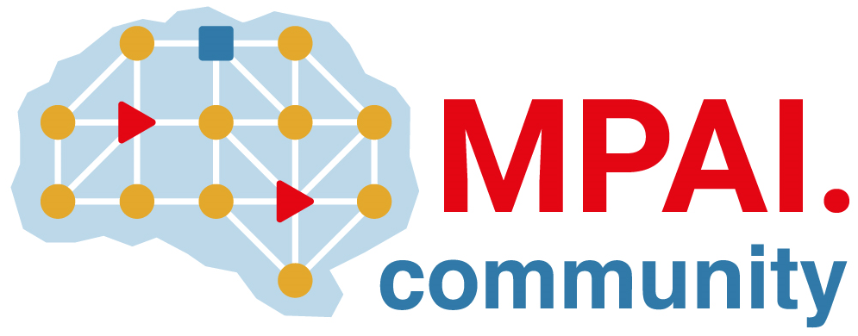 | Moving Picture, Audio and Data Coding by Artificial Intelligence  www.mpai.community

Public document
N961 | 2022/11/23
Source | Requirements (AIH)
Title | MPAI-AIH Progress report and plans
Target | MPAI-26

- Requirements for MPAI-AIH: work in progress
- Major architectural components identification (smart device, third parties and blockchain) and integration with MPAI-AIF (AIM and AIW).
- Work being done:
  - APIs, Blockchain and Smart Contracts.
  - Study of workflows for potential standardization.
  - Identification data types acquired.
  - Identification of processing flows on the data, either as a single entity or a workflow;
  - Identification of potential processing that can leverage the architecture.

