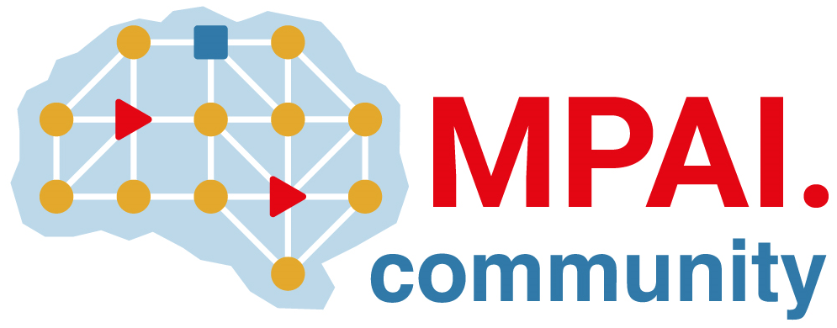 | Moving Picture, Audio and Data Coding by Artificial Intelligence  www.mpai.community

Public document
N965 | 2022/11/23
Source | Requirements (EEV)
Title | Requirements (EEV) progress report and plans
Target | MPAI-26

Requirements (EEV) plans to further investigate the end-to-end video coding framework with emerging techniques in computer vision and also seek possible applications to emerging solutions.

In current GA meeting cycle, the Requirements (EEV) has made significant progress in drone video coding, and submitted a paper to IEEE DCC.

