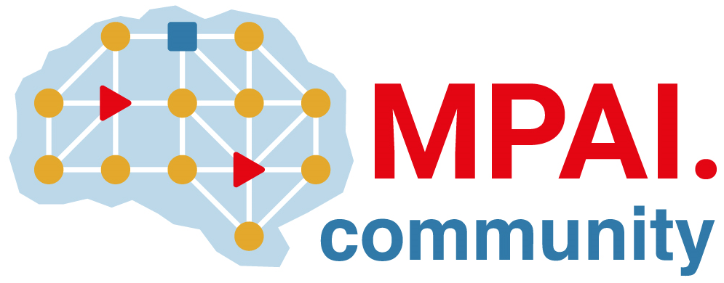 | Moving Picture, Audio and Data Coding by Artificial Intelligence  www.mpai.community

Public document
N1006 | 2022/12/21
Source | Requirements (EEV)
Title | Requirements (EEV) progress report and plans
Target | MPAI-26

Requirements (EEV) is currently investigating the further development on the top of the EEV-0.3 model with advanced predictive coding model using neural networks. Specifically, the multiple reference frame based inter prediction is under construction such that richer temporal information is leveraged to further boost the coding performances of drone videos. Another attempt is that the EEV is going to particularly use the in-door scene videos from the corridor dataset such that the performances of in-door UAV video coding is projected to be enhanced.

In next GA meeting cycle, the Requirements (EEV) also anticipates to compare the rate-distortion performances with the H.266/VVC reference software to show the performances status.

