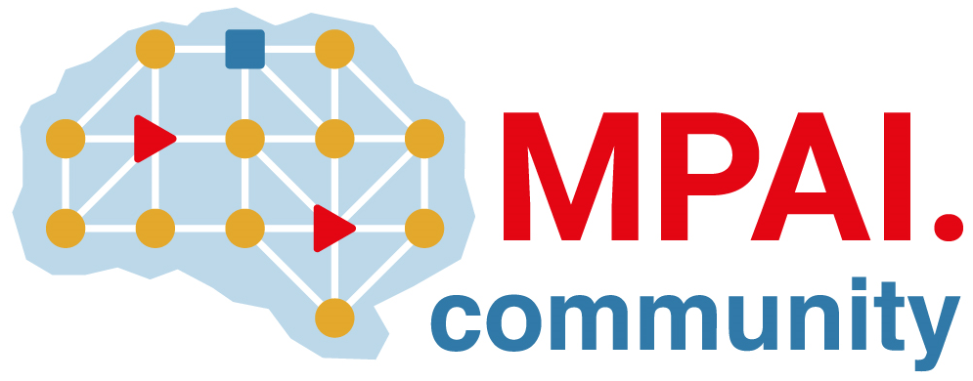 | Moving Picture, Audio and Data Coding  by Artificial Intelligence  www.mpai.community

 | Public document
N985 | 2022/12/21
Source | Requirements (ARA)
Title | MPAI-ARA Progress report and plans
Target | MPAI-27

Requirements (ARA) have come to the following conclusions.

Avatar Representation and Animation (MPAI-ARA) specifies the technologies enabling the implementation of the Avatar-Based Videoconference Use Case specified in Chapter 5 - Avatar-Based Videoconference, specifically:
- A Digital Environment populated with non-human audio-visual objects.
- A Digital Human Model.
- The Representation of the motion a human.
- The Animation of a Digital Human Model.
- The Representation of the features of a human.

