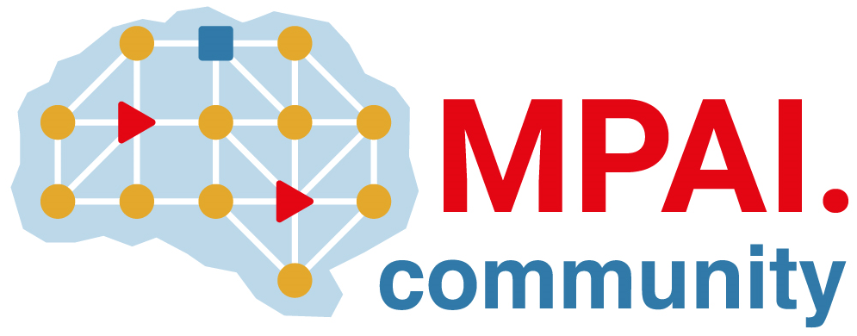 | Moving Picture, Audio and Data Coding by Artificial Intelligence  www.mpai.community

Public document
N1049 | 2023/01/25
Source | Requirements (EEV)
Title | Requirements (EEV) progress report and plans
Target | MPAI-28

Requirements (EEV) has made significant progress in learned video coding for drone videos. Specifically, the benchmark for learned drone video coding has been established, including 14 video clips with diverse drone contents. A technical paper describing those update has been accepted as a short paper in the IEEE Data Compression Conference in 2023. The official website of EEV is also updated with the latest information with status description and contact information. The direct comparison of the rate-distortion performances with the H.266/VVC reference software against EEV are also shown.

In next GA meeting cycle, the Requirements (EEV) also anticipates to release a strong baseline to update the reference model of EEV. The model under development has shown great potentials to outperform H.266/VVC in some sort of subjective metrics.

Regarding the participants, more experts from Tsinghua Univ. and Shanghai Jiao Tong Univ. are invited to join this group.

