Moving Picture, Audio and Data Coding
by Artificial Intelligence
www.mpai.community

N1081 | 2023/02/22
Source | Marina Bosi-Chair MPAI-CAE
Title | Technical Specification – Context-based Audio Enhancement (MPAI-CAE) WD1.5
Target | MPAI-29

Moving Picture, Audio and Data Coding
by Artificial Intelligence
www.mpai.community

MPAI Technical Specification

Context-based Audio Enhancement
MPAI-CAE V2

WD1.5

WARNING

Use of the technologies described in this Technical Specification may infringe patents, copyrights or intellectual property rights of MPAI Members or non-members.

MPAI and its Members accept no responsibility whatsoever for damages or liability, direct or consequential, which may result from use of this Technical Specification.

Readers are invited to review Annex 2 - Notices and Disclaimers.

© Copyright MPAI 2021-2023. All rights reserved
Context-based Audio Enhancement
Version V2 (under development)

1 Introduction 4
2 Scope of standard 6
2.1 Emotion-Enhanced Speech (EES) 6
2.2 Audio Recording Preservation (ARP) 6
2.3 Speech Restoration System (SRS) 7
2.4 Enhanced Audioconference Experience (EAE) 7
2.5 Human Connected Autonomous Vehicle (CAV) Interaction 7
2.6 Normative content of the Use Cases 7
3 Terms and Definitions 8
4 References 10
4.1 Normative References 10
4.2 Informative References 11
5 Use Case Architectures 11
5.1 Emotion-Enhanced Speech (EES) 11
5.1.1 Scope of Use Case 11
5.1.2 I/O data 11
5.1.3 Implementation Architecture 11
5.1.4 AI Modules 12
5.2 Audio Recording Preservation (ARP) 13
5.2.1 Scope of Use Case 13
5.2.2 I/O data 13
5.2.3 Implementation Architecture 13
5.2.4 AI Modules 15
5.3 Speech Restoration System (SRS) 15
5.3.1 Scope of Use Case 15
5.3.2 I/O Data 16
5.3.3 Implementation Architecture 16
5.3.4 AI Modules 17
5.4 Enhanced Audioconference Experience (EAE) 17
5.4.1 Scope of Use Case 17
5.4.2 I/O data 18
5.4.3 Implementation Architecture 18
5.4.4 AI Modules 19
5.5 Human-Connected Autonomous Vehicle (CAV) Interaction 20
5.5.1 Scope of Use Case 20
5.5.2 Reference architecture 20
5.5.3 Specifications 22
6 AIMs 22
6.1 AIM Interoperability 22
6.2 AIMs and their data 22
6.2.1 Emotion Enhanced Speech 22
6.2.2 Audio Recording Preservation (ARP) 23
6.2.3 Speech Restoration System (SRS) 23
6.2.4 Enhanced Audioconference Experience (EAE) 23
6.3 Audio Scene Description Composite AIM 24
6.3.1 Scope 24
6.3.2 Reference architecture 24
6.3.3 AI Modules 24
6.3.4. Data formats 25
6.4 Data Formats 26
6.4.1 Access Copy Files 26
6.4.2 Audio Block 27
6.4.3 Audio File 27
6.4.4 Audio Scene Geometry 27
6.4.5 Audio Scene Descriptor 28
6.4.6 Audio Segment 29
6.4.7 Damaged List 29
6.4.8 Denoised Speech 30
6.4.9 Editing List 30
6.4.10 Emotion 32
6.4.11 Emotionless Speech 36
6.4.12 Enhanced Source 36
6.4.13 Interleaved Multichannel Audio 36
6.4.14 Irregularity File 37
6.4.15 Irregularity Image 40
6.4.16 Microphone Array Audio 40
6.4.17 Microphone Array Geometry 41
6.4.18 Mode Selection 43
6.4.19 Multichannel Audio Stream 43
6.4.20 Neural Network Speech Model 44
6.4.21 Preservation Audio File 44
6.4.22 Preservation Audio-Visual File 44
6.4.23 Preservation Master Files 44
6.4.24 Source Dictionary 44
6.4.25 Source Model KB Query Format 44
6.4.26 Source Spatial Attributes 44
6.4.27 Speech Features 46
6.4.28 Spherical Harmonic Decomposition 48
6.4.29 Transform Denoised Speech 48
6.4.30 Transform Enhanced Source 48
6.4.31 Transform Speech 49
6.4.32 Transform Multichannel Audio 49
6.4.33 Video 49
Annex 1 - MPAI-wide terms and definitions (Normative) 51
Annex 2 - Notices and Disclaimers Concerning MPAI Standards (Informative) 54
Annex 3 - The Governance of the MPAI Ecosystem (Informative) 56
Annex 4 – Patent Declarations 58
Annex 5 - Examples (Informative) 59
3.1 Audio Scene Geometry 59
3.2 Damaged List 59
3.3 Editing List 59
3.4 Irregularity File 60
3.5 Microphone Array Geometry 61
3.6 Speech Features 1 62
3.7 Speech Features 2 62
Annex 6 - AIW and AIM Metadata of CAE-EES 64
6.1 AIW Metadata 64
6.2 AIM Metadata 66
6.2.1 Speech Feature Analyser1 66
6.2.2 Speech Feature Analyser2 67
6.2.3 Emotion Feature Producer 68
6.2.4 Emotion Inserter1 69
6.2.5 Emotion Inserter2 69
Annex 7 - AIW and AIM of ARP 71
7.1 AIW metadata 71
7.2 AIM metadata 75
7.2.1 Audio Analyser 75
7.2.2 Video Analyser 76
7.2.3 Tape Irregularity classifier 77
7.2.4 Tape Audio Restoration 78
7.2.5 Packager 79
Annex 8 - AIW and AIM of SRS 81
8.1 AIW metadata 81
8.2 AIM metadata 83
8.2.1 Speech Model Creation 83
8.2.2 Speech Synthesiser 83
8.2.3 Assembler 84
Annex 9 - AIW and AIM of EAE 86
9.1 AIW Metadata 86
9.2 AIM Metadata 91
9.2.1 Metadata of CAE-EAE Analysis Transform AIM 91
9.2.2 Metadata of CAE-EAE Sound Field Description AIM 92
9.2.3 Metadata of CAE-EAE Speech Detection and Separation AIM 93
9.2.4 Metadata of CAE-EAE Noise Cancellation AIM 94
9.2.5 Metadata of CAE-EAE Synthesis Transform AIM 95
9.2.6 Metadata of CAE-EAE Packager AIM 96

Introduction
In recent years, Artificial Intelligence (AI) and related technologies have been introduced in a broad range of applications, have started affecting the life of millions of people and are expected to do so even more in the future. As digital media standards have positively influenced industry and billions of people, so AI-based data coding standards are expected to have a similar positive impact. Indeed, research has shown that data coding with AI-based technologies is generally more efficient than with existing technologies for, e.g., compression and feature-based description.
However, some AI technologies may carry inherent risks, e.g., in terms of bias toward some classes of users. Therefore, the need for standardisation is more important and urgent than ever.
The international, unaffiliated, not-for-profit MPAI – Moving Picture, Audio and Data Coding by Artificial Intelligence Standards Developing Organisation has the mission to develop AI-enabled data coding standards. MPAI Application Standards enable the development of AI-based products, applications, and services.
As a rule, MPAI standards include four documents: Technical Specification, Reference Software Specifications, Conformance Testing Specifications, and Performance Assessment Specifications. Sometimes Technical Reports are produced to provide informative guidance in specific areas for which the development of standards in premature.
Performance Assessment Specifications include standard operating procedures to enable users of MPAI Implementations to make informed decision about their applicability based on the notion of Performance, defined as a set of attributes characterising a reliable and trustworthy implementation.
In the following, Terms beginning with a capital letter are defined in Table 1 if they are specific to this Standard and in Table 25 if they are common to all MPAI Standards.
In general, MPAI Application Standards are defined as aggregations – called AI Workflows (AIW) – of processing elements – called AI Modules (AIM) – executed in an AI Framework (AIF). MPAI defines Interoperability as the ability to replace an AIW or an AIM Implementation with a functionally equivalent Implementation.
MPAI also defines 3 Interoperability Levels of an AIF that executes an AIW. The AIW and its AIMs may have 3 Levels:
Level 1 – Implementer-specific and satisfying the MPAI-AIF Standard.
Level 2 – Specified by an MPAI Application Standard.
Level 3 – Specified by an MPAI Application Standard and certified by a Performance Assessor.
MPAI offers Users access to the promised benefits of AI with a guarantee of increased transparency, trust and reliability as the Interoperability Level of an Implementation moves from 1 to 3. Additional information on Interoperability Levels is provided in reference [20].
Figure 1 depicts the MPAI-AIF Reference Model under which Implementations of MPAI Application Standards and user-defined MPAI-AIF Conforming applications operate. MPAI is currently developing MPAI-AIF V2 that will compatibly extend MPAI-AIF V1 with security support.

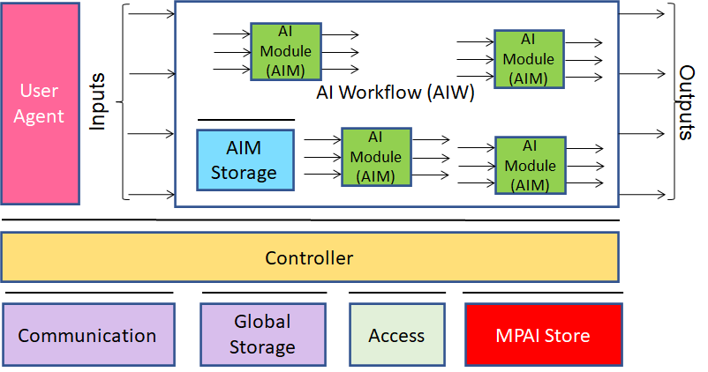
Figure 1 – The AI Framework (AIF) Reference Model and its Components

MPAI Application Standards normatively specify the Syntax and Semantics of the input and output data and the Function of the AIW and the AIMs, and the Connections between and among the AIMs of an AIW.
In particular, an AIM is defined by its Function and data, but not by its internal architecture, which may be based on AI or data processing, and implemented in software, hardware or hybrid software and hardware technologies.
MPAI Standards are designed to enable a User to obtain, via standard protocols, an Implementation of an AIW and of the set of corresponding AIMs and execute it in an AIF Implementation. The MPAI Store in Figure 1 is an entity from which Implementations are downloaded. MPAI Standards assume that the AIF, AIW, and AIM Implementations may have been developed by independent implementers. A necessary condition for this to be possible, is that any AIF, AIW, and AIM implementations be uniquely identified. MPAI has appointed an ImplementerID Registration Authority (IIDRA) to assign unique ImplementerIDs (IID) to Implementers.
A necessary condition to make possible the operations described in the paragraph above is the existence of an ecosystem composed of Conformance Testers, Performance Assessors, an instance of the IIDRA and of the MPAI Store. Reference [20] provides an informative example of such ecosystem.
The chapters and the annexes of this Technical Specification are Normative, unless they are labelled as Informative.

Scope of standard
The common characteristic shared by the MPAI-CAE Use Cases is the improvement of the user experience for audio-related applications including entertainment, communication, teleconferencing, gaming, post-production, restoration etc. in a variety of contexts such as in the home, in the car, on-the-go, in the studio etc. using context information to act on the input audio content, and potentially deliver the processed output via an appropriate protocol. These use cases are Emotion Enhanced Speech (EES), Audio Recording Preservation (ARP), Speech Restoration System (SSR), and Enhanced Audioconference Experience (EAE).
This version of the MPAI-CAE Technical Specification has been developed by the CAE-DC Development Committee. Future Versions may revise and/or extend the Scope of the Standard.

Emotion-Enhanced Speech (EES)
Speech carries information not only about its lexical content, but also about several other aspects including age, gender, identity, and emotional state of the speaker. Speech synthesis is evolving towards support of these aspects.
In many use cases, emotional force can usefully be added to speech which by default would be neutral or emotionless, possibly with grades of a particular emotion. For instance, in a human-machine dialogue, messages conveyed by the machine can be more effective if they carry emotions appropriately related to the emotions detected in the human speaker.
Emotion-Enhanced Speech (EES) enables a user to indicate a model utterance or an Emotion to obtain an emotionally charged version of a given utterance.
CAE-EES implementation can be used to create virtual agents communicating as naturally as possible, and thus improve the quality of human-machine interaction by bringing it closer to human-human interchange.

Audio Recording Preservation (ARP)
Preservation of audio assets recorded on analogue media is an important activity for a variety of application domains, in particular cultural heritage. Preservation goes beyond mere A/D conversion. For instance, the magnetic tape of an open reel may hold important information: it can carry annotations (by the composer or by the technicians) or it can include multiple splices and/or display several types of Irregularities (e.g., corruptions of the carrier, tape of different colour or chemical composition). This information shall be preserved for a correct playback. Nevertheless, some errors can occur during the digitisation as well as the digitisation could be partial because of the corruption of the carrier. These errors shall be restored to make the content listenable. The ARP Use Case (see 5.2) concerns the creation of a digital copy of the digitized audio of open reel magnetic tapes for long-term preservation and of an access copy (restored, if necessary) for correct playback of the digitized recording.

Speech Restoration System (SRS)
The goal of this use case is to restore a Damaged Segment of an Audio Segment containing only speech from a single speaker. The damage may affect the entire segment, or only part of it.
Restoration will not involve filtering or signal processing. Instead, replacements for the damaged vocal elements will be synthesised using a speech model. The latter is a component or set of components, normally including one or more neural networks, which accepts text and possibly other specifications, and delivers audible speech in a specified format – here, the speech of the required replacement or replacements. If the damage affects the entire segment, an entirely new segment is synthesized; if only parts are affected, corresponding segments will be synthesized individually to enable later integration into the undamaged parts of the Damaged Segment, with reference to appropriate Time Labels.
The speech segments necessary for the creation of the speech model can be flexibly resourced from undamaged parts of the input segment or from other recording sources that are consistent with the original segment’s acoustic environment.

Enhanced Audioconference Experience (EAE)
The user experience of a video/audio conference is very often far from satisfactory due to multiple competing speakers, non-ideal acoustical properties of the physical spaces that the speakers occupy and/or background noise. These can lead to a reduction in intelligibility of speech resulting in participants not fully understanding what their interlocutors are saying, in addition to creating a distraction and eventually leading to what is known as audioconference fatigue. When microphone arrays are used to capture the speakers, most of the described problems can be resolved by appropriate processing of the captured signals. The speech signals from multiple speakers can be separated from each other, the non-ideal acoustics of the space can be reduced and any background noise can be substantially suppressed.
Enhanced Audioconference Experience (EAE) aims to provide a complete solution to process speech signals recorded by microphone arrays to provide clear speech signals substantially free from background noise and acoustics-related artefacts to improve the auditory quality of audioconference experience.
The AIMs of the Enhanced Audioconference Experience (EAE) Use Case improve auditory experience in an audioconference, thereby reducing the effects of audioconference fatigue.

Human Connected Autonomous Vehicle (CAV) Interaction
A group of humans approach a Connected Autonomous Vehicle (CAV) in a noisy environment. At least one human should be recognised by his/her voice. All humans may hold a conversation with the CAV through the Human-CAV Interaction Subsystem (HCI), e.g., to request to be taken somewhere.
After they are let into the cabin, the humans sit on the seat. During the travel, they converse between themselves and potentially with the CAV. The HCI function separates the different speech sources to be able to participate in the conversation, e.g., to answer specific questions. The cabin, too, is assumed to be noisy.

Normative content of the Use Cases
Each Use Case normatively defines:
- The Functions of the AIW and of the AIMs.
- The Connections between and among the AIMs.
- The Semantics and the Formats of the input and output data of the AIW and the AIMs.
The word normatively implies that an Implementation claiming Conformance to:
- An AIW, shall:
  - Have the AIW Function specified in the appropriate Section of Chapter 4.2.
  - Have all its AIMs and their Connections conforming with the AIW Reference Model specified in the appropriate Section of Chapter 4.2.
  - The AIW and AIM input and output data should have the Formats specified in the appropriate Subsection of Section 6.3.
- An AIM, shall:
  - Have the AIM Function specified by the appropriate Section of Chapter 4.2.
  - Have input and output data Formats conforming with the appropriate Subsection of Section 6.3.
  - Receive as input and produce as output data having the Format specified in Section 6.3.
3. A data Format, the data shall have the Format specified in Section 6.3.
Users of this Technical Specification should note that:
- This Technical Specification defines Interoperability Levels but does not mandate any.
- Implementers are free to decide the Interoperability Level their Implementation should satisfy.
- Implementers can use the Reference Software specification to develop their Implementations.
- The Conformance Testing specification can be used to test the conformity of an Implementation to this Standard.
- Performance Assessors can assess the level of Performance of an Implementation based on the Performance Assessment specification of this Standard.
- The MPAI Ecosystem outlined in Annex 3 is governed by [1].
- Implementers and Users should consider the notices and disclaimers of Annex 2.

Terms and Definitions
The Terms used in this standard whose first letter is capital have the meaning defined in Table 1. The general MPAI Terms are defined in Table 25.

Table 1 – Table of terms and definitions

Term | Definition
Access Copy Files | Set of files providing the information stored in an audio tape recording, including Restored Audio Files, suitable for audio information access, but not for long-term preservation.
Audio | Digital representation of an analogue audio signal sampled at a frequency between 8-192 kHz with a number of bits/sample between 8 and 32.
Audio Block | A set of consecutive Audio samples.
Audio Channel | A sequence of Audio Blocks.
Audio File | A .wav file [6].
Audio Object | Direct audio source which is in the audible frequency band.
Audio Scene Geometry | Spatial information for the Audio Objects which are included in an audio scene.
Audio Segment | An Audio Block with Start Time and an End Time Labels corresponding to the time of the first and last sample of the Audio Segment, respectively.
Audio-Visual File | A file containing audio and video according to the MP4 File Format [10].
Capstan | The capstan is a rotating spindle used to move recording tape through the mechanism of a tape recorder.
Damaged List | A list of strings of Texts corresponding to the Damaged Segments (if any) requiring replacement with synthetic segments.
Damaged Section | An Audio Segment which is damaged in its entirety and is contained in a Damaged Segment.
Damaged Segment | An Audio Segment containing only speech (and not containing music or other sounds) which is either damaged in its entirety or contains one or more Damaged Sections specified in the Damaged List.
Degree | Strength of a feature, specifically, with respect to Emotion, “High,” “Medium,” or “Low.”
Editing List | The description of the speed, equalisation and reading backwards corrections occurred during the restoration process.
Emotion | One of the human emotions listed in Table 19, or in an augmented or alternate version of this Table 19.
Emotionless Speech | An Audio File containing speech without music and other sounds, and in which little or no identifiable emotion is perceptible by native listeners.
Interleaved Multichannel Audio | A data structure containing at least 2 time-aligned interleaved Audio Channels.
Irregularity | An event of interest to preservation from in Table 21 and Table 22
Irregularity File | A JSON file containing information about Irregularities of the ARP inputs.
Irregularity Image | An Image corresponding to an Irregularity.
JSON | JavaScript object notation [13].
Microphone Array Geometry | Description of the position of each microphone comprising the microphone array and specific characteristics such as microphone type, look directions, and the array type.
Model Utterance | An Audio Segment used as a model or demonstration of the Emotion to be added to Emotionless Speech in order to produce Speech with Emotion.
Multichannel Audio | A set of multiple time-aligned Audio Channels
Multichannel Audio + Audio Scene Geometry | Multichannel Audio packaged with Audio Scene Geometry.
Neural Network Speech Model | A Neural Network Model trained on Speech Segments for Modelling and used to synthesize replacements for the entire Damaged Segment or Damaged Sections within it.
Passthrough AIM | An AIM with the same input and output data of an AIM without executing the Function of that AIM. E.g., a Noise Cancellation AIM that does not cancel the noise.
Preservation Audio File | The input Audio File resulting from the digitisation of an audio open-reel tape to be preserved and, in case, restored.
Preservation Audio-Visual File | The input Audio-Visual File produced by a camera pointed to the playback head of the magnetic tape recorder and the synchronised Audio resulting from the tape digitisation process.
Preservation Image | A Video frame extracted from Preservation Audio-Visual File.
Preservation Master Files | Set of files providing the information stored in an audio tape recording without any restoration. As soon as the original analogue recordings is no more accessible, it becomes the new item for long-term preservation.
Restored Audio Files | Set of Audio Files derived from the Preservation Audio File, where potential speed, equalisation or reading backwards errors that occurred in the digitisation process have been corrected.
Restored Audio Segment | An Audio Segment in which the entire segment has been replaced by a synthetic speech segment, or in which each Damaged Segment has been replaced by a synthetic speech segment.
Speech Segments for Modelling | A set of Audio Files containing speech segments used to train the Neural Network Speech Model.
Speech With Emotion File | An Audio File containing speech with emotional features.
Spherical Coordinate System | A coordinate system where the position of a point is specified by three numbers: the radial distance of that point from a fixed origin, its polar angle measured from a fixed zenith direction, and the azimuthal angle of its orthogonal projection on a reference plane.
Spherical Grid Resolution | The maximum spherical angle between any two neighbouring sampled points on a sphere.
Time Code | Number of ms from 1970-01-01T00:00:00.000 according to [4].
Time Label | A measure of time from a context-dependent zero time expressed as HH:mm:ss.SSS.
Transform Audio | A frequency representation of Audio
Transform Denoised Speech | Transform Audio whose samples are Denoised Speech samples.
Useful Signal | Digital signal resulting from the A/D conversion of the analogue signal recorded in an audio tape.

References

Normative References
This standard normatively references the following technical specifications, both from MPAI and other standard organisations:
- MPAI; Technical Specification: Artificial Intelligence Framework (MPAI-AIF) V1; https://mpai.community/standards/mpai-aif/
- A Universally Unique IDentifier (UUID) URN Namespace; IETF RFC 4122; July 2005.
- Date and Time on the Internet: Time Stamps; IETF RFC 3339; July 2002.
- Universal Coded Character Set (UCS): ISO/IEC 10646; December 2020.
- ITU-R BS.2088-1 (10/2019) - Long-form file format for the international exchange of audio programme materials with metadata.
- ISO/IEC 14496-10; Information technology – Coding of audio-visual objects – Part 10: Advanced Video Coding.
- ISO/IEC 23008-2; Information technology – High efficiency coding and media delivery in heterogeneous environments – Part 2: High Efficiency Video Coding.
- ISO/IEC 23094-1; Information technology – General video coding – Part 1: Essential Video Coding.
- ISO/IEC 14496-12; Information technology – Coding of audio-visual objects – Part 12: ISO base media file format.
- ZIP format, https://pkware.cachefly.net/webdocs/casestudies/APPNOTE.TXT.
- Neural Network Exchange Format; https://www.khronos.org/registry/NNEF/specs/1.0/nnef-1.0.4.pdf; Khronos.
- The JavaScript Object Notation (JSON) Data Interchange Format; https://datatracker.ietf.org/doc/html/rfc8259; IETF rfc8259; December 2017.
- BS EN 60094-1:1994, BS 6288-1: 1994, IEC 94-1:1981 - Magnetic tape sound recording and reproducing systems - Part 1: Specification for general conditions and requirements.
- K. Bradley, IASA TC-04 Guidelines in the Production and Preservation of Digital Audio Objects: standards, recommended practices, and strategies., 2nd ed. International Association of Sound and Audiovisual Archives, (2009): 2014.
- MPAI; The MPAI Statutes; https://mpai.community/statutes/
- MPAI; The MPAI Patent Policy; https://mpai.community/about/the-mpai-patent-policy/.
- Framework Licence of the Context-based Audio Enhancement Technical Specification (MPAI-CAE); https://mpai.community/standards/mpai-cae/framework-licence/
- ITU-R BS.2088-1: Long-form file format for the international exchange of audio programme materials with metadata.
- ITU-T T-81: Information technology — Digital compression and coding of continuous-tone still images: Requirements and guidelines.

Informative References
The references provided here are for information purpose.
- MPAI; Technical Specification: The governance of the MPAI Ecosystem (MPAI-GME) V1.1; https://mpai.community/standards/mpai-gme/
- Ekman, Paul (1999), "Basic Emotions", in Dalgleish, T; Power, M (eds.), Handbook of Cognition and Emotion (PDF), Sussex, UK: John Wiley & Sons.
- B. Rafaely, Fundamentals of spherical array processing, Springer, 2018.
- MPAI; Connected Autonomous Vehicles; https://mpai.community/standards/mpai-cav/

Use Case Architectures

Emotion-Enhanced Speech (EES)

Scope of Use Case
Emotion-Enhanced Speech (EES) converts an individual emotionless speech segment to a segment that has a specified emotion. Both input and output speech segments are contained in files. The desired emotion is expressed either as a tag belonging to a standard list of emotions or derived by extracting features from a model utterance. EES produces an output speech segment with emotion.

I/O data
Table 2 gives the input and output data of Emotion-Enhanced Speech.

Table 2 – I/O data of Emotion-Enhanced Speech

Input data | Comments
Emotionless Speech | See definition in Table 1.
Emotion | See definition in Table 1.
Model Utterance | See definition in Table 1.
Output data | Comments
Speech with Emotion | See definition in Table 1.

Implementation Architecture
The Emotion-Enhanced Speech Reference Model depicted in Figure 2 supports two Modes or pathways enabling addition of emotional charge to an emotionless or neutral input utterance (Emotion-less Speech).
- Along Pathway 1 (Figure 2), upper and middle left), a Model Utterance is input together with the neutral utterance Emotion-less Speech, so that features of the former can be captured and transferred to the latter.
- Alternatively, along Pathway 2 (Figure 2), middle and lower left), neutral utterance Emotionless Speech is input along with a specification of the desired Emotion. Speech Feature Analyser2 extracts Emotionless Speech Features from Emotionless Speech, which describe its initial state. These are sent to Emotion Feature Producer, which produces (emotional) Speech Features2 that can add the desired emotional charge to Emotionless Speech. These Speech Features2 are sent to Emotion Inserter2, which combines Emotionless Speech and the (emotional) Speech Features2 set. Speech with Emotion is then produced as output.

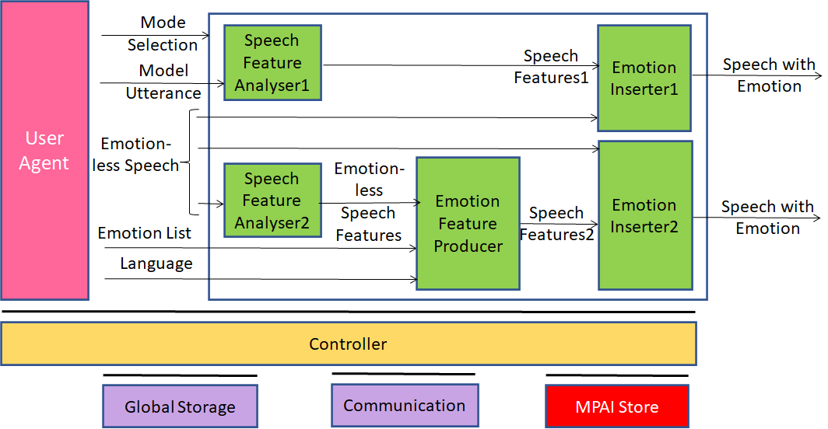

Figure 2 - Emotion-Enhanced Speech Reference Model

AI Modules
The AI Modules of Figure 2 perform the functions described in Table 3.

Table 3 – AI Modules of Emotion-Enhanced Speech

AIM | Function
Speech Feature Analyser 1 | Extracts Speech Features1 of a model emotional utterance and transfers them to the Emotion 1Inserter1.
Speech Feature Analyser2 | Extracts Emotionless Speech Features of an emotionless input utterance, passing these to Emotion Feature Producer.
Emotion Feature Producer | Receives the Emotionless Speech Features produced by Speech Feature Analyser2 plus a list of Emotions to be added. (If the Degree of an Emotion is not specified, the Medium value is used.)
Emotion Inserter1 | Integrates the (emotional) Speech Features1 with those of the Emotionless Speech input, yielding and delivering an emotionally modified utterance.
Emotion I2Inserter2 | Integrates the (emotional) Speech Features2 with those of the Emotionless Speech input, yielding and delivering an emotionally modified utterance.

Audio Recording Preservation (ARP)

Scope of Use Case
In this Audio Recording Preservation Use Case, two files are fed into a preservation system:
- A Preservation Audio File obtained by digitising the analogue tape audio recording composed of music, soundscape or speech read from a magnetic tape.
- A Preservation Audio-Visual File produced by a camera pointed to the playback head of the magnetic tape recorder.
The following is not required:
- Alignment of the start and end times of the two files. However, the maximum tolerated misalignment is 10s.
- Presence of signal at the start and the end of the two files.
- Alignment of the Useful Signal on both files.
- The same time base for both files. However, the time difference between the same samples in two files shall not be more than 30ms for a 1-hour audio tape.
The output of the restoration process is composed by:
- Preservation Master Files.
- Access Copy Files.

I/O data
Table 4 gives the input and output data of Audio Recording Preservation.

Table 4 – I/O data of Audio Recording Preservation

Input | Comments
Preservation Audio File | See 6.4.21
Preservation Audio-Visual File | See 6.4.22
Output data | Comments
Preservation Master Files | See 6.4.23
Access Copy Files | See 6.4.1

Implementation Architecture
Figure 3 depicts the Audio Recording Preservation Reference Model.

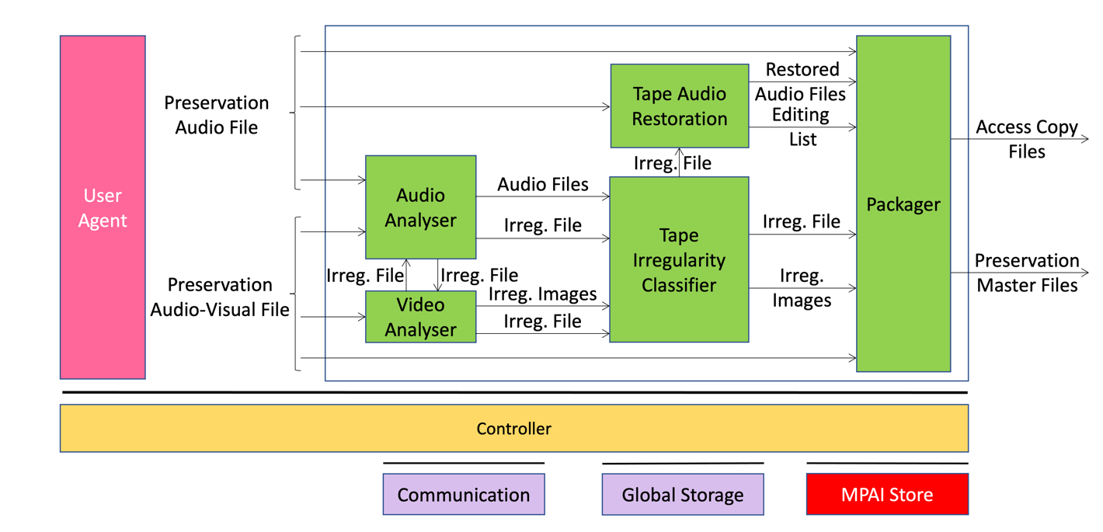

Figure 3 – Audio Recording Preservation Reference Model

The sequence of operations of the Audio Recording Preservation unfolds as follows:
- The analogue audio signal from the open-reel tape recorder is digitised as Preservation Audio File.
- The Preservation Audio-Visual File is the combination of:
  - The video camera pointed at the playback head of the open-reel tape recorder.
  - The analogue audio signal digitised with the same video clock.
- The Video Analyser:
  - Detects Irregularities.
  - Assigns IDs to them that are unique to the analysed open-reel tape.
  - Receives an Irregularity File from the Audio Analyser and the offset between Preservation Audio File and the Preservation Audio-Visual File.
  - Extracts the Irregularity Images corresponding to each Irregularity received or detected.
  - Sends the Irregularity Images and the Irregularity File related to all Irregularities to the Tape Irregularity Classifier.
- The Audio Analyser:
  - Detects Irregularities.
  - Assigns IDs to them that are unique to the analysed open-reel tape.
  - Receives an Irregularity File from the Video Analyser
  - Extracts the Audio Files corresponding to each Irregularity received or detected.
  - Sends the Audio Files and the Irregularity File related to all Irregularities to the Tape Irregularity Classifier.
- The Tape Irregularity Classifier:
  - Receives an Irregularity File with the corresponding Images and Audio Files.
  - Classifies and selects the ones considered relevant.
  - If the Irregularity was detected by the Video Analyser, the selected Irregularity File and the corresponding Irregularity Images are sent to the Packager.
- The Tape Audio Restoration uses the Irregularity File to identify and restore portions of the Preservation Audio File.
- The Packager collects the Preservation Audio File, Restored Audio Files, the Editing List, the Irregularity File and corresponding Irregularity Images if detected by the Video Analyser, and the Preservation Audio-Visual File and then it produces the Preservation Master Files and Access Copy Files.

AI Modules
The AIMs required by this Use Case are described in Table 5.

Table 5 – AI Modules of Audio Recording Preservation

AIM | Function
Audio Analyser | - At the start, it calculates the offset between Preservation Audio and the Audio of the Preservation Audio-Visual File.  - Detects Irregularities of the Preservation Audio File and produces the related Audio Files as well as the corresponding Irregularity File.  - Sends the Irregularity File related to detected Irregularities to the Video Analyser.  - Receives the Irregularity File detected by Video Analyser.  - Extracts Audio Files corresponding to the Irregularities detected by Video Analyser.  - At the end, it merges the produced Irregularity File with the one received from the Video Analyser, and it sends it with corresponding Audio Files to the Tape Irregularity Classifier.
Video Analyser | - At the start, it detects Irregularities of the Preservation Audio-Visual File and produces the related Irregularity Images.  - Sends the Irregularity File related to detected Irregularities to the Audio Analyser.  - Receives the Irregularity File from the Audio Analyser.  - Extracts the Irregularity Images corresponding to the Irregularities detected by Audio Analyser.  - At the end, it merges the produced Irregularity File with the one received from the Audio Analyser, and it sends it with the corresponding Irregularity Images to the Tape Irregularity Classifier.
Tape Irregularities classifier | - Receives all information from Audio Analyser and Video Analyser, classifies and selects the Irregularities of the Preservation Audio-Visual File and Preservation Audio File considered relevant.  - Sends the Irregularity File related to the selected Irregularities and the corresponding Irregularity Images to the Packager.  - Sends the Irregularity File related to the selected Irregularities to Tape Audio Restoration.
Audio Tape Restoration | - Detects and corrects speed, equalisation and reading backwards errors in Preservation Audio File.  - Sends Restored Audio Files and Editing List to Packager.
Packager | Produces Preservation Master Files and Access Copy Files.

Speech Restoration System (SRS)

Scope of Use Case
This Use Case addresses the need for restoration of a Damaged Segment, i.e., a segment containing speech which may be damaged in its entirety or only in part.
Restoration is carried out by synthesizing replacements for the damaged vocal elements as follows:
- If the damage affects the entire segment, restoration will be carried out by synthesizing an entirely new segment version.
- If the damage affects only parts of the segment, then those parts will be synthesized individually, and then integrated into the undamaged parts of the Damaged Segment in a final step, as indicated by appropriate Time Labels.
The Speech Segments for Modelling – Audio Segments necessary for the creation of the Neural Network Speech Model – may be obtained from any undamaged parts of the input speech segment; however, other Audio Segments consistent with the original segment’s sound environment can also be used.

I/O Data
Table 6 gives the input and output data of Speech Restoration System.

Table 6 – I/O data of Audio Recording Preservation

Input | Comments
Speech Segments for Modelling | See Table 1.
Text List | See Table 1.
Damaged List | See Table 1.
Damaged Segment | See Table 1.
Output | Comments
Restored Segment | See Table 1.

Implementation Architecture
The Reference Model of the Speech Restoration System is given by Figure 4
.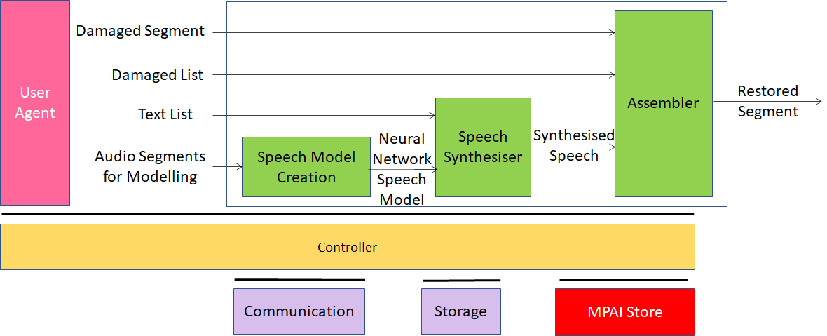

Figure 4 - Speech Restoration System (SRS) Reference Model

In the SRS use case, the entire Damaged Segment can be replaced by a synthesized segment, or parts within it can be synthesized to enable integration of the replaced segments.
The sequence of events in this Use Case is as follows:
- Speech Model Creation receives Audio Segments for Modelling, a set of recordings composing a corpus that will be used to train a Neural Network Speech Model in Speech Model Creation.
- That Neural Network Speech Model is passed to the Speech Synthesiser AIM, which also receives a Text List as input. Each element of Text List is a string specifying the text of a damaged section of Damaged Segment (or of Damaged Segment as a whole). Speech Synthesiser produces synthetic replacements for each damaged section (or for Damaged Segment as a whole) and passes the replacement(s) to Assembler.
- Assembler receives as input the entire Damaged Segment, plus Damaged List, a list indicating the locations of any damaged sections within Damaged Segment. The list will be null if Damaged Segment in its entirety was replaced.
- Assembler produces as output Restored Segment, in which any repaired sections have been replaced by synthetic sections, or in which the entire Damaged Segment has been replaced.

AI Modules
The AIMs required by the Speech Restoration System Use Case are described in Table 7

Table 7 - AI Modules of Audio Recording Preservation
AIM | Function
Speech Model Creation | - Receives in separate files the Audio Segments for Modelling, adequate for model creation.  - Creates the current Neural Network Speech Model.  - Sends that Neural Network Speech Model to the Speech Synthesiser.
Speech Synthesiser | - Receives the current Neural Network Speech Model.  - Receives Damaged List as a data structure:  - Containing one element if Damaged Segment is damaged throughout or  - Representing a list in which each element specifies via Time Labels the start and end of a damaged section within Damaged Segment.  - Synthesizes each Damaged Section in Damaged List.  - Sends the newly synthesised segments to the Assembler as an ordered list.
Assembler | - Receives the Damaged Segment.  - Receives the ordered list of synthetic segments.  - Receives Damaged List Time Labels, indicating where the synthesized segments should be inserted in left-to-right order. In case Damaged Segment as a whole was damaged, the list contains one entry.  - Assembles the final version of the Restored Segment.

Enhanced Audioconference Experience (EAE)

Scope of Use Case
The EAE use case addresses the situation where one or more speakers are active in a noisy meeting room and are trying to communicate with one or more interlocutors using speech over a network. The use case is concerned with extracting from microphone array recordings the speech signals from individual speakers as well as reducing the background noise and the reverberation that reduce speech quality. EAE also extracts the spatial attributes of the speakers with respect to the position of the microphone array to facilitate the spatial representation of the speech signals at the receiver side if necessary. These attributes are represented in a well-defined Audio Scene Geometry metadata format and packaged in a format that is amenable to further processing for efficient delivery and further processing. The coding and compression of the extracted speech signals as well as their reconstruction/representation at the receiver side are outside the scope of this use case.

I/O data
Table 8 shows the input and output data for the Enhanced Audioconference Experience workflow.

Table 8 – I/O data of Enhanced Audioconference Experience

Inputs | Comments
Microphone Array Audio | See 6.4.16
Microphone Array Geometry | See 6.4.17
Outputs | Comments
Multi-channel Audio + Audio Scene Geometry | See Table 1.

Implementation Architecture

Figure 5 shows the Workflow for the EAE.

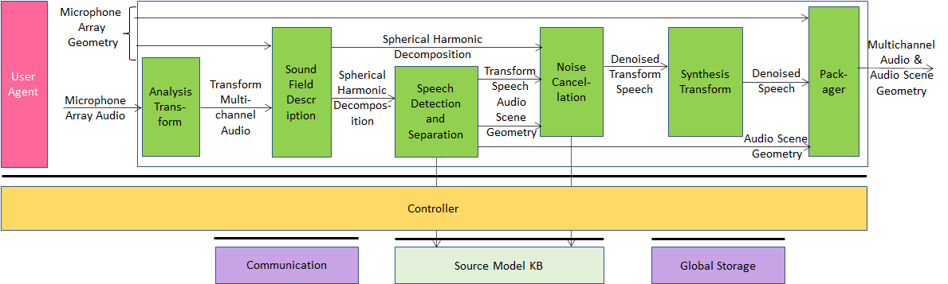

Figure 5 - Enhanced Audioconference Experience Reference Model
The EAE use case receives Microphone Array Audio and Microphone Array Geometry which describes the number, positioning, and configuration of the microphone(s). Using this information, the system can detect the relative directions of the active speakers according to the microphone array and separate relevant audioconference speech sources from each other and from other spurious sounds. Since audio conferencing is a real-time application scenario, the use case operates on Audio Blocks.
The Multichannel Audio is input to EAE as short Multichannel Audio Blocks comprising real valued time domain audio samples where the number of audio samples in each audio block is the same for all the microphones.
The sequence of operations of the EAE use case is the following:
- Analysis Transform transforms the Multichannel Audio into frequency bands via a Fast Fourier Transform (FFT). The following operations are carried out in discrete frequency bands. When such a configuration is used a 50% overlap between subsequent audio blocks needs to be employed. The output is a data structure comprising complex valued audio samples in the frequency domain.
- Sound Field Description converts the output from the Analysis Transform AIM into the spherical frequency domain [22]. If the microphone array used in capturing the scene is a spherical microphone array, Spherical Fourier Transform (SFT) can be used to obtain the Spherical Harmonic Decomposition (SHD) coefficients that represent the captured sound field in the spatial frequency domain. For other types of arrays, more elaborate processing might be necessary. The output of this AIM is (M × (N+1)2) complex valued data frame comprising the SHD coefficients up to an order which depends on the number of individual microphones in the array.
- Speech Detection and Separation receives the SHD coefficients of the sound field to detect directions of active sound sources and to separate them. Each separated source can either be a speech or a non-speech signal. Speech detection is carried out on an Audio Block basis by using on each separated source an appropriate voice activity detector (VAD) that is a part of this AIM. This AIM will output speech as an (M × S) Audio Block comprising transform domain speech signals and block-by-block the Audio Scene Geometry in JSON format comprising auxiliary information which contains a (M × 1) binary mask indicating the channels of the transform domain SHD coefficients that would be used by the Noise Cancellation AIM for denoising. Speech Detection and Separation AIM uses the Source Model KB which contains discrete-time and discrete-valued simple acoustic source models that are used in source separation.
- Noise Cancellation eliminates background noise and reverberation which reduce the audio quality. If environmental conditions do not substantially add ambient noise to the desired speech, this AIM acts as a Passthrough AIM.
  - It receives Transform Speech from Speech Detection and Separation AIM and Acoustic Scene Metadata which includes attributes pertaining to the Audio Block being processed for denoising, and SHD coefficients.
  - It uses Source Model KB. The output of Noise Cancellation AIM is Denoised Transform Speech as an (M × S) complex-valued data structure which will in the next stage be processed through Synthesis Transform AIM to obtain Denoised Speech.
- Synthesis Transform receives Denoised Transform Speech and outputs Denoised Transform Speech (F × S) by applying the inverse of the analysis transform.
- Packager:
  - Receives Denoised Speech and Audio Scene Geometry.
  - Packages the Multichannel Audio stream and the Audio Scene Geometry.
  - Produces one interleaved stream which contains separated Multichannel Speech Streams and Audio Scene Geometry.

AI Modules
The AIMs required by the Enhanced Audioconference Experience are given in Table 9.

Table 9 - AIMs of Enhanced Audioconference Experience
AIM | Function
Analysis Transform | Represents the input Multichannel Audio in a new form amenable to further processing by the subsequent AIMs in the architecture.
Sound Field Description | Produces Spherical Harmonic Decomposition of the Transformed Multichannel Audio.
Speech Detection and Separation | Separates speech and non-speech signals in the Spherical Harmonic Decomposition producing Transform Speech and Audio Scene Geometry.
Noise cancellation | Removes noise and/or suppresses reverberation in the Transform Speech producing Denoised Transform Speech.
Synthesis Transform | Effects inverse transform of Denoised Transform Speech producing Denoised Speech ready for packaging.
Packager | Packages Denoised Speech and the Audio Scene Geometry.

Human-Connected Autonomous Vehicle (CAV) Interaction

Scope of Use Case
This use case is part of the Connected Autonomous Vehicle (CAV) project [23]. A CAV is a system able to execute a command to move itself based on 1) analysis and interpretation of the data sensed by a range of onboard sensors exploring the environment and 2) information transmitted by other sources in range, e.g., other CAVs, traffic lights and roadside units.
Figure 6 depicts the four subsystems of a CAV.

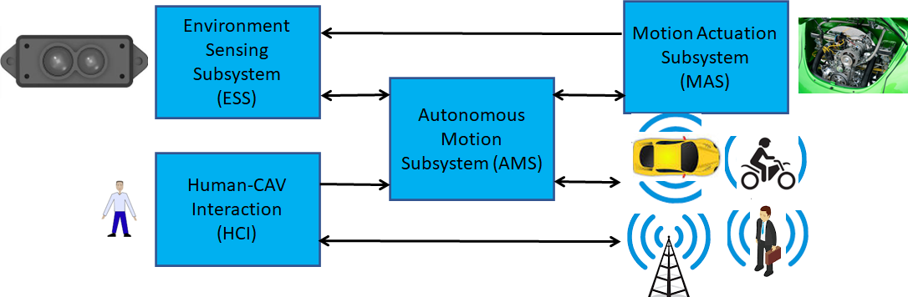
Figure 6 – The Connected Autonomous Vehicle Reference Model
- Human-CAV interaction (HCI) recognises the human owner or renter, responds to humans’ commands and queries, converses with humans during the travel and may activate other Subsystems in response to humans’ requests. The data exchanged between the HCI, and the Autonomous Motion Subsystem (AMS) is depicted in Figure 7 but the requirements of the format of the data exchanged between HCI and AMS are not part of this document.
- Environment Sensing Subsystem (ESS) acquires information from the Environment via a variety of sensors and produces a representation of the Environment (Basic Environment Representation), i.e., its best understanding of the Environment based on the sensed data.
- Autonomous Motion Subsystem (AMS) computes the route to destination, uses different sources of information – CAV sensors, other CAVs and transmitting units – to produce a Full Environment Representation and issues commands to drive the CAV to the intended destination.
- Motion Actuation Subsystem (MAS) provides non-electromagnetic and non-acoustical environment information¸ and receives and actuates motion commands in the physical world.
The CAV in Human-CAV Interaction is represented by an avatar with the following perceptible features:
- Visual: head, face, and shoulders.
- Audio: speech.
Both visual and audio features convey as much as possible the Personal Status that would be displayed by a human driver in similar conditions.

Reference architecture
Figure 7 represents the Human-CAV Interaction (HCI) Reference Model.
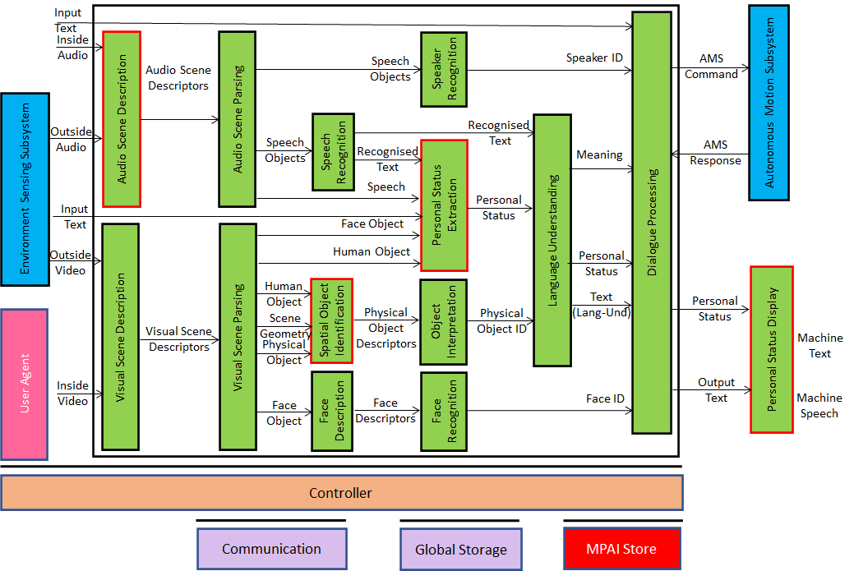
Figure 7 – Human-CAV Interaction Reference Model
The operation of HCI involves the following functions:
- A group of humans approaches the CAV outside the CAV:
  - The Audio Scene Description AIM creates the Audio Scene Description in the form of Audio (Speech) Objects corresponding to each speaking human in the Environment (close to the CAV).
  - The Visual Scene Description creates the Visual Scene Descriptors in the form of Human Objects with the possibility of extracting the Head and Face corresponding to each human in the Environment (close to the CAV).
  - The Speaker Recognition and Face Recognition AIMs authenticate the humans that the HCI is interacting with using Speech and Face Descriptors.
  - The Speech Recognition AIM recognises the speech of each human.
  - The Personal Status Extraction AIM extracts the Personal Status of the humans.
  - The Language Understanding AIM extracts Meaning and produces the refined Text (Language Understanding).
  - The Dialogue Processing AIM validates the human Identities, produces the response and displays the HCI Personal Status, and issues commands to the Autonomous Motion Subsystem.
- A group of humans sits in the seats inside the CAV:
  - The Audio Scene Description AIM creates the Audio Scene Descriptions in the form of Audio (Speech) Objects corresponding to each speaking human in the cabin.
  - The Visual Scene Description creates the Visual Scene Descriptors in the form of Human Objects with the possibility of extracting the Head and Face corresponding to each human in the cabin.
  - The Speaker Recognition and Face Recognition AIMs identify the humans the HCI is interacting with using Speech and Face Descriptors.
  - The Speech Recognition AIM recognises the speech of each human.
  - The Personal Status Extraction AIM extracts the Personal Status of the humans.
  - The Language Understanding AIM extracts Meaning and produces the refined Text (Language Understanding).
  - The Dialogue Processing AIM recognises the human Identities, produces the response and displays the HCI Personal Status, and issues commands to the Autonomous Motion Subsystem.
- The HCI interacts with the humans in the cabin in several ways:
  - By responding to commands/queries from one or more humans at the same time, e.g.:
    - Commands to go to a waypoint, park at a place, etc.
    - Commands with an effect in the cabin, e.g., turn off air conditioning, turn on the radio, call a person, open window or door, search for information etc.
Note: For completeness, Figure 7 includes the conversion of human commands and responses from the CAV. However, this document does not address the format in which the HCI interacts with the Autonomous Motion Subsystem.
  - By conversing with and responding to questions from one or more humans at the same time about travel-related issues (in-depth domain-specific conversation), e.g.:
    - Humans request information, e.g., time to destination, route conditions, weather at destination, etc.
    - CAV offers alternatives to humans, e.g., long but safe way, short but likely to have interruptions.
    - Humans ask questions about objects in the cabin.
  - By following the conversation on travel matters held by humans in the cabin if 1) the passengers allow the HCI to do so, and 2) the processing is carried out inside the CAV.

Specifications
This Use Case is shared by two other MPAI standards. MPAI-ARA [] addresses the avatar representation and animation part and MPAI-MMC [] addresses the conversational part. Personal Status Display is the Composite AIM for the former and Personal Status Extraction is a key Composite AIM for the latter.
This standard specifies the Audio Scene Description Composite AIM in Section 6.3.

AIMs

AIM Interoperability
To the extent possible, AIM input and output data are specified in a way that is neutral to the technology used to implement the AIM internals. In some cases, however, AIM input and output data of strongly depend on whether the technology used is data processing or Artificial Intelligence.
If an AIM is based on, e.g., a neural network, it will need either (1) a usable neural model whose training has included specifiable features, or (2) a precise specification of the features themselves plus an adequate training corpus, so that the AIM using that data can create its own usable model.

AIMs and their data

Emotion Enhanced Speech

Table 10 – CAE-EES AIMs and their data

AIM | Input Data | Output Data
Speech features Analyser1 | Model Utterance | Speech Features1
Speech features Analyser2 | Emotionless Speech | Emotionless Speech Features
Emotion Feature Producer | Emotionless Speech Features  Emotion List  Language | Speech Features2
Emotion Inserter1 | Emotionless Speech  Speech Features1 | Speech with Emotion
Emotion Inserter2 | Emotionless Speech  Speech Features2 | Speech with Emotion

Audio Recording Preservation (ARP)

Table 11 – CAE-ARP AIMs and their data

AIM | Input Data | Output Data
Audio Analyser | Preservation Audio File  Preservation Audio-Visual File  Irregularity File | Audio Files  Irregularity File
Video analyser | Preservation Audio-Visual File  Irregularity File | Irregularity File  Irregularity Images
Tape Irregularity classifier | Audio Files  Irregularity Images  Irregularity File | Irregularity File  Irregularity Images
Tape Audio Restoration | Irregularity File  Preservation Audio File | Editing List  Restored Audio Files
Packager | Preservation Audio File  Restored Audio Files  Editing List  Irregularity File  Irregularity Images  Preservation Audio-Visual File | Access Copy Files  Preservation Master Files

Speech Restoration System (SRS)

Table 12 – CAE-SRS AIMs and their data

AIM | Input Data | Output Data
Speech Model Creation | Audio Segments for Modelling | Neural Network Speech Model
Speech Synthesiser | Text List  Neural Network Speech Model | Synthesised Speech
Assembler | Damaged Segments  Damaged List | Restored Segment

Enhanced Audioconference Experience (EAE)

Table 13 – CAE-EAE AIMs and their data

AIM | Input Data | Output Data
Analysis Transform | Multichannel Audio | Transform Multichannel Audio
Sound field Description | Transform Multichannel Audio  Geometry Information | Spherical Harmonic Decomposition
Speech Detection and Separation | Spherical Harmonic Decomposition | Transform Speech  Audio Scene Geometry
Noise Cancellation | Spherical Harmonic Decomposition  Transform Speech  Audio Scene Geometry | Denoised Transform Speech
Synthesis Transform | Denoised Transform Speech | Denoised Speech
Packager | Denoised Speech  Audio Scene Geometry | Multichannel Audio  Audio Scene Geometry

Audio Scene Description Composite AIM

Scope
The Audio Scene Description Composite AIM receives Audio Data from the external and internal Microphone Arrays and produces the Audio Scene Description.

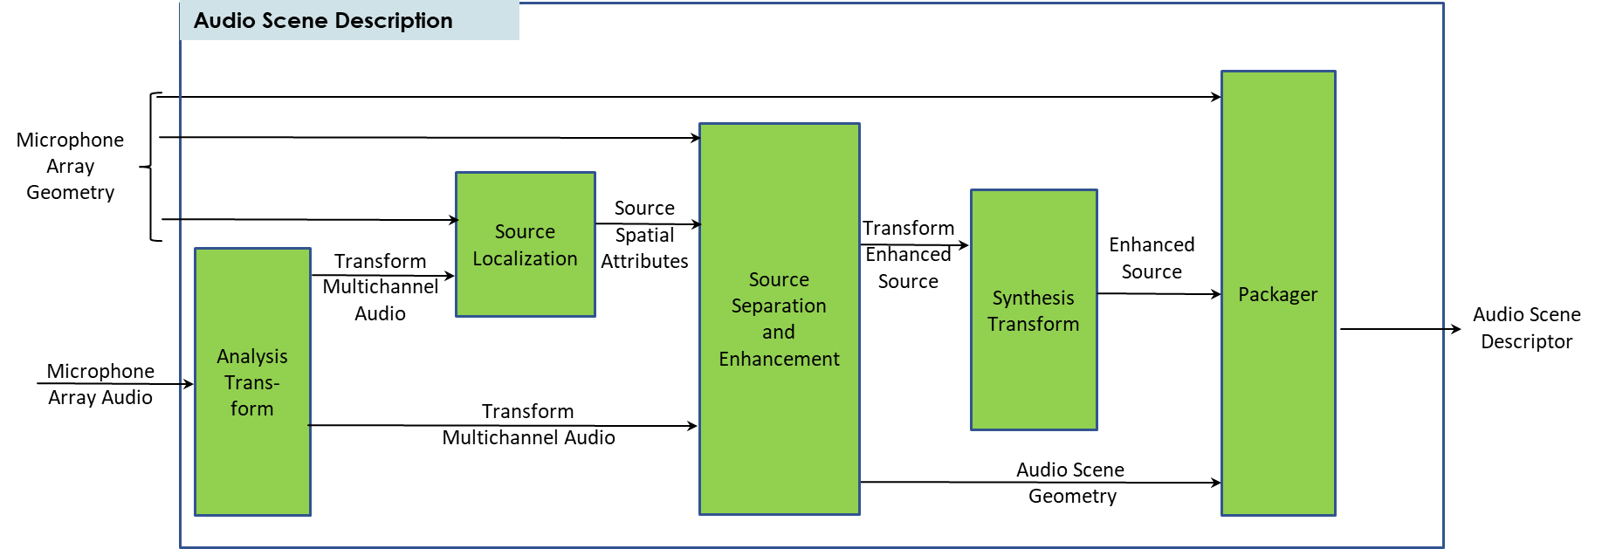

Reference architecture
Table 14 gives the input/output data of Audio Scene Description.

Table 14 – I/O data of Audio Scene Description

Input data | From | Comment
Outside Audio | Microphone Array | Environment Sensing Subsystem
Inside Audio | Microphone Array | Inside the cabin
Output data | To | Comments
Audio Scene Descriptors | Speech Description | For Authentication
 | Speech Recognition | For Text extraction
 | Personal Status Extraction | For Personal Status extraction

AI Modules
Table 15 gives the list of the AIMs with their functions.

Table 15 – AI Modules of Audio Scene Description

AIM | Function
Analysis Transform | transforms the Multichannel Audio into frequency bands via a Fast Fourier Transform (FFT). The following operations are carried out in discrete frequency bands. When such a configuration is used, a 50% overlap between subsequent audio blocks needs to be employed. The output is a data structure comprising complex valued audio samples in the frequency domain.
Source Localization | is an AIM to detect the audio sources in the audio scene with their spatial attributes. It receives Transform Multichannel Audio, and Microphone Array Geometry. Its output is Source Spatial Attributes.
Source Separation and Enhancement | is an AIM to separate the sources by using their spatial attributes. It receives Transform Multichannel Audio, Source Spatial Attributes and Microphone Array Geometry. Its outputs are Transform Enhanced Source and Audio Scene Geometry.
Synthesis Transform | transforms the Transform Enhanced Source into time domain via an Inverse Fast Fourier Transform (IFFT). It receives Transform Enhanced Source and outputs Enhanced Source by applying the inverse of the analysis transform.
Packager | receives Enhanced Source, Microphone Array Geometry and Audio Scene Geometry. It packages the Enhanced Source and the Audio Scene Geometry and then produces one interleaved stream which contains Audio Scene Descriptor.

6.3.4. Data formats

Table 16 – Audio Scene Description and their data

AIM | Input Data | Output Data
Analysis Transform | Microphone Array Audio | Transform Multichannel Audio
Source Localization | Transform Multichannel Audio  Microphone Array Geometry | Source Spatial Attributes
Source Separation and Enhancement | Source Spatial Attributes  Transform Multichannel Audio  Microphone Array Geometry | Transform Enhanced Source  Audio Scene Geometry
Synthesis Transform | Transform Enhanced Source | Enhanced Source
Packager | Enhanced Source  Audio Scene Geometry  Microphone Array Geometry | Audio Scene Descriptor

Data Formats
Table 17 lists all data formats specified in this Technical Specification.

Table 17 – Data formats

Data Format Name | Subsection | Use Case
Access Copy Files | 6.4.1 | ARP
Audio Block | 6.4.2 | EAE
Audio File | 6.4.3 | ARP
Audio Scene Geometry | 6.4.4 | EAE
Audio Scene Descriptor | 6.4.5 | ASD
Audio Segment | 6.4.6 | SRS
Damaged List | 6.4.7 | SRS
Denoised Speech | 6.4.8 | SRS
Editing List | 6.4.9 | ARP
Emotion | 6.4.10 | EES
Emotionless Speech | 6.4.11 | EES
Enhanced Source | 6.4.12 | ASD
Interleaved Multichannel Audio | 6.4.13 | EAE
Irregularity File | 6.4.14 | ARP
Irregularity Image | 6.4.15 | ARP
Microphone Array Audio | 6.4.16 | EAE, ASD
Microphone Array Geometry | 6.4.17 | EAE, ASD
Mode Selection | 6.4.18 | EES
Multichannel Audio | 6.4.19 | EAE
Neural Network Speech Model | 6.4.20 | SRS
Preservation Audio File | 6.4.21 | ARP
Preservation Audio-Visual File | 6.4.22 | ARP
Preservation Master Files | 6.4.23 | ARP
Source Dictionary | 6.4.24 | EAE
Source Model KB Query Format | 6.4.25 | EAE
Source Spatial Attributes | 6.4.26 | ASD
Speech Features1 | 6.4.27 | EES
Speech Features2 | 6.4.27 | EES
Spherical Harmonics Decomposition | 6.4.28 | EAE
Transform Denoised Speech | 6.4.29 | EAE
Transform Enhanced Source | 6.4.30 | ASD
Transform Speech | 6.4.31 | EAE
Transform Multichannel Audio | 6.4.32 | EAE, ASD
Video | 6.4.33 | ARP

Access Copy Files
The following set of files:
- The Restored Audio Files.
- Editing List.
- The set of Irregularity Images in a .zip file [11].
- The Irregularity File.

Audio Block
A set of consecutive samples without time code.

Audio File
A wave file conforming to WAV RF64 file format [19].

Audio Scene Geometry
Syntax and Semantics are given below

Syntax
{
"$schema": "http://json-schema.org/draft-07/schema#",
"title": "Audio Scene Geometry",
"type": "object",
"properties": {
"BlockIndex": {
"type": "integer"
},
"BlockStart": {
"type": "integer"
},
"BlockEnd": {
"type": "integer"
},
"SpeechCount": {
"type": "integer"
},
"SourceDetectionMask": {
"type": "array",
"items": {
"type": "uint8",
}
},
"SpeechList": {
"type": "array",
"items": {
"type": "object",
"properties": {
"SpeechID": {
"type":"string",
"format":"uuid"
},
"ChannelID": {
"type": "integer"
},
"AzimuthDirection": {
"type": "float"
},
"ElevationDirection": {
"type": "float"
},
"DistanceFlag": {
"type": "boolean",
},
"Distance": {
"type": "float"
}
}
},
"minItems": 1,
"uniqueItems": true,
"required": ["SpeechID","ChannelID","AzimuthDirection","ElevationDirection", "DistanceFlag","Distance" ]
}
},
"required": ["BlockIndex","BlockStart", "BlockEnd", "SpeechCount", "SourceDetectionMask", "SpeechList"]
}

Semantics
Name | Definition
BlockIndex | Block ID starting from 0 and incremented by 1 for each consecutive audio block processed by the system. (long integer)
BlockStart | Unix timestamp in ms from epoch. (long integer)
BlockEnd | Unix timestamp in ms from epoch. (long integer)
SpeechCount | Number of speech sources in the scene. (uint8)
SpeechList | A list containing Speech attributes.
SpeechList:Speech | A nested JSON block describing a speech source with the following elements.  SpeechID : Speech source ID ([7], uuid)  ChannelID : Channel ID (uint8)  AzimuthDirection: Azimuth direction in degrees. (float)  ElevationDirection: Elevation direction in degrees. (float)  Distance: Distance in m. (float32)  DistanceFlag: 0: Valid, 1: NonValid. (uint8)
SourceDetectionMask | A binary mask that represents the indices of the transform coefficients that will be used in denoising. (uint8)

Audio Scene Descriptor
Interleaved Multichannel Audio packaged with Time Code according to the structure of
Figure 12 specified in Table 23.

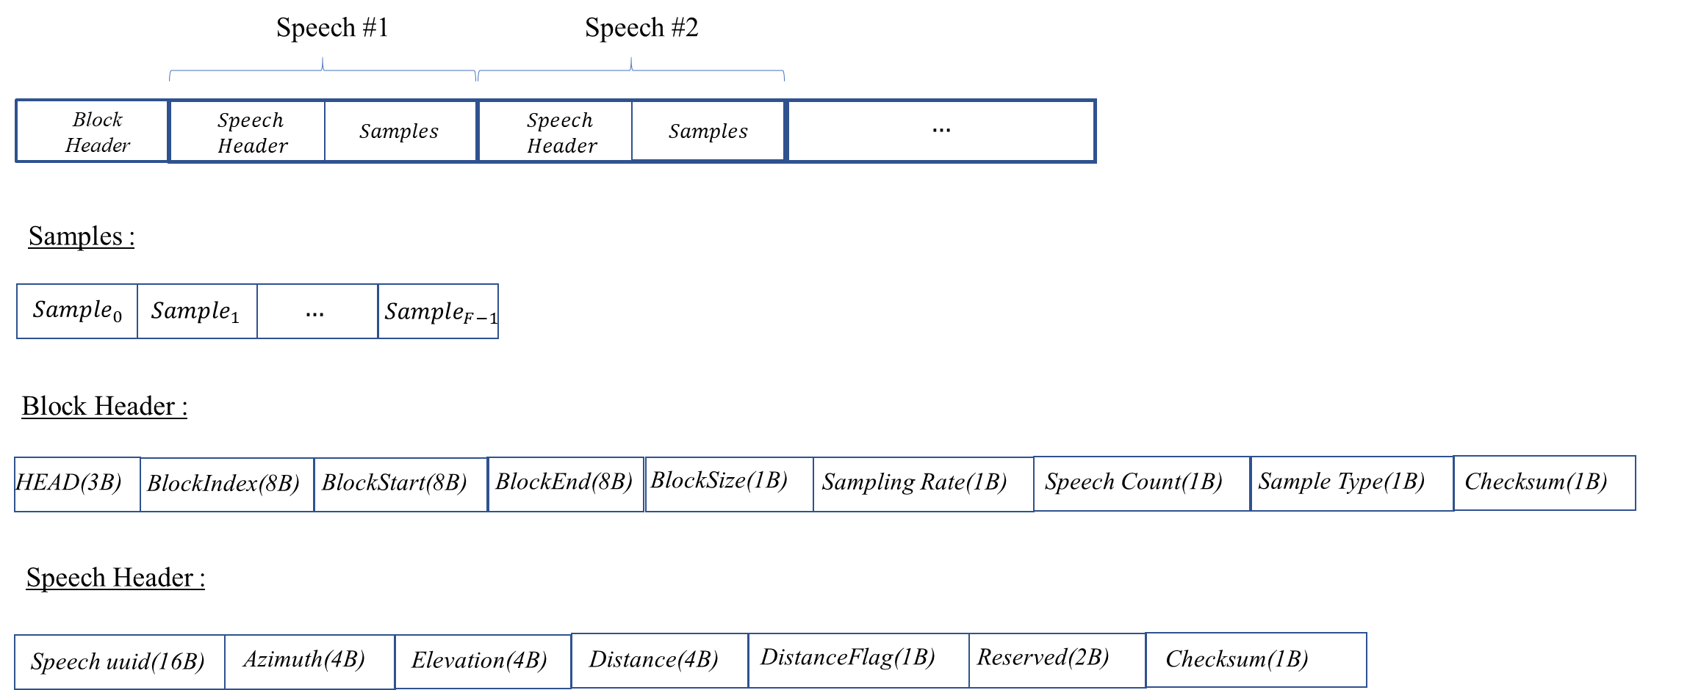

Figure 8 – Multichannel speech stream packages

Table 18 – Multichannel separated speech signals packaging

Label | Size | Description
HEAD | 3 Bytes | Comprises 3 characters ‘ASD’.
BlockIndex | 8 Bytes | Copy of the value BlockIndex in Audio Scene Geometry, indicating the timing order of the output block.
BlockStart | 8 Bytes | Copy of the value BlockStart in Audio Scene Geometry.
BlockEnd | 8 Bytes | Copy of the value BlockEnd in Audio Scene Geometry.
BlockSize | 1 Byte | Copy of the value BlockSize in Microphone Array Geometry.
Sampling Rate | 1 Byte | Copy of the value SamplingRate Microphone Array Geometry.
Speech Count | 1 Byte | Copy of the value SpeechCount in Audio Scene Geometry.
Sample Type | 1 Byte | Copy of the value SampleType in Microphone Array Geometry.
Checksum | 1 Byte | Checksum is calculated by summing the block and speech header bytes and taking its modulo by 256.
Speech uuid | 16 Bytes | Copy of the value Speech uuid in Audio Scene Geometry.
Azimuth | 4 Bytes | Copy of the value Speech:Azimuth in Audio Scene Geometry.
Elevation | 4 Bytes | Copy of the value Speech:Elevation in Audio Scene Geometry.
Distance | 4 Bytes | Copy of the value Speech:Distance in Audio Scene Geometry.
DistanceFlag | 1 Byte | Copy of the value Speech:DistanceFlag in Audio Scene Geometry.

Audio Segment
An Audio Block with Time Labels.

Damaged List
Syntax and Semantics are given below.

Syntax
{
"$schema": "http://json-schema.org/draft-07/schema#",
"title": "Damaged list",
"type": "object",
"properties": {
"DamagedSections": {
"type": "array",
"items": {
"type": "object",
"properties": {
"SegmentStart": {
"type":"string",
"pattern":"[0-9]{2}:[0-5][0-9]:[0-5][0-9]\\.[0-9]{3}"
},
"SegmentEnd": {
"type":"string",
"pattern":"[0-9]{2}:[0-5][0-9]:[0-5][0-9]\\.[0-9]{3}"
}
}
},
"minItems": 1,
"uniqueItems": true,
"required": ["SegmentStart","SegmentEnd"]
}
},
"required": ["DamagedSections"]
}

Semantics
Name | Definition
DamagedSections | A JSON array containing metadata description of Audio Segments within the given Damaged Segments.
SectionStart | Time Label of the beginning of the DamagedSection. (string)
SectionEnd | Time Label of the of the end of the DamagedSection. (string)

Denoised Speech
Interleaved Multichannel Audio where each channel contains time aligned denoised speech samples digitally represented with at least single precision floating point.

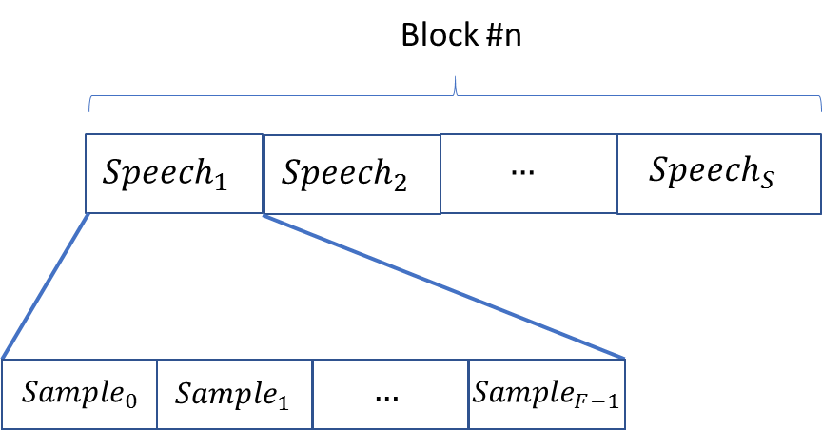

Figure 9 – Denoised speech signals after synthesis transform

Editing List
A JSON file encoded in UTF-8 according to [5].

Syntax
{
"$schema": "http://json-schema.org/draft-07/schema#",
"title": "Editing List",
"type": "object",
"properties": {
"OriginalSpeedStandard": {
"enum": [0.9375, 1.875, 3.75, 7.5, 15, 30]
},
"OriginalEqualisationStandard": {
"enum": ["IEC", "IEC1", "IEC2"]
},
"OriginalSamplingFrequency": {
"type": "integer"
},
"Restorations": {
"type": "array",
"items": {
"type": "object",
"properties": {
"RestorationID": {
"type": "string",
"format": "uuid"
},
"PreservationAudioFileStart": {
"type": "string",
"pattern": "[0-9]{2}:[0-5][0-9]:[0-5][0-9]\\.[0-9]{3}"
},
"PreservationAudioFileEnd": {
"type": "string",
"pattern": "[0-9]{2}:[0-5][0-9]:[0-5][0-9]\\.[0-9]{3}"
},
"RestoredAudioFileURI": {
"type": "string",
"format": "uri"
},
"ReadingBackwards": {
"type": "boolean"
},
"AppliedSpeedStandard": {
"enum": [0.9375, 1.875, 3.75, 7.5, 15, 30]
},
"AppliedSamplingFrequency": {
"type": "integer"
},
"AppliedEqualisationStandard": {
"enum": ["IEC", "IEC1", "IEC2"]
}
}
},
"minItems": 1,
"uniqueItems": true,
"required": ["RestorationID", "RestoredAudioFileURI", "PreservationAudioFileStart", "PreservationAudioFileEnd", "AppliedSamplingFrequency", "ReadingBackwards"]
}
},
"required": ["Restorations", "OriginalSamplingFrequency"]
}

Semantics
Name | Definition
OriginalSpeedStandard | Speed standard applied to the tape recorder during the digitisation of an open-reel tape. It can be one of the following values: 0.9375, 1.875, 3.75, 7.5, 15, 30. These values are in inch per seconds (ips). This field is optional.
OriginalEqualisationStandard | Equalisation standard applied to the tape recorder during the digitisation of an open-reel tape. It can be one of the following values: "IEC", "IEC1", "IEC2".  The notation refers to documents [14,15].  The association with OriginalSpeedStandard shall be compliant to the values indicated in [14,15].  This field is optional.
OriginalSamplingFrequency | UUID [3] that identifies a Restoration.
Restorations | List of restorations objects. Each object shall have at least the following fields: RestorationID, RestoredAudioFileURI, PreservationAudioFileStart, PreservationAudioFileEnd, AppliedSamplingFrequency, ReadingBackwards.
RestorationID | UUID [7] that identifies a Restoration.
PreservationAudioFileStart | Time Label indicating the instant of the Preservation Audio File when the restoration starts.
PreservationAudioFileEnd | Time Label indicating the instant of the Preservation Audio File when the restoration ends.
RestoredAudioFileURI | URI of a Restored Audio File.
ReadingBackwords | Boolean value indicating if the audio signal direction has been inverted during the restoration process.
AppliedSpeedStandard | Speed standard applied during the restoration process. It can be one of the following values: 0.9375, 1.875, 3.75, 7.5, 15, 30. These values are in inch per seconds (ips). This field is optional.
AppliedSamplingFrequency | Specifies the sampling frequency of the Restored Audio File. This field is mandatory.
AppliedEqualisationStandard | Equalisation standard applied during the restoration process. It can be one of the following values: "IEC", "IEC1", "IEC2".  The notation refers to documents [14,15].  The association with AppliedSpeedStandard shall be compliant to the values indicated in [14,15].

Emotion
The Syntax and Semantics of Emotion are given by the following clauses.

Syntax
Human Emotion is represented by.
{
"$schema":"http://json-schema.org/draft-07/schema",
"definitions":{
"emotionType":{
"type":"object",
"properties":{
"emotionDegree":{
"enum": ["High", "Medium", "Low"]
},
"emotionName":{
"type":"number"
},
"emotionSetName":{
"type":"string"
}
}
},
"type":"object",
"properties":{
"primary":{
"$ref":"#/definitions/emotionType"
},
"secondary":{
"$ref":"#/definitions/emotionType"
}
}
}

Semantics
Name | Definition
emotionType | Specifies the Emotion that the input carries.
emotionDegree | Specifies the Degree of Emotion as one of “Low,” “Medium,” and “High.”
emotionName | Specifies the ID of an Emotion listed in Table 19
emotionSetName | Specifies the name of the Emotion set which contains the Emotion. Emotion set of Table 19 is used as a baseline, but other sets are possible.

Emotions are expressed vocally through combinations of prosody (pitch, rhythm, and volume variations); separable speech effects (such as degrees of voice tension, breathiness, etc.); and vocal gestures (laughs, sobs, etc.).
Table 19 gives the MPAI standardised three-level Basic Emotion Set partly based on Paul Eckman [21]:
- The EMOTION CATEGORIES column specifies the categories using nouns.
- The GENERAL ADJECTIVAL column gives adjectival labels for general or basic emotions within a category.
- The SPECIFIC ADJECTIVAL column gives labels for more specific (sub-categorized) emotions in the relevant category, often (but not always) representing differing degrees of the basic emotion.
Table 20 provides the semantics for each label in the GENERAL ADJECTIVAL and SPECIFIC ADJECTIVAL columns.
An Implementer wishing to extend or replace Table 19 is requested to do the following:
- Create a new Table 19 where:
  - Proposed additions are clearly marked (in case of extension).
  - All Emotions and levels (up to 3) are listed (in case of replacement).
- Create a new Table 20 where:
  - the semantics of the Emotions is added to the semantics of the existing emotions (in case of extension).
  - is provided (in case of replacement).
The semantics provided should have a level of details comparable to the semantics given in the current Table 20
- Submit both tables to the MPAI Secretariat.
The appropriate MPAI Development Committee will examine the proposed extension or replacement. Only the adequacy of the proposed new tables in terms of clarity and completeness will be considered. In case the new tables are not clear or complete, a revision of the tables will be requested.
The accepted External Emotion Set will be identified as proposed by the submitter and reviewed by the appropriate MPAI Committee and posted to the MPAI web site.

Table 19 - Basic Emotion Set

EMOTION CATEGORIES | GENERAL ADJECTIVAL | SPECIFIC ADJECTIVAL
ANGER | anger | furious  irritated  frustrated
APPROVAL, DISAPPROVAL | admiring/approving  disapproving  indifferent | awed  contemptuous
AROUSAL | aroused/excited/energetic | cheerful  playful  lethargic  sleepy
ATTENTION | attentive | expectant/anticipating  thoughtful  distracted/absent-minded  vigilant  hopeful/optimistic
BELIEF | credulous | sceptical
CALMNESS | calm | peaceful/serene  resigned
DISGUST | disgust | loathing
FEAR | fearful/scared | terrified  anxious/uneasy
HAPPINESS | happy | joyful  content  delighted  amused
HURT | hurt  jealous
INTEREST | interested | fascinated  curious  bored
PRIDE/SHAME | proud  ashamed | guilty/remorseful/sorry  embarrassed
SADNESS | sad | lonely  grief-stricken  discouraged  depressed  disappointed
SOCIAL DOMINANCE, CONFIDENCE | arrogant  confident  submissive
SURPRISE | surprised | astounded  startled
UNDERSTANDING | comprehending | uncomprehending  bewildered/puzzled

Table 20 - Semantics of the Basic Emotion Set

ID | Emotion | Meaning
1 | admiring/approving | emotion due to perception that others' actions or results are valuable
2 | amused | positive emotion combined with interest (cognitive)
3 | anger | emotion due to perception of physical or emotional damage or threat
4 | anxious/uneasy | low or medium degree of fear, often continuing rather than instant
5 | aroused/excited/energetic | cognitive state of alertness and energy
6 | arrogant | emotion communicating social dominance
7 | astounded | high degree of surprised
8 | attentive | cognitive state of paying attention
9 | awed | approval combined with incomprehension or fear
10 | bewildered/puzzled | high degree of incomprehension
11 | bored | not interested
12 | calm | relative lack of emotion
13 | cheerful | energetic combined with and communicating happiness
14 | comprehending | cognitive state of successful application of mental models to a situation
15 | confident | emotion due to belief in ability
16 | contemptuous | high degree of disapproval
17 | content | medium or low degree of happiness, continuing rather than instant
18 | credulous | cognitive state of conformance to mental models of a situation
19 | curious | interest due to drive to know or understand
20 | delighted | high degree of happiness, often combined with surprise
21 | depressed | high degree of sadness, continuing rather than instant, combined with lethargy (see AROUSAL)
22 | disappointed | sadness due to failure of desired outcome
23 | disapproving | not approving
24 | discouraged | sadness combined with frustration
25 | disgust | emotion due to urge to avoid, often due to unpleasant perception or disapproval
26 | distracted/absent-minded | not attentive to present situation due to competing thoughts
27 | embarrassed | shame due to consciousness of violation of social conventions
28 | expectant/anticipating | attentive to (expecting) future event or events
29 | fascinated | high degree of interest
30 | fearful/scared | emotion due to anticipation of physical or emotional pain or other undesired event or events
31 | frustrated | angry due to failure of desired outcome
32 | furious | high degree of anger
33 | grief-stricken | sadness due to loss of an important social contact
34 | guilty/remorseful/sorry | shame due to consciousness of hurting or damaging others
35 | happy | positive emotion, often continuing rather than instant
36 | hopeful/optimistic | expectation of good outcomes
37 | hurt | emotion due to perception that others have caused social pain or embarrassment
38 | indifferent | neither approving nor disapproving
39 | interested | cognitive state of attentiveness due to salience or appeal to emotions or drives
40 | irritated | low or medium degree of anger
41 | jealous | emotion due to perception that others are more fortunate or successful
42 | joyful | high degree of happiness, often due to a specific event
43 | lethargic | not aroused
44 | loathing | high degree of disgust
45 | lonely | sadness due to insufficient social contact
46 | peaceful/serene | calm combined with low degree of happiness
47 | playful | energetic and communicating willingness to play
48 | proud | emotion due to perception of positive social standing
49 | resigned | calm due to acceptance of failure of desired outcome, often combined with low degree of sadness
50 | sad | negative emotion, often continuing rather than instant, often associated with a specific event
51 | sceptical | not credulous
52 | sleepy | not aroused due to need for sleep
53 | startled | surprised by a sudden event or perception
54 | submissive | emotion communicating lack of social dominance
55 | surprised | cognitive state due to violation of expectation
56 | terrified | high degree of fear
57 | thoughtful | attentive to thoughts
58 | uncomprehending | not comprehending
59 | vigilant | high degree of expectation or attentiveness

Emotionless Speech
An Audio File containing only speech in which music and other sounds are absent, and in which little or no identifiable emotion is perceptible by native listeners.

Enhanced Source

Multichannel Audio whose samples are Enhanced Source samples.

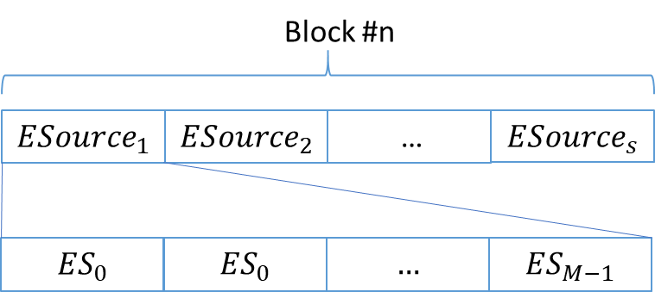

Figure 10 –Enhanced Speech

Interleaved Multichannel Audio
A data structure containing between 4 and 256 time-aligned interleaved Audio Channels and organised in blocks as depicted in Figure 11.

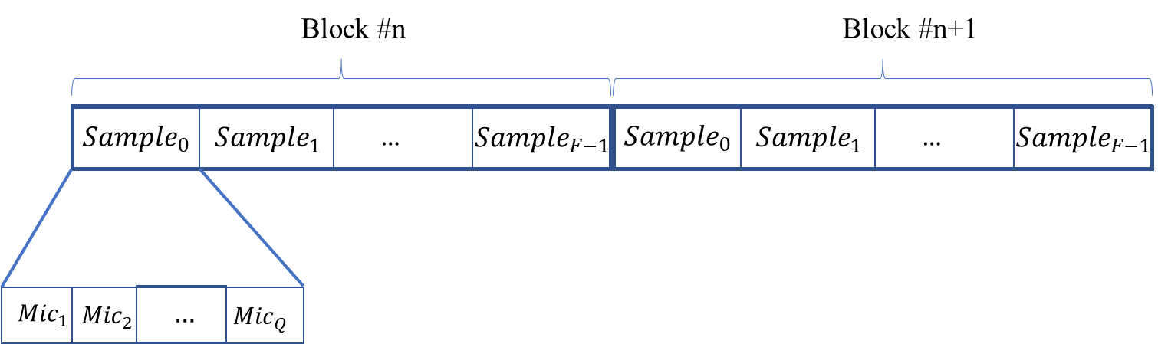

Figure 11 - Microphone Array Signals input sample ordering

Irregularity File
A JSON file encoded in UTF-8 according to [5].

Syntax
The JSON schema of the Irregularity File is:

{
"$schema": "http://json-schema.org/draft-07/schema#",
"title": "Irregularity File",
"type": "object",
"properties": {
"Offset": {
"type": "integer"
},
"Irregularities": {
"type": "array",
"items": {
"type": "object",
"properties": {
"IrregularityID": {
"type": "string",
"format": "uuid"
},
"Source": {
"enum": ["a", "v", "b"]
},
"TimeLabel": {
"type": "string",
"pattern": "[0-9]{2}:[0-5][0-9]:[0-5][0-9]\\.[0-9]{3}"
},
"IrregularityType": {
"enum": ["sp", "b", "sot", "eot", "da", "di", "m", "s", "wf", "pps", "ssv", "esv", "sb"]
},
"IrregularityProperties": {
"type": "object",
"properties": {
"ReadingSpeedStandard": {
"enum": [0.9375, 1.875, 3.75, 7.5, 15, 30]
},
"ReadingEqualisationStandard": {
"enum": ["IEC", "IEC1", "IEC2"]
},
"WritingSpeedStandard": {
"enum": [0.9375, 1.875, 3.75, 7.5, 15, 30]
},
"WritingEqualisationStandard": {
"enum": ["IEC", "IEC1", "IEC2"]
},
}
},
"ImageURI": {
"type": "string",
"format": "uri"
},
"AudioFileURI": {
"type": "string",
"format": "uri"
}
}
},
"minItems": 1,
"uniqueItems": true,
"required": ["IrregularityID", "Source", "TimeLabel"]
}
},
"required": ["Irregularities"]
}

Semantics

Name | Definition
Offset | Integer value indicating the time offset (in milliseconds) between Preservation Audio File and Preservation Audio-Visual File. The time reference is the Preservation Audio File.
Irregularities | Array of Irregularities. Each Irregularity shall have at least an IrregularityID, TimeLabel and TimeReference.
IrregularityID | UUID [7] that identifies an Irregularity.
Source | “a”: if the Irregularity is detected by the Audio Analyser.  “v”: if the Irregularity is detected by the Video Analyser.  “b”: if the Irregularity is detected by both Audio Analyser and Video Analyser.
TimeLabel | Time Label indicating the timing of an Irregularity. The time reference is the Preservation Audio File.
AudioFileURI | URI of the Audio File related to an Irregularity. It is only used in the message between Audio Analyser and Tape Irregularity Classifier.
IrregularityType | Class of an Irregularity (see values in following Tables).
IrregularityProperties | Optional object containing additional specifications about the current Irregularity.
ReadingSpeedStandard | Speed standard applied during the digitisation phase. It can be one of the following values: 0.9375, 1.875, 3.75, 7.5, 15, 30. These values are in inch per seconds (ips). This field is optional.
ReadingEqualisationStandard | Equalisation standard applied during the digitisation phase. It can be one of the following values: "IEC", "IEC1", "IEC2".  The notation refers to documents [14,15].  The association with ReadingSpeedStandard shall be compliant to the values indicated in [14,15]. This field is optional.
WritingSpeedStandard | Speed standard applied during the recording phase. It can be one of the following values: 0.9375, 1.875, 3.75, 7.5, 15, 30. These values are in inch per seconds (ips). This field is optional.
WritingEqualisationStandard | Equalisation standard applied during the recording phase. It can be one of the following values: "IEC", "IEC1", "IEC2".  The notation refers to documents [14,15].  The association with WritingSpeedStandard shall be compliant to the values indicated in [14,15]. This field is optional.
ImageURI | URI of the Image related to an Irregularity. It is only used in the messages between Audio Analyser, Tape Irregularity Classifier, and Packager.

Table 21 - Extended list of Irregularities that can be detected by the Video Analyser

Code | Name | Definition
sp | Splice | Splice of magnetic tape to magnetic tape, or leader tape to magnetic tape (or vice versa).
b | Brands on tape | Most of the brands consist of the full name of the tape manufacturer, logo, or tape model codes. The brand changes in size, shape, and colour, depending on the tape used.
sot | Start of tape | It refers to what happens when the tape playback starts, at which point it is neither under tension nor in contact with the capstan and pinch roller. The distinguishing visual characteristic of this class is the tape coming in tension and in contact with the capstan and pinch roller. This happens at the beginning of the Preservation Audio-Visual File.
eot | Ends of tape | It refers to what happens when the tape reaches its end of playback, at which point it is neither under tension nor in contact with the capstan and pinch roller. The distinguishing visual characteristic of this class is the tape coming free or completely detached from the capstan. This happens at the end of the Preservation Audio-Visual File.
da | Damaged tape | It groups all kinds of damages on the surface of the tape and alterations of the tape shape. This class includes:  - Ripples: this is formally known in the cataloguing rules as “kink” or “wrinkle”, these may be a single crease on a layer of tape or multiple creases in the tape.  - Cupping: an abnormal flexure of the tape surface across or along its width, due to different rates of shrinkage along the substrate and recording layers.  - Damage to tape edges, occurring when the edges do not appear flat or straight.
di | Dirt | Tape contamination and dirt: presence of mould, powder, crystals, other biological contaminations, or similar sullying.
m | Marks | Marks, signs or words written on the back of the tape (i.e., the nonmagnetic side) or on the adhesive tape of splices.
s | Shadows | The class contains frames in which shadows or reflections are temporarily cast on the tape by external objects in motion.
wf | Wow and flutter | Pitch variation due to the recording or playback equipment. If this effect is due to recording equipment it is detectable only on the Preservation Audio File and not on the Preservation Audio-Visual File.

Table 22 - List of Irregularities that can be detected only on the Preservation Audio File

Code | Name | Definition
pps | Play, pause and stop | Sound audio effects derived by play, pause or stop buttons during the recording. In a single tape several recordings from different sources can be recorded. This kind of irregularities cannot be identified in the digital video.
ssv | Speed standard variation | Instant when the recording has a variation of the speed (and, in case, of the equalization) standard.
esv | Equalization standard variation | Instant when the recording has a variation of the equalization standard without a change of the speed.
sb | Signal backward | Instant when a recording start playback audio signal backwards. This could happen in case of incorrect signal recording or digitization.

The Irregularities that could be identified in both audio and video are: sp, sot, eot, da, di, and wf.
Considering that Brands on tape are usually very frequent and repetitive, only one occurrence (usually the first one) is considered as a valid Irregularity by the Tape Irregularity Classifier.
Shadows has no impact on the signal. They should be considered because they can have an important impact on the classification, but they should not be included in the Preservation Master File.

Irregularity Image
JPEG file corresponding to an Irregularity conforming to [20].

Microphone Array Audio
Interleaved Multichannel Audio whose channels are sampled at a minimum of 5.33 ms (e.g., 256 samples at 48 kHz) to a maximum of 85.33 ms (e.g., 4096 samples at 48 kHz) and each sample is in single or double precision float.

Microphone Array Geometry
The Syntax and Semantics of the Microphone Array Geometry are given below.

Syntax
{
"$schema": "http://json-schema.org/draft-07/schema#",
"title": "Microphone Array Geometry",
"type": "object",
"properties": {
"MicrophoneArrayType": {
"type": "integer"
},
"MicrophoneArrayScat": {
"type": "integer"
},
"MicrophoneArrayFilterURI": {
"type": "string",
"format": "uri"
},
"SamplingRate": {
"type": "integer"
},
"SampleType": {
"type": "integer"
},
"BlockSize": {
"type": "integer"
},
"NumberofMicrophones": {
"type": "integer"
},
"MicrophoneList": {
"type": "array",
"items": {
"type": "object",
"properties": {
"xCoord": {
"type": "float"
},
"yCoord": {
"type": "float"
},
"zCoord": {
"type": "float"
},
"directivity": {
"type": "integer"
},
"micxLookCoord": {
"type": "float"
},
"micyLookCoord": {
"type": "float"
},
"miczLookCoord": {
"type": "float"
}
}
},
"minItems": 4,
"uniqueItems": true,
"required": ["xCoord", "yCoord", "zCoord", "directivity", "micxLookCoord", "micyLookCoord", "miczLookCoord"]
},
"MicrophoneArrayLookCoord": {
"type": "object",
"properties": {
"xLookCoord": {
"type": "float"
},
"yLookCoord": {
"type": "float"
},
"zLookCoord": {
"type": "float"
}
},
"uniqueItems": true,
"required": ["xLookCoord", "yLookCoord", "zLookCoord"]
}
},
"required": ["MicrophoneArrayType", "MicrophoneArrayScat", "MicrophoneArrayFilterURI", "SamplingRate", "SampleType", "BlockSize", "NumberofMicrophones", "MicrophoneList", "MicrophoneArrayLookCoord"]
}

Semantics
Name | Definition
MicrophoneArrayType | Indicates the type of microphone array positioning such as 0:Spherical, 1:Circular, 2:Planar, 3:Linear, 4:Other. (uint8)
MicrophoneArrayScat | Indicates the type of the microphone array (0:Rigid, 1:Open, 2:Other). (uint8)
MicrophoneArrayFilterURI | A uniform resource identifier (URI) string identifying the path to a local or remote file containing specific filter coefficients of the microphone array to be used for equalisation. (string)
SamplingRate | Sampling rate used by the microphone array (0:16kHz, 1:24kHz, 2:32kHz, 3:44.1kHz, 4:48kHz, 5:64kHz, 6:96kHz, 7:192kHz). (uint8)
SampleType | Sample type (0:16bit, 1:24bit, 2:32bit). (uint8)
BlockSize | Block Size (0:64,1:128,2:256,3:512,4:1024,5:2048, 6:4096). (uint8)
NumberofMicrophones | Represents the number of Microphones. (uint8)
MicrophoneList | A list containing Microphone attributes.
MicrophoneList:Microphone | A nested JSON block describing a single microphone element with the following elements.  xCoord: x position of the microphone in m. (float)  yCoord: y position of the microphone in m.(float)  zCoord: z position of the microphone in m. (float)  directivity: The directivity pattern of the specific microphone, 0: omnidirectional, 1: figure of eight, 2: cardioid, 3: supercardioid, 4: hypercardioid, 5: other (uint8)  micxLookCoord: x component of the vector representing the look direction of the microphone in m. (float)  micyLookCoord: y component of the vector representing the look direction of the microphone in m. (float)  miczLookCoord: z component of the vector representing the look direction of the microphone. (float)
MicrophoneArrayLookCoord | xLookCoord: x component of the vector representing the look direction of the microphone array. (float)  yLookCoord: y component of the vector representing the look direction of the microphone array. (float)  zLookCoord: z component of the vector representing the look direction of the microphone array. (float)

Mode Selection
In the EES use case, one of “Mode-1” or “Mode-2” indicating that Pathway 1 or Pathway 2, respectively, will be followed in adding emotion to Emotionless Speech. In Mode-1, a suitably configured Speech Feature Analyser1 module will capture emotional features from Model Utterance and transfer them to Emotionless Speech, thus producing Speech with Emotion. By contrast, in Mode-2, a suitable Speech Feature Analyser2 module will analyse Emotionless Speech and pass extracted Emotionless Speech Features along with a specification of the desired emotion to Emotion Feature Producer. These modules will produce (emotional) Speech Features2 and pass them to an Emotion Inserter2 module capable of combining Emotionless Speech and (emotional) Speech Features2 to produce Speech with Emotion. See Section 5.1.3.

Multichannel Audio Stream
Interleaved Multichannel Audio packaged with Time Code according to the structure of
Figure 12 specified in Table 23.

Figure 12 – Multichannel speech stream packages

Table 23 – Multichannel separated speech signals packaging

Label | Size | Description
HEAD | 3 Bytes | Comprises 3 characters ‘EAE’.
BlockIndex | 8 Bytes | Copy of the value BlockIndex in Metadata, indicating the timing order of the output block.
BlockStart | 8 Bytes | Copy of the value BlockStart in Metadata.
BlockEnd | 8 Bytes | Copy of the value BlockEnd in Metadata.
BlockSize | 1 Byte | Copy of the value BlockSize in Geometry Information.
Sampling Rate | 1 Byte | Copy of the value SamplingRate in Geometry Information.
Speech Count | 1 Byte | Copy of the value SpeechCount in Metadata.
Sample Type | 1 Byte | Copy of the value SampleType in Geometry Information.
Checksum | 1 Byte | Checksum is calculated by summing the block and speech header bytes and taking its modulo by 256.
Speech uuid | 16 Bytes | Copy of the value Speech uuid in Metadata.
Azimuth | 4 Bytes | Copy of the value Speech:Azimuth in Metadata.
Elevation | 4 Bytes | Copy of the value Speech:Elevation in Metadata.
Distance | 4 Bytes | Copy of the value Speech:Distance in Metadata.
DistanceFlag | 1 Byte | Copy of the value Speech:DistanceFlag in Metadata.

Neural Network Speech Model
A Neural Network Model trained on Speech Segments for Modelling and used to synthesize replacements for the entire Damaged Segment or Damaged Sections within it.
The Neural Network Speech Model is passed to Speech Synthesiser as a Khronos Neural Network Exchange Format [12].

Preservation Audio File
An Audio File containing Audio sampled at one of the following values 44.1, 48, 96, 192 kHz with 16 or 24 bits/sample.

Preservation Audio-Visual File
An Audio-Visual File containing:
- Video.
- Audio sampled at one of the following values 32, 44.1, 48 kHz with 16 or 24 bits/sample.

Preservation Master Files
The following set of files:
- Preservation Audio File.
- Preservation Audio-Visual File where the audio has been replaced with the Audio of the Preservation Audio File fully synchronised with the video.
- The set of Irregularity Images in a .zip file [11].
- The Irregularity File listing all detected Irregularities.

Source Dictionary
A dictionary of real-valued functions sampled on the sphere corresponding to plane wave acoustic sources [22]. The plane waves are localized at the nodes of a spherical grid with the first Spherical Grid Resolution, evaluated at the nodes of the spherical grid with the second Spherical Grid Resolution.

Source Model KB Query Format
The Source Model KB is a 2D Source Dictionary. It is queried with Spherical Grid Resolutions. The response is a 2D Source Dictionary.

Source Spatial Attributes
Syntax and Semantics are given below:

Syntax
{
"$schema": "http://json-schema.org/draft-07/schema#",
"title": "Audio Scene Geometry",
"type": "object",
"properties": {
"BlockIndex": {
"type": "integer"
},
"BlockStart": {
"type": "integer"
},
"BlockEnd": {
"type": "integer"
},
"SourceCount": {
"type": "integer"
},
"SourceDetectionMask": {
"type": "array",
"items": {
"type": "uint8",
}
},
"SourceList": {
"type": "array",
"items": {
"type": "object",
"properties": {
"SourceID": {
"type":"string",
"format":"uuid"
},
"ChannelID": {
"type": "integer"
},
"AzimuthDirection": {
"type": "float"
},
"ElevationDirection": {
"type": "float"
},
"Distance": {
"type": "float"
},
"DistanceFlag": {
"type": "boolean",
},
"Yaw": {
"type": "float"
},
"Pitch": {
"type": "float"
},
"Roll": {
"type": "float"
},
"OrientationFlag": {
"type": "boolean",
}

}
},
"minItems": 1,
"uniqueItems": true,
"required": ["SourceID","ChannelID","AzimuthDirection","ElevationDirection", "Distance","DistanceFlag","Yaw","Pitch","Roll","OrientationFlag" ]
}
},
"required": ["BlockIndex","BlockStart", "BlockEnd", "SourceCount", "SourceDetectionMask", "SourceList"]
}

Semantics
Name | Definition
BlockIndex | Block ID starting from 0 and incremented by 1 for each consecutive audio block processed by the system. (long integer)
BlockStart | Unix timestamp in ms from epoch. (long integer)
BlockEnd | Unix timestamp in ms from epoch. (long integer)
SourceCount | Number of speech sources in the scene. (uint8)
SourceList | A list containing Source attributes.
SourceList:Source | A nested JSON block describing a speech source with the following elements.  SpeechID : Speech source ID ([7], uuid)  ChannelID : Channel ID (uint8)  AzimuthDirection: Azimuth direction in degrees. (float)  ElevationDirection: Elevation direction in degrees. (float)  Distance: Distance in m. (float32)  DistanceFlag: 0: Valid, 1: NonValid. (uint8)  Yaw: Orientation yaw in degrees. (float)  Pitch: Orientation pitch in degrees. (float)  Roll: Orientation roll in degrees. (float32)  OrientationFlag: 0: Valid, 1: NonValid. (uint8)
SourceDetectionMask | A binary mask that represents the indices of the transform coefficients that will be used in denoising. (uint8)

Speech Features
Speech Features1 and Speech Features2 are digitally represented as follows.

{
"$schema": "http://json-schema.org/draft-07/schema",
"title": "SpeechFeatures1",
"type": "object",
"properties": {
"intonations": {
"type": "array",
"items": {
"type": "object",
"properties": {
"pitch": {
"type": "number"
},
"intensity": {
"type": "number"
},
"duration": {
"type": "number"
}
},
"required": ["pitch", "intensity", "duration"]
}
},
"unit": {
"type": "string"
},
},
"required": ["intonations", "unit"]
}

{
"$schema": "http://json-schema.org/draft-07/schema",
"title": "SpeechFeatures2",
"type": "array",
"items": {
"type": "number"
}
}

Semantics
Name | Definition
SpeechFeatures1 | Indicates intonation elements extracted from the input speech, specifically pitch, duration, and intensity.
SpeechFeatures2 | Indicates specifically neural-network-based characteristic elements extracted from the input speech by a Neural Network.
intonations | Vector representing an ordered sequence of elements, where each element is a triplet specifying the pitch, duration, and intensity of one linguistic unit. This vector starts at 0.0 ms.
pitch | Member of an element of intonations indicating the fundamental frequency in Hz (Hertz) of linguistic unit.
intensity | Member of an element of intonations indicating the energy of the linguistic unit perceived as loudness. Intensity is expressed as a real number in dBs (decibels).
duration | Member of an element of intonations indicating the length of linguistic units measured in milliseconds expressed as a real number.
unit | Specifies the linguistic unit. Here we are considering only “phonemes”.

Note: Table 24 lists some Basic Tones, e.g., “formal” or “informal,” with semantic characterisations of each. Elements can be added to the Basic Tone Set or new sets can be defined via the registration procedure specified in (6.4.9.2).

Table 24 – Basic Tones

TONE CATEGORIES | ADJECTIVAL | Semantics
FORMALITY | formal  informal | serious, official, polite  everyday, relaxed, casual
ASSERTIVENESS | assertive  factual  hesitant | certain about content  neutral about content  uncertain about content
REGISTER (per situation or use case) | conversational  directive | appropriate to informal speech  related to commands or requests for action

Spherical Harmonic Decomposition
The complex-valued spherical harmonics coefficients for each Transform Audio Block. $A_{l,m,real}(k)$ and $A_{l,m,imag}(k)$ represent the real and imaginary parts of the Spherical Harmonics Decomposition coefficient of order l and degree m corresponding to the k-th transform coefficient respectively.
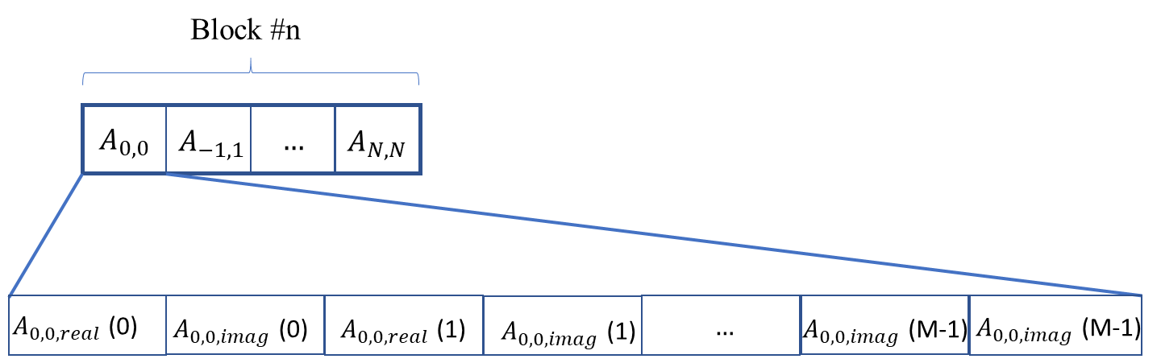

Figure 13 – Spherical Harmonics Decomposition of sound field

Transform Denoised Speech
Transform Audio whose samples are Denoised Speech samples.

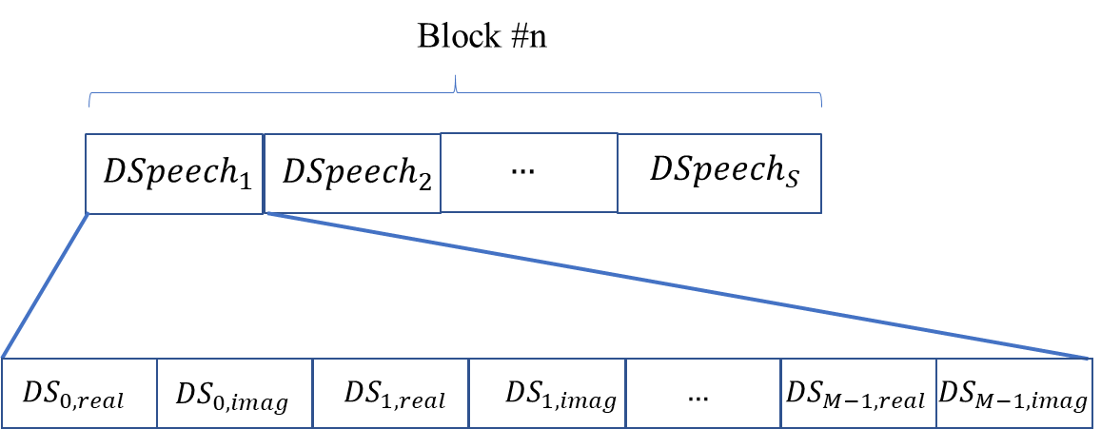

Figure 14 – Denoised transform domain speech signals

Transform Enhanced Source
Transform Audio whose samples are Transform Enhanced Source samples.

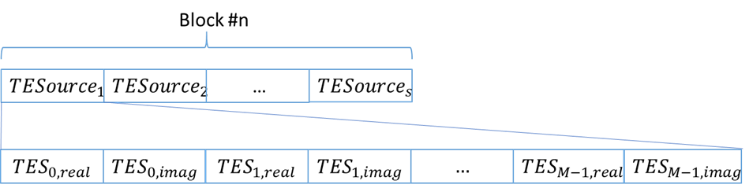

Figure 15 – Transform Enhanced Speech

Transform Speech
A data structure obtained by transforming Multichannel Audio containing speech and where the real and imaginary parts of the transformed data are represented as single or double precision floating point values.

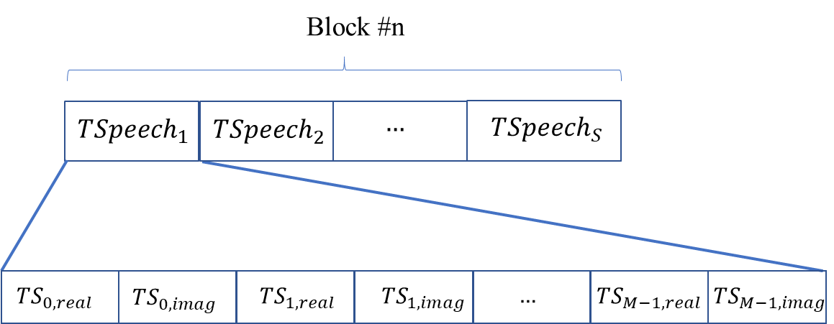

Figure 16 - Transform domain separated speech signals

Transform Multichannel Audio
A data structure obtained from the transformation of Microphone Array Audio.

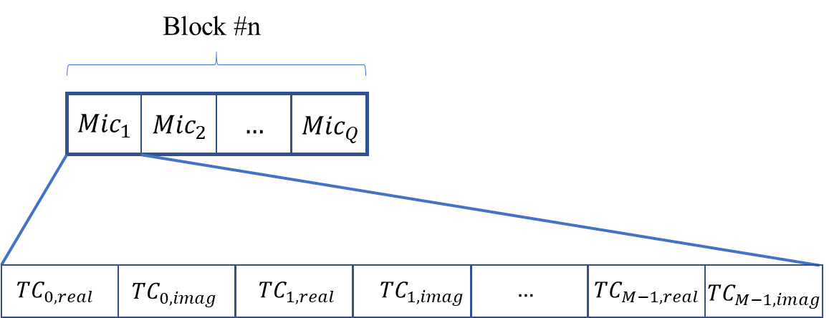

Figure 17 – Transform Multichannel Audio

Video
Video satisfies the following specifications:
- Pixel shape: square.
- Bit depth: 8 or 10 bits/pixel.
- Aspect ratio: 4/3 or 16/9.
- 640 < # of horizontal pixels < 1920.
- 480 < # of vertical pixels < 1080.
- Frame frequency 24-120 Hz.
- Scanning: progressive or interlaced.
- Colorimetry: ITU-R BT709 or BT2020.
- Colour format: RGB or YUV.
- Compression, either:
  - Uncompressed.
  - Compressed according to one of the following standards: MPEG-4 AVC [7], MPEG-H HEVC [8], MPEG-5 EVC [9].

- MPAI-wide terms and definitions (Normative)
The Terms used in this standard whose first letter is capital and are not already included in Table 1 are defined in Table 25.

Table 25 – MPAI-wide Terms

Term | Definition
Access | Static or slowly changing data that are required by an application such as domain knowledge data, data models, etc.
AI Framework (AIF) | The environment where AIWs are executed.
AI Workflow (AIW) | An organised aggregation of AIMs implementing a Use Case receiving AIM-specific Inputs and producing AIM-specific Outputs according to its Function.
AI Module (AIM) | A processing element receiving AIM-specific Inputs and producing AIM-specific Outputs according to according to its Function.
Application Standard | An MPAI Standard designed to enable a particular application domain.
Channel | A connection between an output port of an AIM and an input port of an AIM. The term “connection” is also used as synonymous.
Communication | The infrastructure that implements message passing between AIMs.
Composite AIM | An AIM aggregating more than one AIM.
Component | One of the 7 AIF elements: Access, Communication, Controller, Internal Storage, Global Storage, MPAI Store, and User Agent.
Composite AIM
Conformance | The attribute of an Implementation of being a correct technical Implementation of a Technical Specification.
Conformance Tester | An entity authorised by MPAI to Test the Conformance of an Implementation.
Conformance Testing | The normative document specifying the Means to Test the Conformance of an Implementation.
Conformance Testing Means | Procedures, tools, data sets and/or data set characteristics to Test the Conformance of an Implementation.
Connection | A channel connecting an output port of an AIM and an input port of an AIM.
Controller | A Component that manages and controls the AIMs in the AIF, so that they execute in the correct order and at the time when they are needed.
Data Format | The standard digital representation of data.
Data Semantics | The meaning of data.
Ecosystem | The ensemble of the following actors: MPAI, MPAI Store, Implementers, Conformance Testers, Performance Testers and Users of MPAI-AIF Implementations as needed to enable an Interoperability Level.
Explainability | The ability to trace the output of an Implementation back to the inputs that have produced it.
Fairness | The attribute of an Implementation whose extent of applicability can be assessed by making the training set and/or network open to testing for bias and unanticipated results.
Function | The operations effected by an AIW or an AIM on input data.
Global Storage | A Component to store data shared by AIMs.
Internal Storage | A Component to store data of the individual AIMs.
Identifier | A name that uniquely identifies an Implementation.
Implementation | - An embodiment of the MPAI-AIF Technical Specification, or  - An AIW or AIM of a particular Level (1-2-3) conforming with a Use Case of an MPAI Application Standard.
Implementer | A legal entity implementing MPAI Technical Specifications.
ImplementerID (IID) | A unique name assigned by the ImplementerID Registration Authority to an Implementer.
ImplementerID Registration Authority (IIDRA) | The function within the MPAI Store to assign ImplementerID’s to Implementers.
Interoperability | The ability to functionally replace an AIM with another AIM having the same Interoperability Level.
Interoperability Level | The attribute of an AIW and its AIMs to be executable in an AIF Implementation and to:  - Be proprietary (Level 1).  - Pass the Conformance Testing (Level 2) of an Application Standard.  - `Pass the Performance Testing (Level 3) of an Application Standard.
Knowledge Base | Structured and/or unstructured information made accessible to AIMs via MPAI-specified interfaces.
Message | A sequence of Records transported by Communication through Channels.
Normativity | The set of attributes of a technology or a set of technologies specified by the applicable parts of an MPAI standard.
Performance | The attribute of an Implementation of being Reliable, Robust, Fair and Replicable.
Performance Assessment | The normative document specifying the procedures, the tools, the data sets and/or the data set characteristics to Assess the Grade of Performance of an Implementation.
Performance Assessment Means | Procedures, tools, data sets and/or data set characteristics to Assess the Performance of an Implementation.
Performance Assessor | An entity authorised by MPAI to Assess the Performance of an Implementation in a given Application domain.
Profile | A particular subset of the technologies used in MPAI-AIF or an AIW of an Application Standard and, where applicable, the classes, other subsets, options and parameters relevant to that subset.
Record | A data structure with a specified structure.
Reference Model | The AIMs and theirs Connections in an AIW.
Reference Software | A technically correct software implementation of a Technical Specification containing source code, or source and compiled code.
Reliability | The attribute of an Implementation that performs as specified by the Application Standard, profile and version the Implementation refers to, e.g., within the application scope, stated limitations, and for the period of time specified by the Implementer.
Replicability | The attribute of an Implementation whose Performance, as Assessed by a Performance Assessor, can be replicated, within an agreed level, by another Performance Assessor.
Robustness | The attribute of an Implementation that copes with data outside of the stated application scope with an estimated degree of confidence.
Service Provider | An entrepreneur who offers an Implementation as a service (e.g., a recommendation service) to Users.
Standard | The ensemble of Technical Specification, Reference Software, Conformance Testing and Performance Assessment of an MPAI application Standard.
Technical Specification | (Framework) the normative specification of the AIF.  (Application) the normative specification of the set of AIWs belonging to an application domain along with the AIMs required to Implement the AIWs that includes:  - The formats of the Input/Output data of the AIWs implementing the AIWs.  - The Connections of the AIMs of the AIW.  - The formats of the Input/Output data of the AIMs belonging to the AIW.
Testing Laboratory | A laboratory accredited by MPAI to Assess the Grade of Performance of Implementations.
Time Base | The protocol specifying how Components can access timing information.
Topology | The set of AIM Connections of an AIW.
Use Case | A particular instance of the Application domain target of an Application Standard.
User | A user of an Implementation.
User Agent | The Component interfacing the user with an AIF through the Controller.
Version | A revision or extension of a Standard or of one of its elements.
Zero Trust | A model of cybersecurity primarily focused on data and service protection that assumes no implicit trust.

- Notices and Disclaimers Concerning MPAI Standards (Informative)
The notices and legal disclaimers given below shall be borne in mind when downloading and using approved MPAI Standards.

In the following, “Standard” means the collection of four MPAI-approved and published documents: “Technical Specification”, “Reference Software” and “Conformance Testing” and, where applicable, “Performance Testing”.

Life cycle of MPAI Standards
MPAI Standards are developed in accordance with the MPAI Statutes. An MPAI Standard may only be developed when a Framework Licence has been adopted. MPAI Standards are developed by especially established MPAI Development Committees who operate on the basis of consensus, as specified in Annex 1 of the MPAI Statutes. While the MPAI General Assembly and the Board of Directors administer the process of the said Annex 1, MPAI does not independently evaluate, test, or verify the accuracy of any of the information or the suitability of any of the technology choices made in its Standards.

MPAI Standards may be modified at any time by corrigenda or new editions. A new edition, however, may not necessarily replace an existing MPAI standard. Visit the web page to determine the status of any given published MPAI Standard.

Comments on MPAI Standards are welcome from any interested parties, whether MPAI members or not. Comments shall mandatorily include the name and the version of the MPAI Standard and, if applicable, the specific page or line the comment applies to. Comments should be sent to the MPAI Secretariat. Comments will be reviewed by the appropriate committee for their technical relevance. However, MPAI does not provide interpretation, consulting information, or advice on MPAI Standards. Interested parties are invited to join MPAI so that they can attend the relevant Development Committees.

Coverage and Applicability of MPAI Standards
MPAI makes no warranties or representations concerning its Standards, and expressly disclaims all warranties, expressed or implied, concerning any of its Standards, including but not limited to the warranties of merchantability, fitness for a particular purpose, non-infringement etc. MPAI Standards are supplied “AS IS”.

The existence of an MPAI Standard does not imply that there are no other ways to produce and distribute products and services in the scope of the Standard. Technical progress may render the technologies included in the MPAI Standard obsolete by the time the Standard is used, especially in a field as dynamic as AI. Therefore, those looking for standards in the Data Compression by Artificial Intelligence area should carefully assess the suitability of MPAI Standards for their needs.

IN NO EVENT SHALL MPAI BE LIABLE FOR ANY DIRECT, INDIRECT, INCIDENTAL, SPECIAL, EXEMPLARY, OR CONSEQUENTIAL DAMAGES (INCLUDING, BUT NOT LIMITED TO: THE NEED TO PROCURE SUBSTITUTE GOODS OR SERVICES; LOSS OF USE, DATA, OR PROFITS; OR BUSINESS INTERRUPTION) HOWEVER CAUSED AND ON ANY THEORY OF LIABILITY, WHETHER IN CONTRACT, STRICT LIABILITY, OR TORT (INCLUDING NEGLIGENCE OR OTHERWISE) ARISING IN ANY WAY OUT OF THE PUBLICATION, USE OF, OR RELIANCE UPON ANY STANDARD, EVEN IF ADVISED OF THE POSSIBILITY OF SUCH DAMAGE AND REGARDLESS OF WHETHER SUCH DAMAGE WAS FORESEEABLE.

MPAI alerts users that practicing its Standards may infringe patents and other rights of third parties.
Submitters of technologies to this standard have agreed to licence their Intellectual Property according to their respective Framework Licences.

Users of MPAI Standards should consider all applicable laws and regulations when using an MPAI Standard. The validity of Conformance Testing is strictly technical and refers to the correct implementation of the MPAI Standard. Moreover, positive Performance Assessment of an implementation applies exclusively in the context of the MPAI Governance and does not imply compliance with any regulatory requirements in the context of any jurisdiction. Therefore, it is the responsibility of the MPAI Standard implementer to observe or refer to the applicable regulatory requirements. By publishing an MPAI Standard, MPAI does not intend to promote actions that are not in compliance with applicable laws, and the Standard shall not be construed as doing so. In particular, users should evaluate MPAI Standards from the viewpoint of data privacy and data ownership in the context of their jurisdictions.

Implementers and users of MPAI Standards documents are responsible for determining and complying with all appropriate safety, security, environmental and health and all applicable laws and regulations.

Copyright
MPAI draft and approved standards, whether they are in the form of documents or as web pages or otherwise, are copyrighted by MPAI under Swiss and international copyright laws. MPAI Standards are made available and may be used for a wide variety of public and private uses, e.g., implementation, use and reference, in laws and regulations and standardisation. By making these documents available for these and other uses, however, MPAI does not waive any rights in copyright to its Standards. For inquiries regarding the copyright of MPAI standards, please contact the MPAI Secretariat.

The Reference Software of an MPAI Standard is released with the MPAI Modified Berkeley Software Distribution licence. However, implementers should be aware that the Reference Software of an MPAI Standard may reference some third party software that may have a different licence.

- The Governance of the MPAI Ecosystem (Informative)
Level 1 Interoperability
With reference to Figure 1, MPAI issues and maintains a standard – called MPAI-AIF – whose components are:
- An environment called AI Framework (AIF) running AI Workflows (AIW) composed of interconnected AI Modules (AIM) exposing standard interfaces.
- A distribution system of AIW and AIM Implementation called MPAI Store from which an AIF Implementation can download AIWs and AIMs.
A Level 1 Implementation shall be an Implementation of the MPAI-AIF Technical Specification executing AIWs composed of AIMs able to call the MPAI-AIF APIs.

Implementers’ benefits | Upload to the MPAI Store and have globally distributed Implementations of  - AIFs conforming to MPAI-AIF.  - AIWs and AIMs performing proprietary functions executable in AIF.
Users’ benefits | Rely on Implementations that have been tested for security.
MPAI Store | - Tests the Conformance of Implementations to MPAI-AIF.  - Verifies Implementations’ security, e.g., absence of malware.  - Indicates unambiguously that Implementations are Level 1.

Level 2 Interoperability
In a Level 2 Implementation, the AIW shall be an Implementation of an MPAI Use Case, and the AIMs shall conform with an MPAI Application Standard.

Implementers’ benefits | Upload to the MPAI Store and have globally distributed Implementations of  - AIFs conforming to MPAI-AIF.  - AIWs and AIMs conforming to MPAI Application Standards.
Users’ benefits | - Rely on Implementations of AIWs and AIMs whose Functions have been reviewed during standardisation.  - Have a degree of Explainability of the AIW operation because the AIM Functions and the data Formats are known.
Market’s benefits | - Open AIW and AIM markets foster competition leading to better products.  - Competition of AIW and AIM Implementations fosters AI innovation.
MPAI Store’s role | - Tests Conformance of Implementations with the relevant MPAI Standard.  - Verifies Implementations’ security.  - Indicates unambiguously that Implementations are Level 2.

Level 3 Interoperability
MPAI does not generally set standards on how and with what data an AIM should be trained. This is an important differentiator that promotes competition leading to better solutions. However, the performance of an AIM is typically higher if the data used for training are in greater quantity and more in tune with the scope. Training data that have large variety and cover the spectrum of all cases of interest in breadth and depth typically lead to Implementations of higher “quality”.
For Level 3, MPAI normatively specifies the process, the tools and the data or the characteristics of the data to be used to Assess the Grade of Performance of an AIM or an AIW.

Implementers’ benefits | May claim their Implementations have passed Performance Assessment.
Users’ benefits | Get assurance that the Implementation being used performs correctly, e.g., it has been properly trained.
Market’s benefits | Implementations’ Performance Grades stimulate the development of more Performing AIM and AIW Implementations.
MPAI Store’s role | - Verifies the Implementations’ security.  - Indicates unambiguously that Implementations are Level 3.

The MPAI ecosystem
The following Figure 18 is a high-level description of the MPAI ecosystem operation applicable to fully conforming MPAI implementations as specified in the Governance of the MPAI Ecosystem Specification [20]:
- MPAI establishes and controls the not-for-profit MPAI Store.
- MPAI appoints Performance Assessors.
- MPAI publishes Standards.
- Implementers submit Implementations to Performance Assessors.
- If the Implementation Performance is acceptable, Performance Assessors inform Implementers and MPAI Store.
- Implementers submit Implementations to the MPAI Store
- MPAI Store verifies security and Tests Conformance of Implementation.
- Users download Implementations and report their experience to MPAI.

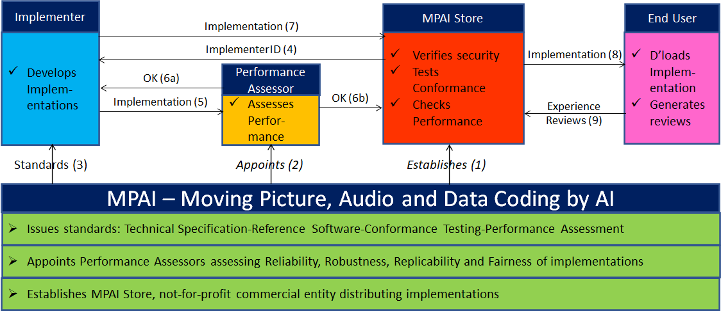
Figure 18 – The MPAI ecosystem operation

Annex 4 – Patent Declarations
The MPAI Context-based Audio Enhancement (MPAI-CAE) Technical Specification has been developed according to the process outlined in the MPAI Statutes [16] and the MPAI Patent Policy [17].
The following entities have agreed to license their standard essential patents reading on the MPAI Context-based Audio Enhancement (MPAI-CAE) Technical Specification according to the MPAI-CAE Framework License [18]:

Entity | Email address
ASELSAN A. Ş. | Mert Burkay Çöteli MBCoteli@aselsan.com.tr
Middle East Technical University (METU) | Huseyin Hacihabiboglu hhuseyin@metu.edu.tr
Speech Morphing, Inc. | Fathy Yassa fathy@speechmorphing.com

Annex 5 - Examples (Informative)
- Audio Scene Geometry
An example of Audio Scene Geometry.

{
"BlockIndex": 1,
"BlockStart": 1631536788000,
"BlockEnd": 1631536788063,
"SpeechCount": 2,
"SpeechList": [
{
"SpeechID": "09859d16-3c73-4bb0-9c74-91b451e34925",
"ChannelID": 1,
"AzimuthDirection": 90.0,
"ElevationDirection": 30.0,
"Distance": 2.0,
"DistanceFlag": false
},
{
"SpeechID": "3cdc2973-e95e-4125-acb7-121ad89067ef",
"ChannelID": 2,
"AzimuthDirection": 180.0,
"ElevationDirection": 30.0,
"Distance": 1.27,
"DistanceFlag": false
}
],
"SourceDetectionMask": [0,1]
}
- Damaged List
An example of a damaged list JSON file:
{
"DamagedSections": [
{
"SegmentStart": "00:00:01.351",
"SegmentEnd": "00:01:55.654",
},
{
"SegmentStart": "00:01:55.654",
"SegmentEnd": "00:02:35.168",
}
]
}
- Editing List
Example of a complete Editing List with two elements: the first related to reading backwards error, whereas the second to speed and equalisation errors.

{
"OriginalSpeedStandard": 15,
"OriginalEqualisationStandard": "IEC1",
"OriginalSampleFrequency": 96000,
"Restorations": [{
"RestorationID": "09859d16-3c73-4bb0-9c74-91b451e34925",
"PreservationAudioFileStart": "00:00:00.000",
"PreservationAudioFileEnd": "00:00:05.125",
"RestoredAudioFileURI": "http://www.place_to_be_defined.com/restored_1",
"ReadingBackwords": true,
"AppliedSpeedStandard": 15,
"AppliedSampleFrequency": 96000,
"OriginalEqualisationStandard": "IEC1"
},
{
"RestorationID": "3cdc2973-e95e-4125-acb7-121ad89067ef ",
"PreservationAudioFileStart": "00:00:05.125",
"PreservationAudioFileEnd": "00:00:15.230",
"RestoredAudioFileURI": "http://www.place_to_be_defined.com/restored_2",
"ReadingBackwords": false,
"AppliedSpeedStandard": 7.5,
"AppliedSampleFrequency": 48000,
"OriginalEqualisationStandard": "IEC2"
}]
}

- Irregularity File
An example of Irregularity File from Audio Analyser to Video Analyser is:
{
"Offset": 150,
"Irregularities": [{
"IrregularityID": "09859d16-3c73-4bb0-9c74-91b451e34925",
"Source": "a",
"TimeLabel": "00:02:45.040"
},{
"IrregularityID": "3cdc2973-e95e-4125-acb7-121ad89067ef",
"Source": "a",
"TimeLabel": "00:04:89.020"
}]
}

An example of Irregularity File from Video Analyser to Audio Analyser is:
{
"Irregularities": [{
"IrregularityID": "09859d16-3c73-4bb0-9c74-91b451e34925",
"Source": "v",
"TimeLabel": "00:02:45.040"
},{
"IrregularityID": "3cdc2973-e95e-4125-acb7-121ad89067ef",
"Source": "v",
"TimeLabel": "00:04:89.020"
}]
}

An example of Irregularity File from Audio Analyser to Tape Irregularity Classifier is:
{
"Offset": 150,
"Irregularities": [{
"IrregularityID": "09859d16-3c73-4bb0-9c74-91b451e34925",
"Source": "a",
"TimeLabel": "00:02:45.040",
"AudioSegmentURI": "http://www.place_to_be_defined.com/audio_segment_1",
"IrregularityType": "ssv",
"IrregularityProperties: {
"ReadingSpeedStandard": 15,
"ReadingEqualisationStandard": "IEC1",
"WritingSpeedStandard": 7.5,
"WritingEqualisationStandard": "IEC2"
}
},{
"IrregularityID": "3cdc2973-e95e-4125-acb7-121ad89067ef",
"Source": "v",
"TimeLabel": "00:04:89.020",
"AudioSegmentURI": "http://www.place_to_be_defined.com/audio_segment_2"
}]
}

An example of Irregularity File from Video Analyser to Tape Irregularity Classifier is:
{
"Offset": 150,
"Irregularities": [{
"IrregularityID": "09859d16-3c73-4bb0-9c74-91b451e34925",
"Source": "a",
"TimeLabel": "00:02:45.040",
"ImageURI": "http://www.place_to_be_defined.com/image_1"
},{
"IrregularityID": "3cdc2973-e95e-4125-acb7-121ad89067ef",
"Source": "v",
"TimeLabel": "00:04:89.020",
"ImageURI": "http://www.place_to_be_defined.com/image_2"
}]
}

An example of Irregularity File from Tape Irregularity Classifier to Tape Audio Restoration is:
{
"Irregularities": [{
"IrregulatityID": "09859d16-3c73-4bb0-9c74-91b451e34925",
"Source": "a",
"TimeLabel": "00:02:45.040",
"IrregularityType": "ssv",
"IrregularityProperties: {
"ReadingSpeedStandard": 15,
"ReadingEqualisationStandard": "IEC1",
"WritingSpeedStandard": 7.5,
"WritingEqualisationStandard": "IEC2"
}
},{
"IrregulatityID": "3cdc2973-e95e-4125-acb7-121ad89067ef",
"Source": "a",
"TimeLabel": "00:04:89.020",
"IrregularityType": "esv",
"IrregularityProperties: {
"ReadingSpeedStandard": 7.5,
"ReadingEqualisationStandard": "IEC2",
"WritingSpeedStandard": 7.5,
"WritingEqualisationStandard": "IEC1"
}
}]
}

An example of Irregularity File from Tape Irregularity Classifier to Packager is:
{
"Offset": 150,
"Irregularities": [{
"IrregulatityID": "09859d16-3c73-4bb0-9c74-91b451e34925",
"Source": "v",
"TimeLabel": "00:02:45.040",
"IrregularityType": "sot",
"ImageURI": "http://www.place_to_be_defined.com/image_1"
},{
"IrregulatityID": "3cdc2973-e95e-4125-acb7-121ad89067ef",
"Source": "b",
"TimeLabel": "00:04:89.020",
"IrregularityType": "sp",
"ImageURI": "http://www.place_to_be_defined.com/image_2"
}]
}

- Microphone Array Geometry
{
"MicrophoneArrayType": 0,
"MicrophoneArrayScat": 0,
"MicrophoneArrayFilterURI": "https://mpai.community/standards/mpai-cae/",
"SamplingRate": 4,
"SampleType": 0,
"BlockSize": 3,
"NumberofMicrophones": 4,
"MicrophoneList": [
{
"xCoord": 1.0,
"yCoord": 2.0,
"zCoord": 3.0,
"directivity": 0,
"micxLookCoord": 70.2,
"micyLookCoord": 75.5,
"miczLookCoord": 87.3
},
{
"xCoord": 5.3,
"yCoord": 5.6,
"zCoord": 74.3,
"directivity": 1,
"micxLookCoord": 67.9,
"micyLookCoord": 75.2,
"miczLookCoord": 90.0
},
{
"xCoord": 34.2,
"yCoord": 65.2,
"zCoord": 56.9,
"directivity": 2,
"micxLookCoord": 56.8,
"micyLookCoord": 87.9,
"miczLookCoord": 78.3
},
{
"xCoord": 34.9,
"yCoord": 29.7,
"zCoord": 89.8,
"directivity": 3,
"micxLookCoord": 56.9,
"micyLookCoord": 65.4,
"miczLookCoord": 72.9
}
],
"MicrophoneArrayLookCoord": [{
"xLookCoord": 56.0,
"yLookCoord": 90.0,
"zLookCoord": 86.3
}]
}

- Speech Features 1
{
"intonations": [{
"pitch": 300,
"intensity": 88.7,
"duration”:100.0
},{
"pitch": 180,
"intensity": 85.2,
"duration”:98.0
},{
"pitch": 280,
"intensity": 92.5,
"duration”:92.0
},{
"pitch": 230,
"intensity": 81.9,
"duration”:98.0
},{
"pitch": 150,
"intensity": 78.3,
"duration”:98.0
}],
"unit": "phoneme"
}
- Speech Features 2
[
1.456,
5.1289,
0.12,
12345.54378,
12389943.2837,
58.29
]
- AIW and AIM Metadata of CAE-EES
- AIW Metadata
{
"$schema": "https://json-schema.org/draft/2020-12/schema",
"$id": "https://mpai.community/standards/resources/MPAI-AIF/V1/AIW-AIM-metadata.schema.json",
"title": "EES v1 AIW/AIM metadata",
"Identifier": {
"ImplementerID": 100,
"Specification": {
"Standard": "MPAI-CAE",
"AIW": "CAE-EES",
"AIM": "CAE-EES",
"Version": "1"
}
},
"Description":"This AIW implements EES application of MPAI-CAE",
"Types":[
{
"Name": "Speech_t",
"Type": "uint32[]"
},
{
"Name": "Emotion_t",
"Type": "uint8"
},
{
"Name": "EmotionList_t",
"Type": "Emotion_t[]"
},
{
"Name": "Text_t",
"Type": "{byte[] One_Byte_Text | uint16[] Two_Byte_Text}"
},
{
"Name": "SpeechFeatures1_t",
"Type": "float[]"
},
{
"Name": "SpeechFeatures2_t",
"Type": "float[]"
}
],
"Ports":[
{
"Name":"ModeSelection",
"Direction":"InputOutput",
"RecordType":"Text_t",
"Technology":"Software",
"Protocol":"",
"IsRemote": false
},
{
"Name":"ModelUtterance",
"Direction":"InputOutput",
"RecordType":"Speech_t",
"Technology":"Software",
"Protocol":"",
"IsRemote": false
},
{
"Name":"EmotionlessSpeech1",
"Direction":"InputOutput",
"RecordType":"Speech_t",
"Technology":"Software",
"Protocol":"",
"IsRemote": false
},
{
"Name":"EmotionlessSpeech2",
"Direction":"InputOutput",
"RecordType":"Speech_t",
"Technology":"Software",
"Protocol":"",
"IsRemote": false
},

{
"Name":"EmotionList",
"Direction":"InputOutput",
"RecordType":"Text_t",
"Technology":"Software",
"Protocol":"",
"IsRemote": false
},
{
"Name":"Language",
"Direction":"InputOutput",
"RecordType":"Text_t",
"Technology":"Software",
"Protocol":"",
"IsRemote": false
},
{
"Name":"SpeechWithEmotion",
"Direction":"OutputInput",
"RecordType":"Speech_t",
"Technology":"Software",
"Protocol":"",
"IsRemote": false
}
],
"SubAIMs":[
{
"Name": "SpeechFeatureAnalyser1",
"Identifier": {
"ImplementerID": 100,
"Specification": {
"Standard": "MPAI-CAE",
"AIW": "CAE-EES",
"AIM": "SpeechFeatureAnalyser1",
"Version": "1"
}
}
},
{
"Name": "SpeechFeatureAnalyser2",
"Identifier": {
"ImplementerID": 100,
"Specification": {
"Standard": "MPAI-CAE",
"AIW": "CAE-EES",
"AIM": "SpeechFeatureAnalyser2",
"Version": "1"
}
}
},
{
"Name": "EmotionFeatureProducer",
"Identifier": {
"ImplementerID": 100,
"Specification": {
"Standard": "MPAI-CAE",
"AIW": "CAE-EES",
"AIM": "EmotionFeatureProducer",
"Version": "1"
}
}
},
{
"Name": "EmotionInserter1",
"Identifier": {
"ImplementerID": 100,
"Specification": {
"Standard": "MPAI-CAE",
"AIW": "CAE-EES",
"AIM": "EmotionInserter1",
"Version": "1"
}
}
},
{
"Name": "EmotionInserter2",
"Identifier": {
"ImplementerID": 100,
"Specification": {
"Standard": "MPAI-CAE",
"AIW": "CAE-EES",
"AIM": "EmotionInserter2",
"Version": "1"
}
}
}
],
"Topology":[
{
"Output":{
"AIMName":"SpeechFeatureAnalyser1",
"PortName":"SpeechFeatures1"
},
"Input":{
"AIMName":"EmotionInserter1",
"PortName":"SpeechFeatures1"
}
},
{
"Output":{
"AIMName":"SpeechFeatureAnalyser2",
"PortName":"EmotionlessSpeechFeatures"
},
"Input":{
"AIMName":"EmotionFeatureProducer",
"PortName":"EmotionlessSpeechFeatures"
}
},
{
"Output":{
"AIMName":"EmotionFeatureProducer",
"PortName":"SpeechFeatures2"
},
"Input":{
"AIMName":"EmotionInserter2",
"PortName":"SpeechFeatures2"
}

}
]
}
- AIM Metadata
- Speech Feature Analyser1
{
"Identifier":{
"ImplementerID":100,
"Specification":{
"Name": "CAE",
"AIW": "EES",
"AIM": "SpeechFeatureAnalyser1",
"Version":"1"
}
},
"Description": "This AIM implements speech feature analyser 1 function for CAE-EES that extracts Speech Features1 of a model emotional utterance and transfers them to the Emotion Inserter1.",
"Types":[
{
"Name": "Speech_t",
"Type": "uint32[]"
},
{
"Name": "SpeechFeatures1_t",
"Type": "float[]"
}
],
"Ports":[
{
"Name":"ModelUtterance",
"Direction":"InputOutput",
"RecordType":"Speech_t",
"Technology":"Software",
"Protocol":"",
"IsRemote": false
},
{
"Name":"SpeechFeatures1",
"Direction":"OutputInput",
"RecordType":"SpeechFeatures1_t",
"Technology":"Software",
"Protocol":"",
"IsRemote": false
}
]
}
- Speech Feature Analyser2
{
"Identifier":{
"ImplementerID":100,
"Specification":{
"Name": "CAE",
"AIW": "EES",
"AIM": "SpeechFeatureAnalyser2",
"Version":"1"
}
},
"Description": "This AIM implements speech feature analyser 2 function for CAE-EES that extracts Speech Features2 of an emotionless input utterance, passing these to Emotion Feature Inserter2.",
"Types":[
{
"Name": "Speech_t",
"Type": "uint32[]"
},
{
"Name": "SpeechFeatures2_t",
"Type": "float[]"
}
],
"Ports":[
{
"Name":"EmotionlessSpeech_2",
"Direction":"InputOutput",
"RecordType":"Speech_t",
"Technology":"Software",
"Protocol":"",
"IsRemote": false
},
{
"Name":"EmotionlessSpeechFeatures",
"Direction":"OutputInput",
"RecordType":"SpeechFeatures2_t",
"Technology":"Software",
"Protocol":"",
"IsRemote": false
}
]
}

- Emotion Feature Producer
{
"Identifier":{
"ImplementerID":100,
"Specification":{
"Name": "CAE",
"AIW": "EES",
"AIM": "EmotionFeatureProducer",
"Version": "1"
}
},
"Description":"This AIM implements emotion feature Producer function for CAE-EES that receives the Speech Features produced by Speech Feature Analyser2 plus a list of Emotions to be added.",
"Types":[
{
"Name": "SpeechFeatures2_t",
"Type": "float[]"
},
{
"Name": "Emotion_t",
"Type": "uint8"
},
{
"Name": "EmotionList_t",
"Type": "Emotion_t[]"
},
{
"Name": "Text_t",
"Type": "{byte[] One_Byte_Text | uint16[] Two_Byte_Text}"
}
],
"Ports":[
{
"Name":"EmotionlessSpeechFeatures",
"Direction":"InputOutput",
"RecordType":"SpeechFeatures2_t",
"Technology":"Software",
"Protocol":"",
"IsRemote": false
},
{
"Name":"EmotionList",
"Direction":"InputOutput",
"RecordType":"EmotionList_t",
"Technology":"Software",
"Protocol":"",
"IsRemote": false
},
{
"Name":"Language",
"Direction":"InputOutput",
"RecordType":"Text_t",
"Technology":"Software",
"Protocol":"",
"IsRemote": false
},
{
"Name":"SpeechFeatures2",
"Direction":"OutputInput",
"RecordType":"SpeechFeatures2_t",
"Technology":"Software",
"Protocol":"",
"IsRemote": false
}
]
}

- Emotion Inserter1
{
"Identifier":{
"ImplementerID":100,
"Specification":{
"Name": "CAE",
"AIW": "EES",
"AIM": "EmotionInserter",
"Version":"1"
}
},
"Description":"This AIM implements emotion inserter1 function for CAE-EES that integrates the Speech Features with those of the Emotionless Speech input, yielding and delivering an emotionally modified utterance.",
"Types":[
{
"Name": "Speech_t",
"Type": "uint32[]"
},
{
"Name": "Emotion_t",
"Type": "uint8"
},
{
"Name": "EmotionList_t",
"Type": "Emotion_t[]"
},
{
"Name": "SpeechFeatures1_t",
"Type": "float[]"
}
],
"Ports":[

{
"Name":"SpeechFeatures1",
"Direction":"InputOutput",
"RecordType":"SpeechFeatures1_t",
"Technology":"Software",
"Protocol":"",
"IsRemote": false
},
{
"Name":"EmotionlessSpeech",
"Direction":"InputOutput",
"RecordType":"Speech_t",
"Technology":"Software",
"Protocol":"",
"IsRemote": false
},
{
"Name":"SpeechWithEmotion",
"Direction":"OutputInput",
"RecordType":"Speech_t",
"Technology":"Software",
"Protocol":"",
"IsRemote": false
}
]
}
- Emotion Inserter2
{
"Identifier":{
"ImplementerID":100,
"Specification":{
"Name": "CAE",
"AIW": "EES",
"AIM": "EmotionInserter",
"Version":"1"
}
},
"Description":"This AIM implements emotion inserter2 function for CAE-EES that integrates the Speech Features with those of the Emotionless Speech input, yielding and delivering an emotionally modified utterance.",
"Types":[
{
"Name": "Speech_t",
"Type": "uint32[]"
},
{
"Name": "Emotion_t",
"Type": "uint8"
},
{
"Name": "EmotionList_t",
"Type": "Emotion_t[]"
},
{
"Name": "SpeechFeatures2_t",
"Type": "float[]"
}
],
"Ports":[

{
"Name":"SpeechFeatures2",
"Direction":"InputOutput",
"RecordType":"SpeechFeatures2_t",
"Technology":"Software",
"Protocol":"",
"IsRemote": false
},
{
"Name":"EmotionlessSpeech",
"Direction":"InputOutput",
"RecordType":"Speech_t",
"Technology":"Software",
"Protocol":"",
"IsRemote": false
},
{
"Name":"SpeechWithEmotion",
"Direction":"OutputInput",
"RecordType":"Speech_t",
"Technology":"Software",
"Protocol":"",
"IsRemote": false
}
]
}

- AIW and AIM of ARP
- AIW metadata
{
"Identifier": {
"ImplementerID": 100,
"Specification": {
"Standard": "CAE",
"AIW": "ARP",
"AIM": "ARP",
"Version": "1.00"
}
},
"Description": "This AIW implements ARP application of MPAI-CAE",
"Types": [{
"Name": "Audio_t",
"Type": "uint32[]"
},{
"Name": "AudioFileArray_t",
"Type": "Audio_t[]"
},{
"Name": "Image_t",
"Type": "uint64[]"
},{
"Name": "IrregularityImages_t",
"Type": "Image_t[]"
},{
"Name": "Video_t",
"Type": "{int32 frameNumber; int16 x; int16 y; byte[] frame}"
},{
"Name": "JSON_t",
"Type": "{byte[] oneByteText | uint16[] twoByteText}"
},{
"Name": "AccessCopyFiles_t",
"Type": "{AudioFileArray_t RestoredAudioFiles; JSON_t EditingList; IrregularityImages_t IrregularityImages; JSON_t IrregularityFile}"
},{
"Name": "PreservationMasterFiles_t",
"Type": "{Audio_t PreservationAudioFile; Video_t PreservationAudioVisualFile; IrregularityImages_t IrregularityImages; JSON_t IrregularityFile}"
}],
"Ports": [{
"Name": "PreservationAudioFile",
"Direction": "InputOutput",
"RecordType": "Audio_t",
"Technology": "Software",
"Protocol": "",
"IsRemote": false
},{
"Name": "PreservationAudioVisualFile",
"Direction": "InputOutput",
"RecordType": "Frame_t",
"Technology": "Software",
"Protocol": "",
"IsRemote": false
},{
"Name": "AccessCopyFiles",
"Direction": "OutputInput",
"RecordType": "AccessCopy_t",
"Technology": "Software",
"Protocol": "",
"IsRemote": false
},{
"Name": "PreservationMasterFiles",
"Direction": "OutputInput",
"RecordType": "PreservationMasterFiles_t",
"Technology": "Software",
"Protocol": "",
"IsRemote": false
}],
"SubAIMs": [{
"Name": "AudioAnalyser",
"Identifier": {
"ImplementerID": 101,
"Specification": {
"Standard": "CAE",
"AIW": "ARP",
"AIM": "AudioAnalyser",
"Version": "1.00"
}
}
},{
"Name": "VideoAnalyser",
"Identifier": {
"ImplementerID": 102,
"Specification": {
"Standard": "CAE",
"AIW": "ARP",
"AIM": "VideoAnalyser",
"Version": "1.00"
}
}
},{
"Name": "TapeAudioRestoration",
"Identifier": {
"ImplementerID": 103,
"Specification": {
"Standard": "CAE",
"AIW": "ARP",
"AIM": "TapeAudioRestoration",
"Version": "1.00"
}
}
},{
"Name": "TapeIrregularityClassifier",
"Identifier": {
"ImplementerID": 104,
"Specification": {
"Standard": "CAE",
"AIW": "ARP",
"AIM": "TapeIrregularityClassifier",
"Version": "1.00"
}
}
},{
"Name": "Packager",
"Identifier": {
"ImplementerID": 105,
"Specification": {
"Standard": "CAE",
"AIW": "ARP",
"AIM": "Packager",
"Version": "1.00"
}
}
}],
"Topology": [{
"Output": {
"AIMName": "",
"PortName": "PreservationAudioFile"
},
"Input": {
"AIMName": "AudioAnalyser",
"PortName": "PreservationAudioFile"
}
},{
"Output": {
"AIMName": "",
"PortName": "PreservationAudioFile"
},
"Input": {
"AIMName": "TapeAudioRestoration",
"PortName": "PreservationAudioFile"
}
},{
"Output": {
"AIMName": "",
"PortName": "PreservationAudioFile"
},
"Input": {
"AIMName": "Packager",
"PortName": "PreservationAudioFile"
}
},{
"Output": {
"AIMName": "",
"PortName": "PreservationAudioVisualFile"
},
"Input": {
"AIMName": "AudioAnalyser",
"PortName": "PreservationAudioVisualFile"
}
},{
"Output": {
"AIMName": "",
"PortName": "PreservationAudioVisualFile"
},
"Input": {
"AIMName": "VideoAnalyser",
"PortName": "PreservationAudioVisualFile"
}
},{
"Output": {
"AIMName": "",
"PortName": "PreservationAudioVisualFile"
},
"Input": {
"AIMName": "Packager",
"PortName": "PreservationAudioVisualFile"
}
},{
"Output": {
"AIMName": "AudioAnalyser",
"PortName": "IrregularityFileOutput_1"
},
"Input": {
"AIMName": "VideoAnalyser",
"PortName": "IrregularityFileInput"
}
},{
"Output": {
"AIMName": "VideoAnalyser",
"PortName": "IrregularityFileOutput_1"
},
"Input": {
"AIMName": "AudioAnalyser",
"PortName": "IrregularityFileInput"
}
},{
"Output": {
"AIMName": "AudioAnalyser",
"PortName": "IrregularityFileOutput_2"
},
"Input": {
"AIMName": "TapeIrregularityClassifier",
"PortName": "IrregularityFileInput_1"
}
},{
"Output": {
"AIMName": "VideoAnalyser",
"PortName": "IrregularityFileOutput_2"
},
"Input": {
"AIMName": "TapeIrregularityClassifier",
"PortName": "IrregularityFileInput_2"
}
},{
"Output": {
"AIMName": "TapeIrregularityClassifier",
"PortName": "IrregularityFileOutput_1"
},
"Input": {
"AIMName": "TapeAudioRestoration",
"PortName": "IrregularityFile"
}
},{
"Output": {
"AIMName": "TapeIrregularityClassifier",
"PortName": "IrregularityFileOutput_2"
},
"Input": {
"AIMName": "Packager",
"PortName": "IrregularityFile"
}
},{
"Output": {
"AIMName": "AudioAnalyser",
"PortName": "AudioFiles"
},
"Input": {
"AIMName": "TapeIrregularityClassifier",
"PortName": "AudioFiles"
}
},{
"Output": {
"AIMName": "VideoAnalyser",
"PortName": "IrregularityImages"
},
"Input": {
"AIMName": "TapeIrregularityClassifier",
"PortName": "IrregularityImagesInput"
}
},{
"Output": {
"AIMName": "TapeIrregularityClassifier",
"PortName": "IrregularityImagesOutput"
},
"Input": {
"AIMName": "Packager",
"PortName": "IrregularityImages"
}
},{
"Output": {
"AIMName": "TapeAudioRestoration",
"PortName": "RestoredAudioFiles"
},
"Input": {
"AIMName": "Packager",
"PortName": "RestoredAudioFiles"
}
},{
"Output": {
"AIMName": "TapeAudioRestoration",
"PortName": "EditingList"
},
"Input": {
"AIMName": "Packager",
"PortName": "EditingList"
}
},{
"Output": {
"AIMName": "Packager",
"PortName": "AccessCopyFiles"
},
"Input": {
"AIMName": "",
"PortName": "AccessCopyFiles"
}
},{
"Output": {
"AIMName": "Packager",
"PortName": "PreservationMasterFiles"
},
"Input": {
"AIMName": "",
"PortName": "PreservationMasterFiles"
}
}],
"Implementations": []
}
- AIM metadata
- Audio Analyser
{
"Identifier": {
"ImplementerID": 101,
"Specification": {
"Standard": "CAE",
"AIW": "ARP",
"AIM": "AudioAnalyser",
"Version": "1.00"
}
},
"Description": "This AIM implements the Audio Analyser.",
"Types": [{
"Name": "Audio_t",
"Type": "uint32[]"
},{
"Name": "AudioFileArray_t",
"Type": "Audio_t[]"
},{
"Name": "Video_t",
"Type": "{int32 frameNumber; int16 x; int16 y; byte[] frame}"
},{
"Name": "JSON_t",
"Type": "{byte[] oneByteText | uint16[] twoByteText}"
}],
"Ports": [{
"Name": "PreservationAudioFile",
"Direction": "InputOutput",
"RecordType": "Audio_t",
"Technology": "Software",
"Protocol": "",
"IsRemote": false
},{
"Name": "PreservationAudioVisualFile",
"Direction": "InputOutput",
"RecordType": "Video_t",
"Technology": "Software",
"Protocol": "",
"IsRemote": false
},{
"Name": "IrregularityFileInput",
"Direction": "InputOutput",
"RecordType": "JSON_t",
"Technology": "Software",
"Protocol": "",
"IsRemote": false
},{
"Name": "IrregularityFileOutput_1",
"Direction": "OutputInput",
"RecordType": "JSON_t",
"Technology": "Software",
"Protocol": "",
"IsRemote": false
},{
"Name": "IrregularityFileOutput_2",
"Direction": "OutputInput",
"RecordType": "JSON_t",
"Technology": "Software",
"Protocol": "",
"IsRemote": false
},{
"Name": "AudioFiles",
"Direction": "OutputInput",
"RecordType": "AudioFileArray_t",
"Technology": "Software",
"Protocol": "",
"IsRemote": false
}],
"SubAIMs": [],
"Topology": [],
"Implementations": []
}
- Video Analyser
{
"Identifier": {
"ImplementerID": 102,
"Specification": {
"Standard": "CAE",
"AIW": "ARP",
"AIM": "VideoAnalyser",
"Version": "1.00"
}
},
"Description": "This AIM implements the Video Analyser.",
"Types": [{
"Name": "Image_t",
"Type": "uint64[]"
},{
"Name": "IrregularityImages_t",
"Type": "Image_t[]"
},{
"Name": "Video_t",
"Type": "{int32 frameNumber; int16 x; int16 y; byte[] frame}"
},{
"Name": "JSON_t",
"Type": "{byte[] oneByteText | uint16[] twoByteText}"
}],
"Ports": [{
"Name": "PreservationAudioVisualFile",
"Direction": "InputOutput",
"RecordType": "Video_t",
"Technology": "Software",
"Protocol": "",
"IsRemote": false
},{
"Name": "IrregularityFileInput",
"Direction": "InputOutput",
"RecordType": "JSON_t",
"Technology": "Software",
"Protocol": "",
"IsRemote": false
},{
"Name": "IrregularityFileOutput_1",
"Direction": "OutputInput",
"RecordType": "JSON_t",
"Technology": "Software",
"Protocol": "",
"IsRemote": false
},{
"Name": "IrregularityFileOutput_2",
"Direction": "OutputInput",
"RecordType": "JSON_t",
"Technology": "Software",
"Protocol": "",
"IsRemote": false
},{
"Name": "IrregularityImages",
"Direction": "OutputInput",
"RecordType": "IrregularityImages_t",
"Technology": "Software",
"Protocol": "",
"IsRemote": false
}],
"SubAIMs": [],
"Topology": [],
"Implementations": []
}
- Tape Irregularity classifier
{
"Identifier": {
"ImplementerID": 103,
"Specification": {
"Standard": "CAE",
"AIW": "ARP",
"AIM": "TapeIrregularityClassifier",
"Version": "1.00"
}
},
"Description": "This AIM implements the Tape Irregularity Classifier.",
"Types": [{
"Name": "Audio_t",
"Type": "uint32[]"
},{
"Name": "AudioFileArray_t",
"Type": "Audio_t[]"
},{
"Name": "Image_t",
"Type": "uint64[]"
},{
"Name": "IrregularityImages_t",
"Type": "Image_t[]"
},{
"Name": "JSON_t",
"Type": "{byte[] oneByteText | uint16[] twoByteText}"
}],
"Ports": [{
"Name": "AudioFiles",
"Direction": "InputOutput",
"RecordType": "AudioFileArray_t",
"Technology": "Software",
"Protocol": "",
"IsRemote": false
},{
"Name": "IrregularityFileInput_1",
"Direction": "InputOutput",
"RecordType": "JSON_t",
"Technology": "Software",
"Protocol": "",
"IsRemote": false
},{
"Name": "IrregularityFileInput_2",
"Direction": "InputOutput",
"RecordType": "JSON_t",
"Technology": "Software",
"Protocol": "",
"IsRemote": false
},{
"Name": "IrregularityImagesInput",
"Direction": "InputOutput",
"RecordType": "IrregularityImages_t",
"Technology": "Software",
"Protocol": "",
"IsRemote": false
},{
"Name": "IrregularityFileOutput_1",
"Direction": "OutputInput",
"RecordType": "JSON_t",
"Technology": "Software",
"Protocol": "",
"IsRemote": false
},{
"Name": "IrregularityFileOutput_2",
"Direction": "OutputInput",
"RecordType": "JSON_t",
"Technology": "Software",
"Protocol": "",
"IsRemote": false
},{
"Name": "IrregularityImagesOutput",
"Direction": "OutputInput",
"RecordType": "IrregularityImages_t",
"Technology": "Software",
"Protocol": "",
"IsRemote": false
}],
"SubAIMs": [],
"Topology": [],
"Implementations": []
}
- Tape Audio Restoration
{
"Identifier": {
"ImplementerID": 104,
"Specification": {
"Standard": "CAE",
"AIW": "ARP",
"AIM": "TapeAudioRestoration",
"Version": "1.00"
}
},
"Description": "This AIM implements the Tape Audio Restoration.",
"Types": [{
"Name": "Audio_t",
"Type": "uint32[]"
},{
"Name": "AudioFileArray_t",
"Type": "Audio_t[]"
},{
"Name": "JSON_t",
"Type": "{byte[] oneByteText | uint16[] twoByteText}"
}],
"Ports": [{
"Name": "PreservationAudioFile",
"Direction": "InputOutput",
"RecordType": "Audio_t",
"Technology": "Software",
"Protocol": "",
"IsRemote": false
},{
"Name": "IrregularityFile",
"Direction": "InputOutput",
"RecordType": "JSON_t",
"Technology": "Software",
"Protocol": "",
"IsRemote": false
},{
"Name": "RestoredAudioFiles",
"Direction": "OutputInput",
"RecordType": "AudioFileArray_t",
"Technology": "Software",
"Protocol": "",
"IsRemote": false
},{
"Name": "EditingList",
"Direction": "OutputInput",
"RecordType": "JSON_t",
"Technology": "Software",
"Protocol": "",
"IsRemote": false
}],
"SubAIMs": [],
"Topology": [],
"Implementations": []
}
- Packager
{
"Identifier": {
"ImplementerID": 105,
"Specification": {
"Standard": "CAE",
"AIW": "ARP",
"AIM": "Packager",
"Version": "1.00"
}
},
"Description": "This AIM implements the Packager.",
"Types": [{
"Name": "Audio_t",
"Type": "uint32[]"
},{
"Name": "AudioFileArray_t",
"Type": "Audio_t[]"
},{
"Name": "Image_t",
"Type": "uint64[]"
},{
"Name": "IrregularityImages_t",
"Type": "Image_t[]"
},{
"Name": "Video_t",
"Type": "{int32 frameNumber; int16 x; int16 y; byte[] frame}"
},{
"Name": "JSON_t",
"Type": "{byte[] oneByteText | uint16[] twoByteText}"
},{
"Name": "AccessCopyFiles_t",
"Type": "{AudioFileArray_t RestoredAudioFiles; JSON_t EditingList; IrregularityImages_t IrregularityImages; JSON_t IrregularityFile}"
},{
"Name": "PreservationMasterFiles_t",
"Type": "{Audio_t PreservationAudioFile; Video_t PreservationAudioVisualFile; IrregularityImages_t IrregularityImages; JSON_t IrregularityFile}"
}],
"Ports": [{
"Name": "PreservationAudioFile",
"Direction": "InputOutput",
"RecordType": "Audio_t",
"Technology": "Software",
"Protocol": "",
"IsRemote": false
},{
"Name": "RestoredAudioFiles",
"Direction": "InputOutput",
"RecordType": "AudioFileArray_t",
"Technology": "Software",
"Protocol": "",
"IsRemote": false
},{
"Name": "EditingList",
"Direction": "InputOutput",
"RecordType": "JSON_t",
"Technology": "Software",
"Protocol": "",
"IsRemote": false
},{
"Name": "IrregularityFile",
"Direction": "InputOutput",
"RecordType": "JSON_t",
"Technology": "Software",
"Protocol": "",
"IsRemote": false
},{
"Name": "IrregularityImages",
"Direction": "InputOutput",
"RecordType": "IrregularityImages_t",
"Technology": "Software",
"Protocol": "",
"IsRemote": false
},{
"Name": "PreservationAudioVisualFile",
"Direction": "InputOutput",
"RecordType": "Video_t",
"Technology": "Software",
"Protocol": "",
"IsRemote": false
},{
"Name": "AccessCopyFiles",
"Direction": "OutputInput",
"RecordType": "AccessCopyFiles_t",
"Technology": "Software",
"Protocol": "",
"IsRemote": false
},{
"Name": "PreservationMasterFiles",
"Direction": "OutputInput",
"RecordType": "PreservationMasterFiles_t",
"Technology": "Software",
"Protocol": "",
"IsRemote": false
}],
"SubAIMs": [],
"Topology": [],
"Implementations": []
}
- AIW and AIM of SRS
- AIW metadata
{
"$schema": "https://json-schema.org/draft/2020-12/schema",
"$id": "https://mpai.community/standards/resources/MPAI-AIF/V1/AIW-AIM-metadata.schema.json",
"title": "SRS AIF v1 AIW/AIM metadata",
"Identifier": {
"ImplementerID": 100,
"Specification": {
"Standard": "MPAI-CAE",
"AIW": "CAE-SRS",
"AIM": "CAE-SRS",
"Version": "1"
}
},

"APIProfile": "Main",
"Description":"This AIW implements SRS application of MPAI-CAE",
"Types":[
{
"Name": "Speech_t",
"Type": "uin32[]"
},
{
"Name": "AudioSegments_t",
"Type": "Speech_t[]"
},
{
"Name": "JSON_t",
"Type": "{byte[] One_Byte_Text | uint16[] Two_Byte_Text}"
}
],
"Ports":[
{
"Name":"DamagedSegments",
"Direction":"InputOutput",
"RecordType":"Speech_t",
"Technology":"Software",
"Protocol":"",
"IsRemote": false
},
{
"Name":"DamagedList",
"Direction":"InputOutput",
"RecordType":"JSON_t",
"Technology":"Software",
"Protocol":"",
"IsRemote": false
},
{
"Name":"TextList",
"Direction":"InputOutput",
"RecordType":"JSON_t",
"Technology":"Software",
"Protocol":"",
"IsRemote": false
},
{
"Name":"AudioSegmentsForModelling",
"Direction":"InputOutput",
"RecordType":"AudioSegments_t",
"Technoogy":"Software",
"Protocol":"",
"IsRemote": false
},
{
"Name":"RestoredSegment",
"Direction":"OutputInput",
"RecordType":"Speech_t",
"Technology":"Software",
"Protocol":"",
"IsRemote": false
}
],
"SubAIMs":[
{
"Name": "SpeechModelCreation",
"Identifier": {
"ImplementerID": 100,
"Specification": {
"Standard": "MPAI-CAE",
"AIW": "CAE-SRS",
"AIM": "SpeechModelCreation",
"Version": "1"
}
}
},
{
"Name": "SpeechSynthesiser",
"Identifier": {
"ImplementerID": 100,
"Specification": {
"Standard": "MPAI-CAE",
"AIW": "CAE-SRS",
"AIM": "SpeechSynthesiser",
"Version": "1"
}
}
},
{
"Name": "Assembler",
"Identifier": {
"ImplementerID": 100,
"Specification": {
"Standard": "MPAI-CAE",
"AIW": "CAE-SRS",
"AIM": "Assembler",
"Version": "1"
}
}
}
],
"Topology":[
{
"Output":{
"AIMName":"SpeechModelCreation",
"PortName":"NeuralNetworkSpeechModel"
},
"Input":{
"AIMName":"SpeechSynthesiser",
"PortName":"NeuralNetworkSpeechModel"
}
},
{
"Output":{
"AIMName":"SpeechSynthesiser",
"PortName":"SynthesisedSpeech"
},
"Input":{
"AIMName":"Assembler",
"PortName":"SynthesisedSpeech"
}
}
]
}

- AIM metadata
- Speech Model Creation
{
"Identifier":{
"ImplementerID":100,
"Specification":{
"Name": "CAE",
"AIW": "SRS",
"AIM": "SpeechModelCreation",
"Version":"1
}
},
"Description":"This AIM implements Speech Model Creation function for CAE-SRS that receives Audio Segments for Modelling, a set of recordings composing a corpus that will be used to train a Neural Network Speech Model in Speech Model Creation.",
"Types":[
{
"Name": "Speech_t",
"Type": "uin32[]"
},
{
"Name": "AudioSegments_t",
"Type": "Speech_t[]"
},
{
"Name": "JSON_t",
"Type": "{byte[] One_Byte_Text | uint16[] Two_Byte_Text}"
}
],
"Ports":[
{
"Name":"AudioSegmentsForModelling",
"Direction":"InputOutput",
"RecordType":"AudioSegments_t",
"Technology":"Software",
"Protocol":"",
"IsRemote": false
},
{
"Name":"NeuralNetworkSpeechModel",
"Direction":"OutputInput",
"RecordType":"Text_t",
"Type":"Software",
"Protocol":"",
"IsRemote": false
}
]
}

- Speech Synthesiser
{
"Identifier":{
"ImplementerID":100,
"Specification":{
"Name": "CAE",
"AIW": "SRS",
"AIM": "SpeechSynthesiser",
"Version":"1
}
},
"Description":"This AIM implements Speech Synthesiser function for CAE-SRS. The Neural Network Speech Model is passed to the Speech Synthesiser AIM, which also receives a Text List as input. Each element of Text List is a string specifying the text of a damaged section of Damaged Segment (or of Damaged Segment as a whole). Speech Synthesiser produces synthetic replacements for each damaged section (or for Damaged Segment as a whole) and passes the replacement(s) to Assembler.",
"Types":[
{
"Name": "Speech_t",
"Type": "uin32[]"
},
{
"Name": "AudioSegments_t",
"Type": "Speech_t[]"
},
{
"Name": "Text_t",
"Type": "{byte[] One_Byte_Text | uint16[] Two_Byte_Text}"
}
{
"Name": "JSON_t",
"Type": "{byte[] One_Byte_Text | uint16[] Two_Byte_Text}"
}
],
"Ports":[
{
"Name":"TextList",
"Direction":"InputOutput",
"RecordType":"JSON_t",
"Technology":"Software",
"Protocol":"",
"IsRemote": false
},{
"Name":"NeuralNetworkSpeechModel",
"Direction":"InputOutput",
"RecordType":"Text_t",
"Technology":"Software",
"Protocol":"",
"IsRemote": false
},{
"Name":"SynthesisedSpeech",
"Direction":"OutputInput",
"RecordType":"AudioSegments_t",
"Technology":"Software",
"Protocol":"",
"IsRemote": false
}
]
}

- Assembler
{
"Identifier":{
"ImplementerID":100,
"Specification":{
"Name": "CAE",
"AIW": "SRS",
"AIM": "Assembler",
"Version":"1
}
},
"Description":"This AIM implements Assembler function for CAE-SRS. Assembler receives as input the entire Damaged Segment, plus Damaged List Time Labels, a list indicating the locations of any damaged sections within Damaged Segment. The list will be null if Damaged Segment in its entirety was replaced. Assembler produces as output Restored Segment, in which any repaired sections have been replaced by synthetic sections, or in which the entire Damaged Segment has been replaced.",
"Types":[
{
"Name": "Speech_t",
"Type": "uin32[]"
},
{
"Name": "AudioSegments_t",
"Type": "Speech_t[]"
},
{
"Name": "Text_t",
"Type": "{byte[] One_Byte_Text | uint16[] Two_Byte_Text}"
}
{
"Name": "JSON_t",
"Type": "{byte[] One_Byte_Text | uint16[] Two_Byte_Text}"
}
],
"Ports":[
{
"Name":"DamagedSegments",
"Direction":"InputOutput",
"RecordType":"Text_t",
"Technology":"Software",
"Protocol":"",
"IsRemote": false
},
{
"Name":"DamagedList",
"Direction":"InputOutput",
"RecordType":"JSON_t",
"Technology":"Software",
"Protocol":"",
"IsRemote": false
},
{
"Name":"SynthesisedSpeech",
"Direction":"InputOutput",
"RecordType":"AudioSegments_t",
"Technology":"Software",
"Protocol":"",
"IsRemote": false
},
{
"Name":"RestoredSegment",
"Direction":"OutputInput",
"RecordType":"Speech_t",
"Technology":"Software",
"Protocol":"",
"IsRemote": false
}
]
}

- AIW and AIM of EAE
- AIW Metadata

{
"$schema": "https://json-schema.org/draft/2020-12/schema",
"$id": "https://mpai.community/standards/resources/MPAI-AIF/V1/AIW-AIM-metadata.schema.json",
"title": "EAE AIF v1 AIW/AIM metadata",
"Identifier": {
"ImplementerID": 100,
"Specification": {
"Standard": "MPAI-CAE",
"AIW": "CAE-EAE",
"AIM": "CAE-EAE",
"Version": "1"
}
},
"APIProfile": "Main",
"Description": "This AIF is used to call the AIW of EAE",
"Types": [
{
"Name":"Audio_t",
"Type":"uint16[]",
},
{
"Name":"Array_Audio_t",
"Type":"Audio_t[]",
},
{
"Name":"TransformArray_Audio_t",
"Type":"Array_Audio_t[]",
},
{
"Name":"Text_t",
"Type":"uint8[]",
}
],
"Ports": [
{
"Name":"MicrophoneArrayAudio",
"Direction":"InputOutput",
"RecordType":"Array_Audio_t",
"Technology":"Software",
"Protocol":"",
"IsRemote": false
},
{
"Name":"TransformMultichannelAudio",
"Direction":"OutputInput",
"RecordType":"TransformArray_Audio_t",
"Technology":"Software",
"Protocol":"",
"IsRemote": false
},
{
"Name":"TransformMultichannelAudio",
"Direction":"InputOutput",
"RecordType":"TransformArray_Audio_t",
"Technology":"Software",
"Protocol":"",
"IsRemote": false
},
{
"Name":"MicrophoneArrayGeometry",
"Direction":"InputOutput",
"RecordType":"Text_t",
"Technology":"Software",
"Protocol":"",
"IsRemote": false
},
{
"Name":"SphericalHarmonicsDecomposition",
"Direction":"OutputInput",
"RecordType":"TransformArray_Audio_t",
"Technology":"Software",
"Protocol":"",
"IsRemote": false
},
{
"Name":"SphericalHarmonicsDecomposition",
"Direction":"InputOutput",
"RecordType":"TransformArray_Audio_t",
"Technology":"Software",
"Protocol":"",
"IsRemote": false
},
{
"Name":"TransformSpeech",
"Direction":"OutputInput",
"RecordType":"TransformArray_Audio_t",
"Technology":"Software",
"Protocol":"",
"IsRemote": false
},
{
"Name":"AudioSceneGeometry",
"Direction":"OutputInput",
"RecordType":"Text_t",
"Technology":"Software",
"Protocol":"",
"IsRemote": false
},
{
"Name":"SphericalHarmonicsDecomposition",
"Direction":"InputOutput",
"RecordType":"TransformArray_Audio_t",
"Technology":"Software",
"Protocol":"",
"IsRemote": false
},
{
"Name":"TransformSpeech",
"Direction":"InputOutput",
"RecordType":"TransformArray_Audio_t",
"Technology":"Software",
"Protocol":"",
"IsRemote": false
},
{
"Name":"AudioSceneGeometry",
"Direction":"InputOutput",
"RecordType":"Text_t",
"Technology":"Software",
"Protocol":"",
"IsRemote": false
},
{
"Name":"DenoisedTransformSpeech",
"Direction":"OutputInput",
"RecordType":"TransformArray_Audio_t",
"Technology":"Software",
"Protocol":"",
"IsRemote": false
},
{
"Name":"DenoisedTransformSpeech",
"Direction":"InputOutput",
"RecordType":"TransformArray_Audio_t",
"Technology":"Software",
"Protocol":"",
"IsRemote": false
},
{
"Name":"DenoisedSpeech",
"Direction":"OutputInput",
"RecordType":"Array_Audio_t",
"Technology":"Software",
"Protocol":"",
"IsRemote": false
}
],
"SubAIMs": [
{
"Name": "AnalysisTransform",
"Identifier": {
"ImplementerID": 100,
"Specification": {
"Standard": "MPAI-CAE",
"AIW": "CAE-EAE",
"AIM": "AnalysisTransform",
"Version": "1"
}
}
},
{
"Name": "SoundFieldDescription",
"Identifier": {
"ImplementerID": 100,
"Specification": {
"Standard": "MPAI-CAE",
"AIW": "CAE-EAE",
"AIM": "SoundFieldDescription",
"Version": "1"
}
}
},
{
"Name": "SpeechDetectionandSeparation",
"Identifier": {
"ImplementerID": 100,
"Specification": {
"Standard": "MPAI-CAE",
"AIW": "CAE-EAE",
"AIM": "SpeechDetectionandSeparation",
"Version": "1"
}
}
},
{
"Name": "NoiseCancellation",
"Identifier": {
"ImplementerID": 100,
"Specification": {
"Standard": "MPAI-CAE",
"AIW": "CAE-EAE",
"AIM": "NoiseCancellation",
"Version": "1"
}
}
},
{
"Name": "SynthesisTransform",
"Identifier": {
"ImplementerID": 100,
"Specification": {
"Standard": "MPAI-CAE",
"AIW": "CAE-EAE",
"AIM": "SynthesisTransform",
"Version": "1"
}
}
},
{
"Name": "Packager",
"Identifier": {
"ImplementerID": 100,
"Specification": {
"Standard": "MPAI-CAE",
"AIW": "CAE-EAE",
"AIM": "Packager",
"Version": "1"
}
}
}
],
"Topology": [
{
"Output":{
"AIMName":"",
"PortName":"MicrophoneArrayAudio"
},
"Input":{
"AIMName":"AnalysisTransform",
"PortName":"MicrophoneArrayAudio"
}
},
{
"Output":{
"AIMName":"",
"PortName":"MicrophoneArrayGeometry_1"
},
"Input":{
"AIMName":"SoundFieldDescription",
"PortName":" MicrophoneArrayGeometry_1"
}
},
{
"Output":{
"AIMName":"",
"PortName":"MicrophoneArrayGeometry_2"
},
"Input":{
"AIMName":"Packager",
"PortName":" MicrophoneArrayGeometry_2"
}
},
{
"Output":{
"AIMName":"AnalysisTransform",
"PortName":"TransformMultiChannelAudio"
},
"Input":{
"AIMName":"SoundFieldDescription",
"PortName":"TransformMultiChannelAudio"
}
},
{
"Output":{
"AIMName":"SoundFieldDescription",
"PortName":"SphericalHarmonicsDecomposition_1"
},
"Input":{
"AIMName":"SpeechDetectionandSeparation",
"PortName":"SphericalHarmonicsDecomposition_1"
}
},
{
"Output":{
"AIMName":"SoundFieldDescription",
"PortName":"SphericalHarmonicsDecomposition_2"
},
"Input":{
"AIMName":"SpeechDetectionandSeparation",
"PortName":"SphericalHarmonicsDecomposition_2"
}
},
{
"Output":{
"AIMName":"SpeechDetectionandSeparation",
"PortName":"TransformSpeech"
},
"Input":{
"AIMName":"NoiseCancellation",
"PortName":"TransformSpeech"
}
},
{
"Output":{
"AIMName":"SpeechDetectionandSeparation",
"PortName":"AudioSceneGeometry_1"
},
"Input":{
"AIMName":"NoiseCancellation",
"PortName":"AudioSceneGeometry_1"
}
},
{
"Output":{
"AIMName":"SpeechDetectionandSeparation",
"PortName":"AudioSceneGeometry_2"
},
"Input":{
"AIMName":"Packager",
"PortName":"AudioSceneGeometry_2"
}
},
{
"Output":{
"AIMName":"NoiseCancellation",
"PortName":"DenoisedTransformSpeech"
},
"Input":{
"AIMName":"SynthesisTransform",
"PortName":"DenoisedTransformSpeech"
}
},
{
"Output":{
"AIMName":"SynthesisTransform",
"PortName":"DenoisedSpeech"
},
"Input":{
"AIMName":"Packager",
"PortName":"DenoisedSpeech"
}
}
],
"Implementations": [{
"BinaryName": "eae.exe",
"Architecture": "x64",
"OperatingSystem": "Windows",
"Version": "v0.1",
"Source": "AIMStorage",
"Destination": ""
}
],
"ResourcePolicies": [
{
"Name": "Memory",
"Minimum": "50000",
"Maximum": "100000",
"Request": "75000"
},
{
"Name": "CPUNumber",
"Minimum": "1",
"Maximum": "2",
"Request": "1"
},
{
"Name": "CPU:Class",
"Minimum": "Low",
"Maximum": "High",
"Request": "Medium"
},
{
"Name": "GPU:CUDA:FrameBuffer",
"Minimum": "11GB_GDDR5X",
"Maximum": "8GB_GDDR6X",
"Request": "11GB_GDDR6"
},
{
"Name": "GPU:CUDA:MemorySpeed",
"Minimum": "1.60GHz",
"Maximum": "1.77GHz",
"Request": "1.71GHz"
},
{
"Name": "GPU:CUDA:Class",
"Minimum": "SM61",
"Maximum": "SM86",
"Request": "SM75"
},
{
"Name": "GPU:Number",
"Minimum": "1",
"Maximum": "1",
"Request": "1"
}
],
"Documentation":[
{
"Type":"Tutorial",
"URI":"https://mpai.community/standards/mpai-cae/"
}
]
}

- AIM Metadata
- Metadata of CAE-EAE Analysis Transform AIM

{
"Identifier":{
"ImplementerID":100,
"Specification":{
"Name": "CAE",
"AIW": "EAE",
"AIM": "AnalysisTransform",
"Version":"1"
}
},
"Description":"This AIM implements analysis transform function for CAE-EAE that converts microphone array audio into transform multichannel audio.",
"Types":[
{
"Name": "Audio_t",
"Type": "uint16[]"
},
{
"Name": "Array_Audio_t",
"Type": "Audio_t[]"
},
{
"Name": "Transform_Array_Audio_t",
"Type": "Array_Audio_t[]"
}
],
"Ports":[
{
"Name":"MicrophoneArrayAudio",
"Direction":"InputOutput",
"RecordType":"Array_Audio_t",
"Technology":"Software",
"Protocol":"",
"IsRemote": false
},
{
"Name":"TransformMultichannelAudio",
"Direction":"OutputInput",
"RecordType":"TransformArray_Audio_t",
"Technology":"Software",
"Protocol":"",
"IsRemote": false
}
],
"SubAIMs":[],
"Topology":[],
"Implementations": [],
"Documentation":[
{
"Type":"Tutorial",
"URI":"https://mpai.community/standards/mpai-cae/"
}
]
}

- Metadata of CAE-EAE Sound Field Description AIM

{
"AIM":{
"ImplementerID": 100,
"Standard":{
"Name": "CAE",
"AIW": "EAE",
"AIM": "SoundFieldDescription",
"Version":"1"
},
"Description":"This AIM implements sound field description function for CAE-EAE that converts transform multichannel audio into spherical harmonics decomposition.",
"Types":[
{
"Name": "Text_t",
"Type": "uint8[]"
},
{
"Name": "Audio_t",
"Type": "uint16[]"
},
{
"Name": "Array_Audio_t",
"Type": "Audio_t[]"
},
{
"Name": "Transform_Array_Audio_t",
"Type": "Array_Audio_t[]"
}
],
"Ports":[
{
"Name":"TransformMultichannelAudio",
"Direction":"InputOutput",
"RecordType":"TransformArray_Audio_t",
"Technology":"Software",
"Protocol":"",
"IsRemote": false
},
{
"Name":"MicrophoneArrayGeometry",
"Direction":"InputOutput",
"RecordType":"Text_t",
"Technology":"Software",
"Protocol":"",
"IsRemote": false
},
{
"Name":"SphericalHarmonicsDecomposition",
"Direction":"OutputInput",
"RecordType":"TransformArray_Audio_t",
"Technology":"Software",
"Protocol":"",
"IsRemote": false
}
],
"SubAIMs":[],
"Topology":[],
"Documentation":[
{
"Type":"tutorial",
"URI":"https://mpai.community/standards/mpai-cae/"
}
]
}
}

- Metadata of CAE-EAE Speech Detection and Separation AIM

{
"AIM":{
"ImplementerID": 100,
"Standard":{
"Name": "CAE",
"AIW": "EAE",
"AIM": "SpeechDetectionandSeparation",
"Version":"1"
},
"Description":"This AIM implements speech detection and separation function for CAE-EAE that converts spherical harmonics coefficients into transform speech and Audio Scene Geometry.",
"Types":[
{
"Name": "Text_t",
"Type": "uint8[]"
},
{
"Name": "Audio_t",
"Type": "uint16[]"
},
{
"Name": "Array_Audio_t",
"Type": "Audio_t[]"
},
{
"Name": "Transform_Array_Audio_t",
"Type": "Array_Audio_t[]"
}
],
"Ports":[
{
"Name":"SphericalHarmonicsDecomposition",
"Direction":"InputOutput",
"RecordType":"TransformArray_Audio_t",
"Technology":"Software",
"Protocol":"",
"IsRemote": false

},
{
"Name":"TransformSpeech",
"Direction":"OutputInput",
"RecordType":"TransformArray_Audio_t",
"Technology":"Software",
"Protocol":"",
"IsRemote": false

},
{
"Name":"AudioSceneGeometry",
"Direction":"OutputInput",
"RecordType":"Text_t",
"Technology":"Software",
"Protocol":"",
"IsRemote": false

}
],
"AIMs":[],
"Topology":[],
"Documentation":[
{
"Type":"tutorial",
"URI":"https://mpai.community/standards/mpai-cae/"
}
]
}
}

- Metadata of CAE-EAE Noise Cancellation AIM
{
"AIM":{
"ImplementerID": 100,
"Standard":{
"Name": "CAE",
"AIW": "EAE",
"AIM": "NoiseCancellation",
"Version":"1"
},
"Description":"This AIM implements noise cancellation function for CAE-EAE that converts transform speech into denoised transform speech.",
"Types":[
{
"Name": "Text_t",
"Type": "uint8[]"
},
{
"Name": "Audio_t",
"Type": "uint16[]"
},
{
"Name": "Array_Audio_t",
"Type": "Audio_t[]"
},
{
"Name": "Transform_Array_Audio_t",
"Type": "Array_Audio_t[]"
}
],
"Ports":[
{
"Name":"SphericalHarmonicsDecomposition",
"Direction":"InputOutput",
"RecordType":"TransformArray_Audio_t",
"Technology":"Software",
"Protocol":"",
"IsRemote": false

},
{
"Name":"TransformSpeech",
"Direction":"InputOutput",
"RecordType":"TransformArray_Audio_t",
"Technology":"Software",
"Protocol":"",
"IsRemote": false

},
{
"Name":"AudioSceneGeometry",
"Direction":"InputOutput",
"RecordType":"Text_t",
"Technology":"Software",
"Protocol":"",
"IsRemote": false

},
{
"Name":"DenoisedTransformSpeech",
"Direction":"OutputInput",
"RecordType":"TransformArray_Audio_t",
"Technology":"Software",
"Protocol":"",
"IsRemote": false

}

],
"AIMs":[

],
"Topology":[

],

"Documentation":[
{
"Type":"tutorial",
"URI":"https://mpai.community/standards/mpai-cae/"
}
]
}
}

- Metadata of CAE-EAE Synthesis Transform AIM

{
"AIM":{
"ImplementerID": 100,
"Standard":{
"Name": "CAE",
"AIW": "EAE",
"AIM": "SynthesisTransform",
"Version":"1"
},
"Description":"This AIM implements synthesis transform function for CAE-EAE that converts denoised transform speech into denoised speech.",
"Types":[
{
"Name": "Audio_t",
"Type": "uint16[]"
},
{
"Name": "Array_Audio_t",
"Type": "Audio_t[]"
},
{
"Name": "Transform_Array_Audio_t",
"Type": "Array_Audio_t[]"
}

],

"Ports":[
{
"Name":"DenoisedTransformSpeech",
"Direction":"InputOutput",
"RecordType":"TransformArray_Audio_t",
"Technology":"Software",
"Protocol":"",
"IsRemote": false

},
{
"Name":"DenoisedSpeech",
"Direction":"OutputInput",
"RecordType":"Array_Audio_t",
"Technology":"Software",
"Protocol":"",
"IsRemote": false

}

],
"AIMs":[

],
"Topology":[

],

"Documentation":[
{
"Type":"tutorial",
"URI":"https://mpai.community/standards/mpai-cae/"
}
]
}
}

- Metadata of CAE-EAE Packager AIM

{
"AIM":{
"ImplementerID": 100,
"Standard":{
"Name": "CAE",
"AIW": "EAE",
"AIM": "Packager",
"Version":"1"
},
"Description":"This AIM implements packager function for CAE-EAE that converts denoised speech into Multichannel Audio + Audio Scene Geometry.",
"Types":[
{
"Name": "Text_t",
"Type": "uint8[]"
},
{
"Name": "Audio_t",
"Type": "uint16[]"
},
{
"Name": "Array_Audio_t",
"Type": "Audio_t[]"
}
],
"Ports":[
{
"Name":"DenoisedSpeech",
"Direction":"InputOutput",
"RecordType":"Array_Audio_t",
"Technology":"Software",
"Protocol":"",
"IsRemote": false

},
{
"Name":"AudioSceneGeometry",
"Direction":"InputOutput",
"RecordType":"Text_t",
"Technology":"Software",
"Protocol":"",
"IsRemote": false

},
{
"Name":"MultichannelAudioandAudioSceneGeometry",
"Direction":"OutputInput",
"RecordType":"Array_Audio_t",
"Technology":"Software",
"Protocol":"",
"IsRemote": false
}

],
"AIMs":[],
"Topology":[ ],
"Documentation":[
{
"Type":"tutorial",
"URI":"https://mpai.community/standards/mpai-cae/"
}
]
}
}

At the time of publication of this standard, the MPAI Store was assigned as the IIDRA.

