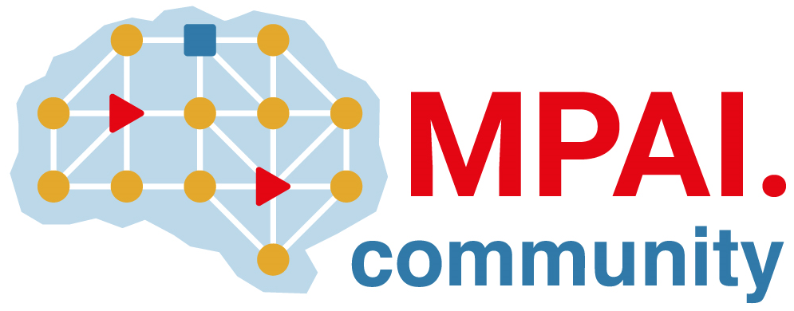 | Moving Picture, Audio and Data Coding by Artificial Intelligence  www.mpai.community

Public document
N1111 | 2023/03/22
Source | 30th MPAI General Assembly (MPAI-30)
Title | MPAI-30 Press Release
Target | MPAI Members

MPAI celebrates 30th month of activity publishing Enhanced Audio V2 and Metaverse Functionalities Profiles for Community Comments

Geneva, Switzerland – 22 March 2023. Today the international, non-profit, unaffiliated Moving Picture, Audio and Data Coding by Artificial Intelligence (MPAI) standards developing organisation has concluded its 30th General Assembly (MPAI-30) approving publication of WD0.3 of the MPAI Metaverse Model – Functionalities Profiles for Community Comments and the Context-based Audio Enhancement (MPAI-CAE) Technical Specification Version 2.

The MPAI Metaverse Model (MPAI-MMM) – Functionalities Profiles implements the second step of the MPAI roadmap of interoperability of metaverse implementations. It defines the protocol infrastructure enabling the different elements of a metaverse instance to request other elements of the same or different metaverse instances to execute actions, such as locating and animating an avatar. The document is posted at. Anybody can send comments to the MPAI Secretariat by the 17th of April 2023. The document will be presented online on the 7th of April 2023 with a view to elicit comments for consideration and possible inclusion in the final version to be approved on 19 April by MPAI-31.

The Context-based Audio Enhancement (MPAI-CAE) Technical Specification allows a device to describe an audio scene in terms of audio objects and their directions. MPAI uses this Technical Specification to enable human interaction with autonomous vehicles, avatar-based videoconference and metaverse applications.

These results are added to 6 Technical, 2 Reference Software, 1 Conformance Testing, and 1 Performance Assessment Specifications and 1Technical Report, 11 excellent reasons to celebrate 30 months of MPAI activity. On the anniversary day – 31st of March 2023 – MPAI will hold two parallel time-shifted events to cover most potential listeners where the 16 main MPAI activities will be presented. See the event program and register.

MPAI is continuing its work plan comprising the development of the following Technical Specifications:

- The AI Framework (MPAI-AIF) V2 Technical Specification will enable an implementer to establish a secure AIF environment to execute AI Workflows (AIW) composed of AI Modules (AIM).
- The Avatar Representation and Animation (MPAI-ARA) V1 Technical Specification will support creation and animation of interoperable human-like avatar models expressing a Personal Status.
- The Multimodal Conversation (MPAI-MMC) V2 Technical Specification will generalise the notion of Emotion by adding Cognitive State and Social Attitude and specify a new data type called Standard for Personal Status.

The MPAI work plan also includes exploratory activities, some of which are close to becoming standard or technical report projects:

- AI Health (MPAI-AIH). Targets an architecture where smartphones store users’ health data processed using AI and AI Models are updated using Federated Learning.
- Connected Autonomous Vehicles (MPAI-CAV). Targets the Human-CAV Interaction Environment Sensing, Autonomous Motion, and Motion Actuation subsystems implemented as AI Workflows.
- End-to-End Video Coding (MPAI-EEV). Extends the video coding frontiers using AI-based End-to-End Video coding.
- AI-Enhanced Video Coding (MPAI-EVC). Improves existing video coding with AI tools for short-to-medium term applications.
- Server-based Predictive Multiplayer Gaming (MPAI-SPG). Uses AI to train neural networks that help an online gaming server to compensate data losses and detects false data.
- XR Venues (MPAI-XRV). Identifies common AI Modules used across various XR-enabled and AI-enhanced use cases where venues may be both real and virtual.

It is still a good opportunity for legal entities supporting the MPAI mission and able to contribute to the development of standards for the efficient use of data to join MPAI.

Please visit the MPAI website, contact the MPAI secretariat for specific information, subscribe to the MPAI Newsletter and follow MPAI on social media: LinkedIn, Twitter, Facebook, Instagram, and YouTube.

