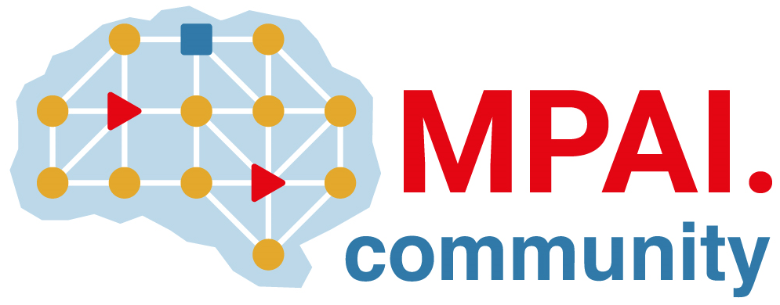 | Moving Picture, Audio and Data Coding  by Artificial Intelligence  www.mpai.community

 | Public document
N1093 | 2023/02/22
Source | Requirements (CAV)
Title | MPAI-CAV Progress report and plans
Target | MPAI-29

Requirements (CAV) has completed the review of the Environment Sensing Subsystems and is conducting the review of the Autonomous Motion Subsystem.
In this meeting cycle, time was dedicated to drafting the paper “A unified path to Metaverse and Connected Autonomous Vehicle functionalities”.

