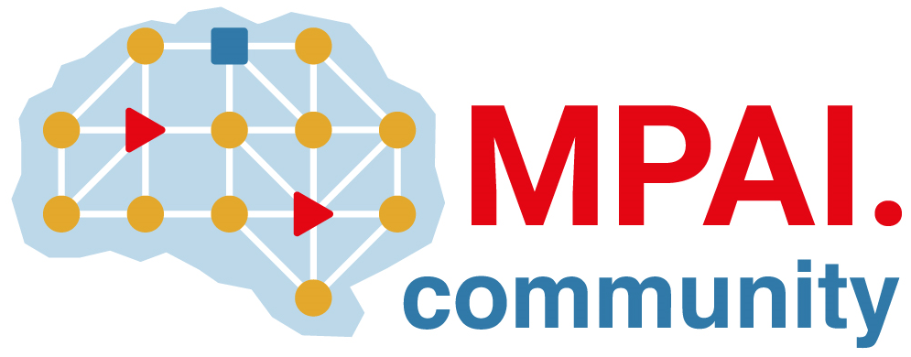 | Moving Picture, Audio and Data Coding by Artificial Intelligence  www.mpai.community

N1134 | 2023/03/22
Source | Requirements (EEV)
Title | Requirements (EEV) progress report and plans
Target | MPAI-30

Requirements (EEV) has made significant progress in learned video coding for drone videos. Specifically, the new version of reference model EEV-0.4 is released. The latest results on drone video coding are also provided in for MSE and MS-SSIM optimized models. Extensive study has been made to analyse the bottleneck and complexity of current EEV model, giving new sights for future research. EEV group has organized a conference with external experts. Over 30 participants registered the events.

The official website of EEV is also updated with the latest information with status description and contact information. The EEV website has release recent documents and data of EEV research for audiences with broad interests.

