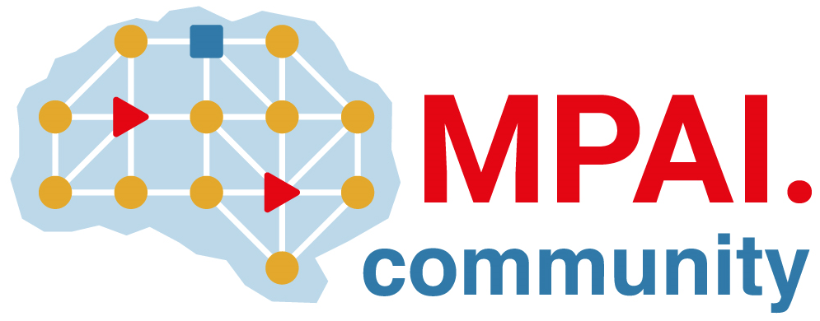 | Moving Picture, Audio and Data Coding by Artificial Intelligence  www.mpai.community

Public document
N1149 | 2023/04/19
Source | 31st MPAI General Assembly (MPAI-31)
Title | MPAI-31 Press Release
Target | MPAI Members

MPAI reaches the 2nd milestone of the
Roadmap for Metaverse Interoperability

Geneva, Switzerland – 19 April 2023. Today, the international, non-profit, and unaffiliated Moving Picture, Audio and Data Coding by Artificial Intelligence (MPAI) organisation developing AI-based data coding standards has concluded its 31st General Assembly (MPAI-31) approving Version 1 of the MPAI Metaverse Model – Functionality Profiles.

Technical Report – MPAI Metaverse Model (MPAI-MMM) – Functionality Profiles implements the second step of the MPAI roadmap for metaverse implementation interoperability. It defines the protocol infrastructure enabling the different elements of a metaverse instance to request elements of the same or different metaverse instances to execute actions, such as locating and animating an avatar; verifies that the infrastructure can support several characteristic use cases; and defines four functionality profiles.

MPAI recognises the role of Simone Casale-Brunet, Gérard Chollet, Panos Kudumakis, and Paolo Ribeca in the development of Technical Report - MPAI Metaverse Model (MPAI-MMM) – Functionality Profiles V1.

The Reference Software of the CAE-EAE (Context-based Audio Enhancement - Enhanced Audioconference Experience) is now available upon request from the MPAI secretariat. By using the software and a microphone array, it is possible to separate and individually hear different audio sources at different positions.

MPAI is continuing its work plan comprising the development of the following Technical Specifications:

- The AI Framework (MPAI-AIF) V2 Technical Specification will enable an implementer to establish a secure AIF environment to execute AI Workflows (AIW) composed of AI Modules (AIM).
- The Avatar Representation and Animation (MPAI-ARA) V1 Technical Specification will support creation and animation of interoperable human-like avatar models expressing a Personal Status.
- The Multimodal Conversation (MPAI-MMC) V2 Technical Specification will generalise the notion of Emotion by adding Cognitive State and Social Attitude and specify a new data type called Standard for Personal Status.

The MPAI work plan also includes exploratory activities, some of which are close to becoming standard or technical report projects:

- AI Health (MPAI-AIH). Targets an architecture where smartphones store users’ health data processed using AI and AI Models are updated using Federated Learning.
- Connected Autonomous Vehicles (MPAI-CAV). Targets the Human-CAV Interaction Environment Sensing, Autonomous Motion, and Motion Actuation subsystems implemented as AI Workflows.
- End-to-End Video Coding (MPAI-EEV). Extends the video coding frontiers using AI-based End-to-End Video coding.
- AI-Enhanced Video Coding (MPAI-EVC). Improves existing video coding with AI tools for short-to-medium term applications.
- Server-based Predictive Multiplayer Gaming (MPAI-SPG). Uses AI to train neural networks that help an online gaming server to compensate data losses and detects false data.
- XR Venues (MPAI-XRV). Identifies common AI Modules used across various XR-enabled and AI-enhanced use cases where venues may be both real and virtual.

Legal entities and representatives of academic departments supporting the MPAI mission and able to contribute to the development of standards for the efficient use of data can become MPAI members.

Please visit the MPAI website, contact the MPAI secretariat for specific information, subscribe to the MPAI Newsletter and follow MPAI on social media: LinkedIn, Twitter, Facebook, Instagram, and YouTube.

