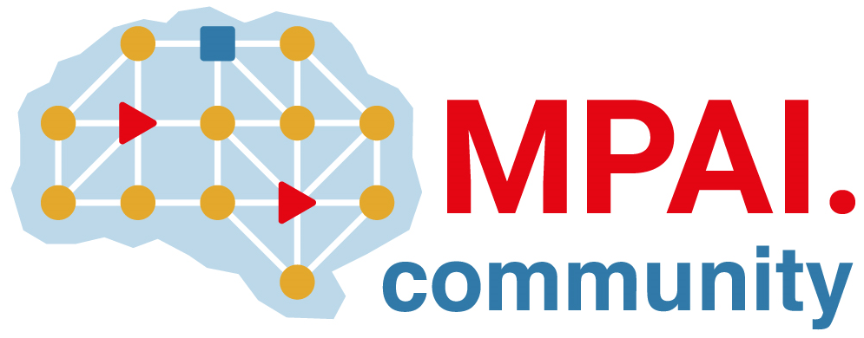 | Moving Picture, Audio and Data Coding  by Artificial Intelligence  www.mpai.community

 | Public document
N1170 | 2023/04/19
Source | Requirements (CAV)
Title | MPAI-CAV Progress report and plans
Target | MPAI-31

Requirements (CAV) has completed the review of the Environment Sensing Subsystems and is conducting the review of the Autonomous Motion Subsystem.
In this meeting cycle, time was dedicated to prepare the paper “A metaverse model supporting connected autonomous vehicles” for submission on the 8th of May 2023.

