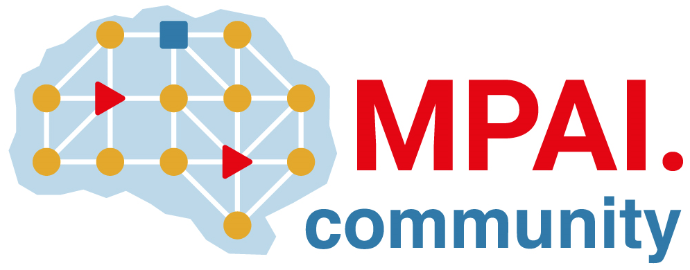 | Moving Picture, Audio and Data Coding by Artificial Intelligence  www.mpai.community

Public document
N1187 | 2023/05/17
Source | 32nd MPAI General Assembly (MPAI-32)
Title | MPAI-32 Press Release
Target | MPAI Members

MPAI announces publication of 3 MPAI standard adopted by IEEE without modification

Geneva, Switzerland – 17 May 2023. Today, the international, non-profit, and unaffiliated Moving Picture, Audio and Data Coding by Artificial Intelligence (MPAI) organisation developing AI-based data coding standards has concluded its 32nd General Assembly (MPAI-32) communicating that IEEE has published three MPAI standards – Multimodal Conversation, AI Framework, and Context-based Audio Enhancement – adopted without modifications.

The 3 IEEE standards only contain sparse editorial modifications compared with the original MPAI standards. The 3 new IEEE standards are accessible at IEEE regular conditions. The MPAI versions of the said standards continue to be accessible, upon registration, from the MPAI website.

MPAI is continuing its work plan comprising the development of the following Technical Specifications:

- The AI Framework (MPAI-AIF) V2 Technical Specification will enable an implementer to establish a secure AIF environment to execute AI Workflows (AIW) composed of AI Modules (AIM).
- The Avatar Representation and Animation (MPAI-ARA) V1 Technical Specification will support creation and animation of interoperable human-like avatar models expressing a Personal Status.
- The Multimodal Conversation (MPAI-MMC) V2 Technical Specification will generalise the notion of Emotion by adding Cognitive State and Social Attitude and specify a new data type called Standard for Personal Status.
- The Call for Technologies of the MPAI-Metaverse Model (MPAI-MMM) – Architecture is being prepared and is expected to be published soon.

The MPAI work plan also includes exploratory activities, some of which are close to becoming standard or technical report projects:

- AI Health (MPAI-AIH). Targets an architecture where smartphones store users’ health data processed using AI and AI Models are updated using Federated Learning.
- Connected Autonomous Vehicles (MPAI-CAV). Targets the Human-CAV Interaction Environment Sensing, Autonomous Motion, and Motion Actuation subsystems implemented as AI Workflows.
- End-to-End Video Coding (MPAI-EEV). Extends the video coding frontiers using AI-based End-to-End Video coding.
- AI-Enhanced Video Coding (MPAI-EVC). Improves existing video coding with AI tools for short-to-medium term applications.
- Server-based Predictive Multiplayer Gaming (MPAI-SPG). Uses AI to train neural networks that help an online gaming server to compensate data losses and detects false data.
- XR Venues (MPAI-XRV). Identifies common AI Modules used across various XR-enabled and AI-enhanced use cases where venues may be both real and virtual.

Legal entities and representatives of academic departments supporting the MPAI mission and able to contribute to the development of standards for the efficient use of data can become MPAI members.

Please visit the MPAI website, contact the MPAI secretariat for specific information, subscribe to the MPAI Newsletter and follow MPAI on social media: LinkedIn, Twitter, Facebook, Instagram, and YouTube.

