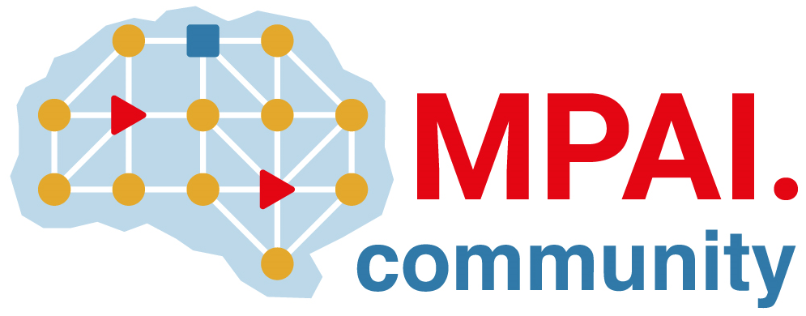 | Moving Picture, Audio and Data Coding by Artificial Intelligence  www.mpai.community

Public Document
N1214 | 2023/05/17
Source | Requirements (EEV)
Title | Requirements (EEV) progress report and plans
Target | MPAI-32

Requirements (EEV) has made significant progress in learned video coding for drone videos in its previous study. On the top of that, EEV is seeking enhanced models to further improve the coding efficiency using fine-tuning and enhanced models. In recent interaction with external experts, there are more and more experts that is interested in the drone video dataset. The meeting with EURASIP JIVP EiC has been held on May 4th. More and more experts are joining and knowing what is happening in EEV project.

