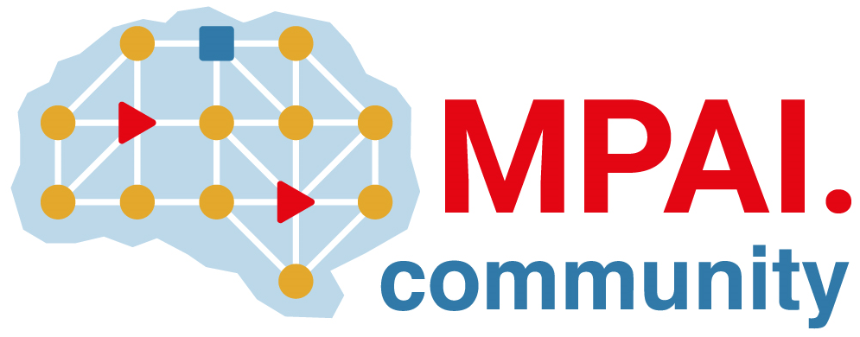 | Moving Picture, Audio and Data Coding  by Artificial Intelligence  www.mpai.community

Public document
N1252 | 2023/06/14
Source | Requirements (MMM)
Title | Template for responses: MPAI MMM Call for Technologies
Target | MPAI Community

Abstract
This document is provided as a help to those who intend to submit a response to Call for Technologies: MPAI Metaverse Model (MPAI-MMM) – Architecture. Text in
- Yellow (as in this sentence) provides guidance to submitters and should not be included in a submission. Text in green shall be mandatorily included in a submission.
- Green is text that must mandatorily be present. If the submission is in multiple files, each file shall include the green statement. If a submission does not include the green text, the submission will be rejected.
- White is text that it is suggested, respondents may use in a submission.

Introduction
This document is submitted by <organisation name> (if an MPAI Member) and/or by <organisation name>, a <company, university etc.> registered in <...> (if not an MPAI member) in response to the Call for Technologies: MPAI Metaverse Model (MPAI-MMM) – Architecture [4] issued by Moving Picture, Audio and Data Coding by Artificial Intelligence (MPAI) on 2023/06/14.
In the opinion of the submitter, this document proposes technologies that satisfy the requirements of MPAI document Use Cases and Functional Requirements: MPAI Metaverse Model (MPAI-MMM) – Architecture [5] issued by MPAI on 2023/06/14.

This document also contains comments on the Functional Requirements as requested by N1249 and N1250.

This document also contains proposed technologies that satisfy additional requirements as allowed by N1249 and N1250.

<Company and/or Member> explicitly agrees to the steps of the MPAI standards development process defined in Annex 1 to the MPAI Statutes (N421) and [1], in particular <Company and/or Member> declares that <Company and/or Member> or its successors will make available the terms of the Licence related to its Essential Patents according to the Framework Licence: MPAI Metaverse Model (MPAI-MMM) – Architecture [6], alone or jointly with other IPR holders after the approval of the Technical Specification: MPAI Metaverse Model (MPAI-MMM) – Architecture by the MPAI General Assembly and in no event after commercial implementations of the Technical Specification become available on the market.

< Company and/or Member> acknowledges the following points:
- MPAI in not obligated, by virtue of this CfT, to select a particular technology or to select any technology if those submitted are found inadequate.
- A representative of <Company and/or Member> shall present this submission at a Requirements (MMM) meeting communicated by the MPAI Secretariat. If no <Company and/or Member> will attend the meeting and present their submission, this will be discarded.
- <Company and/or Member> shall make available a working implementation – including source code – for use in the development of Reference Software Specification: MPAI Metaverse Model (MPAI-MMM) – Architecture and eventual publication by MPAI before the technology submitted is published in Technical Specification: MPAI Metaverse Model (MPAI-MMM) – Architecture.
- The software submitted may be written in programming languages that can be compiled or interpreted and in hardware description languages, upon acceptance by MPAI for further evaluation of their submission in whole or in part.
- <Company> shall immediately join MPAI upon acceptance by MPAI for further evaluation of this submission in whole or in part.
- If <Company> does not join MPAI, this submission shall be discarded.

Information about this submission
This information corresponds to Annex A on N1249. It is included here for submitter’s convenience.

- Title of the proposal
- Organisation: company name, position, e-mail of contact person
- What are the main functionalities of your proposal?
- Does your proposal provide or describe a formal specification and APIs?
- Will you provide a demonstration to show how your proposal meets the evaluation criteria?

Comments on/extensions to requirements (if any)

Overview of Functional Requirements supported by this submission
Please answer Y or N. Detail on the specific answers should be provided in Chapter 6.

# | MPAI-MMM Architecture elements | Response
2 | Use Cases
3 | Functionalities of the MPAI Metaverse Model | Y/N
3.1 | Disclaimer | Y/N
3.2 | Basic Functionalities | Y/N
3.3 | Processes | Y/N
3.4 | Items | Y/N
3.5 | Data Types | Y/N
3.6 | Interoperability support | Y/N
4 | Functional Requirements | Y/N
4.2 | Processes | Y/N
4.2.2 | App | Y/N
4.2.3 | Device | Y/N
4.2.4 | Service | Y/N
4.2.5 | User | Y/N
4.3 | Items | Y/N
4.3.1 | General | Y/N
4.3.2 | Account | Y/N
4.3.3 | Activity Data | Y/N
4.3.4 | Asset | Y/N
4.3.5 | AuthenticateIn | Y/N
4.3.6 | AuthenticateOut | Y/N
4.3.7 | Contract | Y/N
4.3.8 | DiscoverIn | Y/N
4.3.9 | DiscoverOut | Y/N
4.3.10 | Entity | Y/N
4.3.11 | Event | Y/N
4.3.12 | Experience | Y/N
4.3.13 | Identifier | Y/N
4.3.14 | InformIn | Y/N
4.3.15 | InformOut | Y/N
4.3.16 | Interaction | Y/N
4.3.17 | InterpretIn | Y/N
4.3.18 | InterpretOut | Y/N
4.3.19 | Ledger | Y/N
4.3.20 | Map | Y/N
4.3.21 | M-Environment | Y/N
4.3.22 | Message | Y/N
4.3.23 | M-Location | Y/N
4.3.24 | Model | Y/N
4.3.25 | Object | Y/N
4.3.26 | Persona | Y/N
4.3.27 | Personal Profile | Y/N
4.3.28 | Program | Y/N
4.3.29 | Provenance | Y/N
4.3.30 | Request-Action | Y/N
4.3.31 | Response-Action | Y/N
4.3.32 | Rights | Y/N
4.3.33 | Rules | Y/N
4.3.34 | Scene | Y/N
4.3.35 | Social Graph | Y/N
4.3.36 | Stream | Y/N
4.3.37 | Transaction | Y/N
4.3.38 | U-Location | Y/N
4.3.39 | User Data | Y/N
4.3.40 | Value | Y/N
4.3.41 | Wallet | Y/N
4.4 | Actions | Y/N
4.4.2 | Authenticate | Y/N
4.4.3 | Author | Y/N
4.4.4 | Change | Y/N
4.4.5 | Convert | Y/N
4.4.6 | Discover | Y/N
4.4.7 | Execute | Y/N
4.4.8 | Hide | Y/N
4.4.9 | Identify | Y/N
4.4.10 | Inform | Y/N
4.4.11 | Interpret | Y/N
4.4.12 | MM-Add | Y/N
4.4.13 | MM-Animate | Y/N
4.4.14 | MM-Disable | Y/N
4.4.15 | MM-Embed | Y/N
4.4.16 | MM-Enable | Y/N
4.4.17 | MM-Send | Y/N
4.4.18 | Modify | Y/N
4.4.19 | MU-Actuate | Y/N
4.4.20 | MU-Render | Y/N
4.4.21 | MU-Send | Y/N
4.4.22 | Post | Y/N
4.4.23 | Register | Y/N
4.4.24 | Resolve | Y/N
4.4.25 | Track | Y/N
4.4.26 | Transact | Y/N
4.4.27 | UM-Animate | Y/N
4.4.28 | UM-Capture | Y/N
4.4.29 | UM-Render | Y/N
4.4.30 | UM-Send | Y/N
4.4.31 | Validate | Y/N
4.5 | Data Types | Y/N
4.5.2 | Address | Y/N
4.5.3 | Amount | Y/N
4.5.4 | Cognitive State | Y/N
4.5.5 | Coordinates | Y/N
4.5.6 | Currency | Y/N
4.5.7 | Emotion | Y/N
4.5.8 | Orientation | Y/N
4.5.9 | Personal Status | Y/N
4.5.10 | Point of View | Y/N
4.5.11 | Position | Y/N
4.5.12 | Social Attitude | Y/N
4.5.13 | Spatial Attitude | Y/N
4.5.14 | Time | Y/N

New Proposed requirements (if any)

Y/N
Y/N
Y/N

- Detailed description of submission

Proposal section #1

Proposal section #2
....

Conclusions

References
- MPAI Patent Policy; https://mpai.community/about/the-mpai-patent-policy/.
- MPAI; Technical Report: MPAI Metaverse Model (MPAI-MMM) – Functionalities V1; January 2023; https://mpai.community/standards/mpai-mmm/mpai-metaverse-model/mmm-functionalities/
- MPAI; Technical Report: MPAI Metaverse Model (MPAI-MMM) – Functionality Profiles V1; April 2023; N1249; https://mmm.mpai.community
- MPAI; Call for Technologies: MPAI Metaverse Model (MPAI-MMM) – Architecture; N1249; https://mpai.community/standards/mpai-mmm/call-for-technologies-mpai-mmm-architecture/
- MPAI; Use Cases and Functional Requirements: MPAI Metaverse Model (MPAI-MMM) – Architecture; N1250; https://mpai.community/standards/mpai-mmm/mpai-metaverse-model/#Architecture
- MPAI; Framework Licence: MPAI Metaverse Model (MPAI-MMM) – Architecture; N1251; https://mpai.community/standards/mpai-mmm/framework-licence-mpai-metaverse-model-mpai-mmm-architecture/
- MPAI: Template for responses: MPAI Metaverse Model (MPAI-MMM) – Architecture; N1251; https://mpai.community/standards/mpai-mmm/template-for-responses-mpai-mmm-call-for-technologies/

