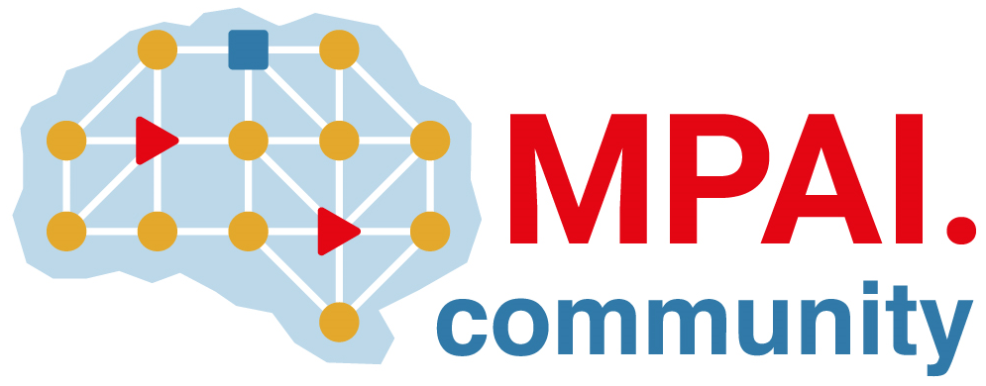 | Moving Picture, Audio and Data Coding by Artificial Intelligence  www.mpai.community

Public document
N1259 | 2023/06/14
Source | Requirements (EEV)
Title | Requirements (EEV) progress report and plans
Target | MPAI-33

Requirements (EEV) has made significant progress in learned video coding for drone videos in its previous study.

On the top of that, EEV is seeking enhanced models to further improve the coding efficiency using fine-tuning and enhanced models. In recent interaction with internal experts, it has been agreed that a standard for learning based video coding is practical and doable.

The EEV group has made a practical step in preparing the draft to standardize a neural video codec. Together with this step, an initial version of the draft has been proposed.

