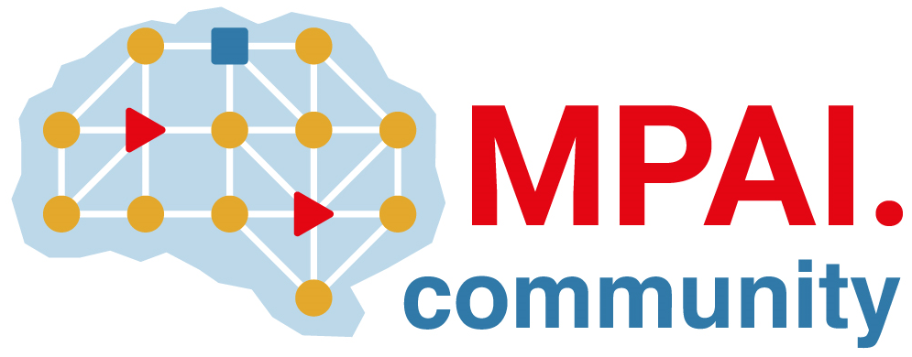 | Moving Picture, Audio and Data Coding  by Artificial Intelligence  www.mpai.community

Public document
N1314 | 2023/07/12
Source | Requirements (SPG)
Title | MPAI-SPG Status report
Target | MPAI Members

Progresses

Across the two projects we have potentially identified un underlying problem with the application of predicted data during the game simulation. In the previous report this problem was simply identified, it is now resolved in the Racing Game use case and will be included in future iterations of the Pong use case.

Concerning the two user cases (UC), there are no significant progresses to be reported on the Pong UC, whereas on the Racing Game the core progresses are as follows:

- Defined the “surrounding” data: position with the track block, type of track block in which the car is positioned.
- Identified in LSTM the most promising predicting network architecture when training the system with also surrounding data.
- Implementation of the networked architecture for the game and the lag simulation modules
- Starting training sessions with greater time extracts. So far the prediction was performed on data from the previous 1 second of game play, we are now approaching the problem to encompass a greater number of samples, thus extending the prediction input data, closer to 5 seconds windows.

Future Plans

Addressing the Pong UC we plan to:
- Recruit human resources to work on the use case as in the current situation we are not capable of significant progresses.

Addressing the Racing Game UC we plan to:

- Experiment directly in the Game Engine with the quality of prediction from the networks trained on surrounding data.
- Fine tune the network application to: Dynamically manipulate the lag simulation, Create real playing scenarios and collect log data for subsequent quality assessments
- Define the experimental protocol of the user study we aim to administer in late September

