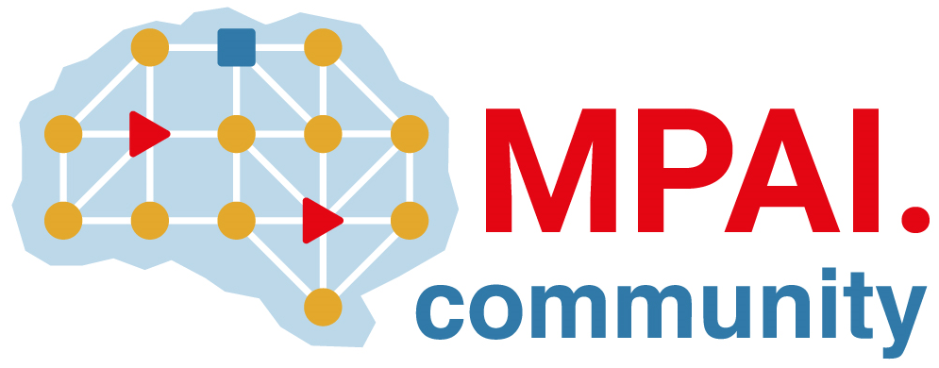 | Moving Picture, Audio and Data Coding by Artificial Intelligence  www.mpai.community

Public document
N1325 | 2023/08/23
Source | 35th MPAI General Assembly (MPAI-35)
Title | MPAI-35 Press Release
Target | MPAI Members

MPAI issues three Calls for Technologies
Publishes five standards for Community Comments

Geneva, Switzerland – 23 August 2023. Today, the international, non-profit, and unaffiliated Moving Picture, Audio and Data Coding by Artificial Intelligence (MPAI) organisation developing AI-based data coding standards has concluded its 35th General Assembly (MPAI-35) approving the publication of three Calls for Technologies and five Technical Reports with request for Community Comments. The table gives links to the documents, dates of and registration links to online presentations and deadlines for submitting responses to Calls and comments on Standards.

Call for Technologies | Link | Presentation | Deadline
AI for Health Data (AIH) | X | Sep 08 08 & 15 | Oct 19 23:59
Object and Scene Description (OSD) | X | Sep 07 09 & 16 | Sep 20 23:59
XR Venues – Live Theatrical Stage Performance (XRV) | X | Sep 12 07 & 17 | Nov 20 23:59
Standard for Community Comments |  | Presentation | Deadline
AI Framework (AIF) V2 | X | Sep 11 08 & 15 | Sep 24 23:59
Avatar Representation and Animation (ARA) | X | Sep 07 08 & 15 | Sep 27 23:59
Connected Autonomous Vehicles – Architecture (CAV) | X | Sep 06 08 & 15 | Sep 26 23:59
Multimodal Conversation (MMC) V2 | X | Sep 05 08 & 15 | Sep 25 23:59
MPAI Metaverse Model – Architecture (MMM) | X | Sep 01 08 & 15 | Sep 21 23:59

Additional information about the purpose of the projects can be found here.

Anybody may respond to any of the three Calls for Technologies. However, non-members should join MPAI to participate in the development of the relevant standards.

Anybody can make comments on the Technical Specifications published with a request for Community Comments.

MPAI is continuing its work plan that includes the development of the following Technical Specifications:

- AIF-DC, the group in charge of AI Framework (MPAI-AIF), is now working on the review of comments made on MPAI-AIF V2, developing the reference software and drafting the conformance testing.
- Requirements (ARA), the group in charge of Avatar Representation and Animation (MPAI-ARA), is now working on the review of comments made on MPAI-AIF V2, developing the reference software and drafting the conformance testing.
- MMC-DC, the group in charge of Multimodal Conversation (MPAI-MMC), is now working on the review of comments made on MPAI-AIF V2, developing the reference software and drafting the conformance testing.
- Requirements (MMM), the group in charge of MPAI Metaverse Model (MPAI-MMM) - Architecture, is now working on the review of comments made on MPAI-AIF V2, developing the reference software and drafting the conformance testing.

The MPAI work plan also includes exploratory activities, some of which are close to becoming standard or technical report projects:

- AI Health (MPAI-AIH). Targets an architecture where smartphones store users’ health data processed using AI and AI Models are updated using Federated Learning.
- End-to-End Video Coding (MPAI-EEV). Extends the video coding frontiers using AI-based End-to-End Video coding.
- AI-Enhanced Video Coding (MPAI-EVC). Improves existing video coding with AI tools for short-to-medium term applications.
- Server-based Predictive Multiplayer Gaming (MPAI-SPG). Uses AI to train neural networks that help an online gaming server to compensate data losses and detects false data.
- XR Venues (MPAI-XRV). Identifies common AI Modules used across various XR-enabled and AI-enhanced use cases where venues may be both real and virtual.

Legal entities and representatives of academic departments supporting the MPAI mission and able to contribute to the development of standards for the efficient use of data can become MPAI members.

Please visit the MPAI website, contact the MPAI secretariat for specific information, subscribe to the MPAI Newsletter and follow MPAI on social media: LinkedIn, Twitter, Facebook, Instagram, and YouTube.

