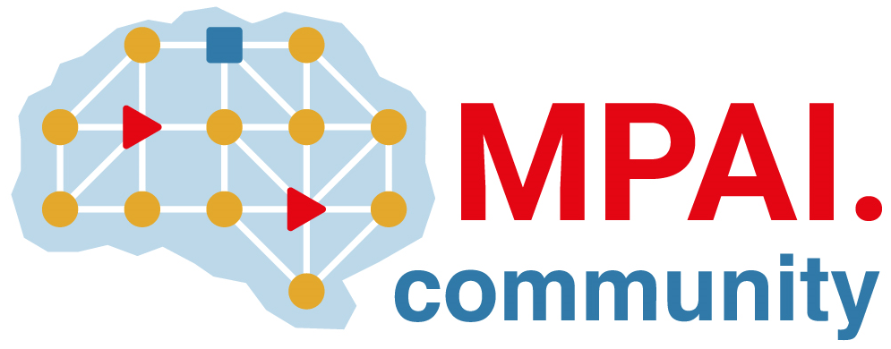 | Moving Picture, Audio and Data Coding by Artificial Intelligence  www.mpai.community

Public document
N1362 | 2023/08/23
Source | IPR Support Advisory Committee
Title | Framework Licence: Object and Scene Description (MPAI-OSD)
Target | MPAI Members

Coverage
This Framework Licence applies to Technical Specification: Object and Scene Description (MPAI-OSD) – in the following “Standard” – as it will be defined in document Nwxyz Technical Specification: Object and Scene Description (MPAI-OSD) planned to be approved Moving Picture, Audio and Data Coding by Artificial Intelligence (MPAI). All contributors to the Standard shall confirm in writing their intention to make available a Licence for their Essential IPR based on the Conditions of use of the Licence in Section 3.

Definitions
Term | Definition
Conforming Implementation | An implementation that has passed the Conformance Testing process of Object and Scene Description.
Data | Any digital representation of a real or computer-generated entity, such as moving pictures, audio, point cloud, computer graphics, sensor, and actuator. Data includes, but is not restricted to, media, manufacturing, automotive, health and generic data.
Development Rights | Licence to use Essential IPRs to develop Implementations of the Standard.
Enterprise | Any entity contributing to the development of or implementing the Standard.
Essential IPR | Any Proprietary Rights, (such as patents) without which it is not possible on technical (but not commercial) grounds, to make, sell, lease, otherwise dispose of, repair, use or operate Implementations without infringing those Proprietary Rights
Framework Licence | A document, developed in compliance with the generally accepted principles of competition law, which contains the conditions of use of the Licence without the values, e.g., currency, percent, dates, etc.
General Availability | The result of the release of a product to the general public. When a product reaches General Availability, it becomes available through the company's general sales channel — as opposed to a limited release, or beta version, used primarily for testing and user feedback purposes.
Implementation | A hardware and/or software reification of the Standard serving the needs of a professional or consumer user directly or through a service
Implementation Rights | Licence to reify the Standard.
Licence | The Framework Licence to which values, e.g., currency, percent, dates etc., related to a Standard Essential IPR will be added. In the Framework Licence, the word Licence will be used as singular. However, multiple Licences from different IPR holders may be issued.
Profile | A particular subset of the technologies that are used in and, where applicable, the classes, subsets, options, and parameters relevant to the subset
Standard | Technical Specification: Object and Scene Description (MPAI-OSD).
Standard Essential IPR | Essential IPR for the Standard specified by MPAI.
Technical Specification | The document specifying how to make an Implementation.
Trial | A release of a product or service to a limited number of participants in the Trial.

Conditions of use of the Licence
The Standard Essential IPR holders commit themselves to issue a Licence with the following conditions:
- The Licence will be in compliance with generally accepted principles of competition law and the MPAI Statutes
- The Licence will cover:
  - All claims to Essential IPR and copyright of a Licensor that are practised by a Licensee of the Standard.
  - Development Rights and Implementation Rights.
- The Licence will grant access to Essential IPRs of the Standard in a non-discriminatory fashion.
- The scope of the Licence may be subject to legal, bias, ethical and moral limitations.
- Royalties will apply:
  - To a baseline profile of the Standard and to other profiles containing additional technologies.
  - To any Implementation that is based on the Standard, with the exclusion of the types of implementations specified in clause 7.1.
  - On a worldwide basis.
- An Implementation of the Standard may use other IPR to extend the Implementation Standard or to provide additional functionalities.
- Exemptions:
  - A Licence for Development and Implementation Rights, to the extent it is developed and implemented only for the purpose of evaluation or demo solutions or technical trials, will be free of charge.
  - A Licence may be granted free of charge for particular uses if so decided by the licensors.
  - A free of charge Licence for a limited time and a limited amount of forfeited royalties will be granted on request.
- A preference will be expressed on the entity that should administer the patent pool of holders of Patents Essential to the Standard.
- The Licence will be issued before commercial implementations of the Standard become available on the market. Commercial implementation implies General Availability to any users and does not include trials.
- The total cost of the Licences issued by IPR holders will be in line with the total cost of the Licences for similar technologies standardised in the context of Standard Development Organisations.
- The total cost of the Licences will take into account the value on the market of the Standard Essential IPR.

